Lampiran 7. Data Penelitian
Data Tes Kekuatan
NO | Hand Grip |  | Push Up |  | Sit UP |  | Leg D
 | Pretest | posttest | Pretest | posttest | Pretest | posttest | Pretest | Posttest
1 | 33,01 | 34,5 | 31 | 35 | 25 | 25 | 242 | 255
2 | 36,17 | 36,17 | 18 | 20 | 18 | 20 | 194 | 200
3 | 34,5 | 36,5 | 30 | 34 | 20 | 23 | 207 | 220
4 | 54 | 60,7 | 20 | 25 | 20 | 24 | 190,5 | 200,5
5 | 36 | 36,22 | 20 | 22 | 20 | 20 | 152,5 | 155,5
6 | 32 | 33,2 | 20 | 27 | 20 | 23 | 208 | 209,5
7 | 24,02 | 30,08 | 16 | 21 | 20 | 21 | 141,5 | 144,5
8 | 42,15 | 43,52 | 24 | 27 | 20 | 27 | 164,5 | 164,5
9 | 28,18 | 33,18 | 15 | 22 | 21 | 23 | 100,5 | 120,5
10 | 25,13 | 35,33 | 15 | 18 | 15 | 17 | 138,5 | 140,5
11 | 40 | 45,45 | 28 | 33 | 22 | 28 | 231 | 244
12 | 30,15 | 31,12 | 20 | 22 | 21 | 22 | 224 | 250
13 | 45 | 46 | 14 | 17 | 25 | 26 | 300 | 300
14 | 36,5 | 37,8 | 15 | 25 | 20 | 22 | 186,5 | 188,5

Data Akurasi
NO | Forehand |  | backhand
 | Pretest | posttest | Pretest | posttest
1 | 18 | 32 | 31 | 27
2 | 23 | 26 | 22 | 27
3 | 27 | 27 | 23 | 28
4 | 16 | 21 | 20 | 30
5 | 25 | 32 | 23 | 20
6 | 21 | 32 | 19 | 21
7 | 28 | 32 | 19 | 23
8 | 27 | 27 | 22 | 24
9 | 20 | 26 | 19 | 26
10 | 19 | 30 | 20 | 32
11 | 33 | 35 | 23 | 30
12 | 20 | 21 | 18 | 22
13 | 23 | 30 | 18 | 30
14 | 22 | 21 | 18 | 28

Lampiran 8. Statistik Data Penelitian
Frequencies

[DataSet0]

Statistics
 |  | Hand Grip (Pretest) | Hand Grip (Posttest)
N | Valid | 14 | 14
 | Missing | 0 | 0
Mean |  | 35,4864 | 38,5550
Median |  | 35,2500 | 36,1950
Mode |  | 24,02ª | 30,08ª
Std. Deviation |  | 8,03670 | 8,06450
Minimum |  | 24,02 | 30,08
Maximum |  | 54,00 | 60,70
Sum |  | 496,81 | 539,77

a. Multiple modes exist. The smallest value is shown

Frequency Table

Hand Grip (Pretest)
 |  | Frequency | Percent | Valid Percent | Cumulative Percent
Valid | 24,02 | 1 | 7,1 | 7,1 | 7,1
 | 25,13 | 1 | 7,1 | 7,1 | 14,3
 | 28,18 | 1 | 7,1 | 7,1 | 21,4
 | 30,15 | 1 | 7,1 | 7,1 | 28,6
 | 32,00 | 1 | 7,1 | 7,1 | 35,7
 | 33,01 | 1 | 7,1 | 7,1 | 42,9
 | 34,50 | 1 | 7,1 | 7,1 | 50,0
 | 36,00 | 1 | 7,1 | 7,1 | 57,1
 | 36,17 | 1 | 7,1 | 7,1 | 64,3
 | 36,50 | 1 | 7,1 | 7,1 | 71,4
 | 40,00 | 1 | 7,1 | 7,1 | 78,6
 | 42,15 | 1 | 7,1 | 7,1 | 85,7
 | 45,00 | 1 | 7,1 | 7,1 | 92,9
 | 54,00 | 1 | 7,1 | 7,1 | 100,0
 | Total | 14 | 100,0 | 100,0

Hand Grip (Posttest)
 |  | Frequency | Percent | Valid Percent | Cumulative Percent
Valid | 30,08 | 1 | 7,1 | 7,1 | 7,1
 | 31,12 | 1 | 7,1 | 7,1 | 14,3
 | 33,18 | 1 | 7,1 | 7,1 | 21,4
 | 33,20 | 1 | 7,1 | 7,1 | 28,6
 | 34,50 | 1 | 7,1 | 7,1 | 35,7
 | 35,33 | 1 | 7,1 | 7,1 | 42,9
 | 36,17 | 1 | 7,1 | 7,1 | 50,0
 | 36,22 | 1 | 7,1 | 7,1 | 57,1
 | 36,50 | 1 | 7,1 | 7,1 | 64,3
 | 37,80 | 1 | 7,1 | 7,1 | 71,4
 | 43,52 | 1 | 7,1 | 7,1 | 78,6
 | 45,45 | 1 | 7,1 | 7,1 | 85,7
 | 46,00 | 1 | 7,1 | 7,1 | 92,9
 | 60,70 | 1 | 7,1 | 7,1 | 100,0
 | Total | 14 | 100,0 | 100,0

Frequencies

[DataSet0]

Statistics
 |  | Push Up (pretest) | Push Up (posttest)
N | Valid | 14 | 14
 | Missing | 0 | 0
Mean |  | 20,4286 | 24,8571
Median |  | 20,0000 | 23,5000
Mode |  | 20,00 | 22,00
Std. Deviation |  | 5,74743 | 5,77604
Minimum |  | 14,00 | 17,00
Maximum |  | 31,00 | 35,00
Sum |  | 286,00 | 348,00

Frequency Table

Push Up (pretest)
 |  | Frequency | Percent | Valid Percent | Cumulative Percent
Valid | 14,00 | 1 | 7,1 | 7,1 | 7,1
 | 15,00 | 3 | 21,4 | 21,4 | 28,6
 | 16,00 | 1 | 7,1 | 7,1 | 35,7
 | 18,00 | 1 | 7,1 | 7,1 | 42,9
 | 20,00 | 4 | 28,6 | 28,6 | 71,4
 | 24,00 | 1 | 7,1 | 7,1 | 78,6
 | 28,00 | 1 | 7,1 | 7,1 | 85,7
 | 30,00 | 1 | 7,1 | 7,1 | 92,9
 | 31,00 | 1 | 7,1 | 7,1 | 100,0
 | Total | 14 | 100,0 | 100,0

Push Up (posttest)
 |  | Frequency | Percent | Valid Percent | Cumulative Percent
Valid | 17,00 | 1 | 7,1 | 7,1 | 7,1
 | 18,00 | 1 | 7,1 | 7,1 | 14,3
 | 20,00 | 1 | 7,1 | 7,1 | 21,4
 | 21,00 | 1 | 7,1 | 7,1 | 28,6
 | 22,00 | 3 | 21,4 | 21,4 | 50,0
 | 25,00 | 2 | 14,3 | 14,3 | 64,3
 | 27,00 | 2 | 14,3 | 14,3 | 78,6
 | 33,00 | 1 | 7,1 | 7,1 | 85,7
 | 34,00 | 1 | 7,1 | 7,1 | 92,9
 | 35,00 | 1 | 7,1 | 7,1 | 100,0
 | Total | 14 | 100,0 | 100,0

Frequencies

Statistics
 |  | Sit Up (Pretest) | Sit UP (Postest)
N | Valid | 14 | 14
 | Missing | 0 | 0
Mean |  | 20,5000 | 22,9286
Median |  | 20,0000 | 23,0000
Mode |  | 20,00 | 23,00
Std. Deviation |  | 2,50384 | 2,97332
Minimum |  | 15,00 | 17,00
Maximum |  | 25,00 | 28,00
Sum |  | 287,00 | 321,00

Frequency Table

Sit Up (Pretest)
 |  | Frequency | Percent | Valid Percent | Cumulative Percent
Valid | 15,00 | 1 | 7,1 | 7,1 | 7,1
 | 18,00 | 1 | 7,1 | 7,1 | 14,3
 | 20,00 | 7 | 50,0 | 50,0 | 64,3
 | 21,00 | 2 | 14,3 | 14,3 | 78,6
 | 22,00 | 1 | 7,1 | 7,1 | 85,7
 | 25,00 | 2 | 14,3 | 14,3 | 100,0
 | Total | 14 | 100,0 | 100,0

Sit UP (Postest)
 |  | Frequency | Percent | Valid Percent | Cumulative Percent
Valid | 17,00 | 1 | 7,1 | 7,1 | 7,1
 | 20,00 | 2 | 14,3 | 14,3 | 21,4
 | 21,00 | 1 | 7,1 | 7,1 | 28,6
 | 22,00 | 2 | 14,3 | 14,3 | 42,9
 | 23,00 | 3 | 21,4 | 21,4 | 64,3
 | 24,00 | 1 | 7,1 | 7,1 | 71,4
 | 25,00 | 1 | 7,1 | 7,1 | 78,6
 | 26,00 | 1 | 7,1 | 7,1 | 85,7
 | 27,00 | 1 | 7,1 | 7,1 | 92,9
 | 28,00 | 1 | 7,1 | 7,1 | 100,0
 | Total | 14 | 100,0 | 100,0

Frequencies

[DataSet0]

Statistics
 |  | Leg Dynamometer (pretest) | Leg Dynamometer (Posttest)
N | Valid | 14 | 14
 | Missing | 0 | 0
Mean |  | 191,4643 | 199,5000
Median |  | 192,2500 | 200,2500
Mode |  | 100,50ª | 120,50ª
Std. Deviation |  | 50,62968 | 51,33712
Minimum |  | 100,50 | 120,50
Maximum |  | 300,00 | 300,00
Sum |  | 2680,50 | 2793,00

a. Multiple modes exist. The smallest value is shown

Frequency Table

Leg Dynamometer (pretest)
 |  | Frequency | Percent | Valid Percent | Cumulative Percent
Valid | 100,50 | 1 | 7,1 | 7,1 | 7,1
 | 138,50 | 1 | 7,1 | 7,1 | 14,3
 | 141,50 | 1 | 7,1 | 7,1 | 21,4
 | 152,50 | 1 | 7,1 | 7,1 | 28,6
 | 164,50 | 1 | 7,1 | 7,1 | 35,7
 | 186,50 | 1 | 7,1 | 7,1 | 42,9
 | 190,50 | 1 | 7,1 | 7,1 | 50,0
 | 194,00 | 1 | 7,1 | 7,1 | 57,1
 | 207,00 | 1 | 7,1 | 7,1 | 64,3
 | 208,00 | 1 | 7,1 | 7,1 | 71,4
 | 224,00 | 1 | 7,1 | 7,1 | 78,6
 | 231,00 | 1 | 7,1 | 7,1 | 85,7
 | 242,00 | 1 | 7,1 | 7,1 | 92,9
 | 300,00 | 1 | 7,1 | 7,1 | 100,0
 | Total | 14 | 100,0 | 100,0

Leg Dynamometer (Posttest)
 |  | Frequency | Percent | Valid Percent | Cumulative Percent
Valid | 120,50 | 1 | 7,1 | 7,1 | 7,1
 | 140,50 | 1 | 7,1 | 7,1 | 14,3
 | 144,50 | 1 | 7,1 | 7,1 | 21,4
 | 155,50 | 1 | 7,1 | 7,1 | 28,6
 | 164,50 | 1 | 7,1 | 7,1 | 35,7
 | 188,50 | 1 | 7,1 | 7,1 | 42,9
 | 200,00 | 1 | 7,1 | 7,1 | 50,0
 | 200,50 | 1 | 7,1 | 7,1 | 57,1
 | 209,50 | 1 | 7,1 | 7,1 | 64,3
 | 220,00 | 1 | 7,1 | 7,1 | 71,4
 | 244,00 | 1 | 7,1 | 7,1 | 78,6
 | 250,00 | 1 | 7,1 | 7,1 | 85,7
 | 255,00 | 1 | 7,1 | 7,1 | 92,9
 | 300,00 | 1 | 7,1 | 7,1 | 100,0
 | Total | 14 | 100,0 | 100,0

Frequencies

Statistics
 |  | Ground Stroke Fore hand (pretest) | Ground Strioke Fore hand (Posttest)
N | Valid | 14 | 14
 | Missing | 0 | 0
Mean |  | 23,0000 | 28,0000
Median |  | 22,5000 | 28,5000
Mode |  | 20,00ª | 32,00
Std. Deviation |  | 4,59096 | 4,62435
Minimum |  | 16,00 | 21,00
Maximum |  | 33,00 | 35,00
Sum |  | 322,00 | 392,00

a. Multiple modes exist. The smallest value is shown

Frequency Table

Ground Stroke Fore hand (pretest)
 |  | Frequency | Percent | Valid Percent | Cumulative Percent
Valid | 16,00 | 1 | 7,1 | 7,1 | 7,1
 | 18,00 | 1 | 7,1 | 7,1 | 14,3
 | 19,00 | 1 | 7,1 | 7,1 | 21,4
 | 20,00 | 2 | 14,3 | 14,3 | 35,7
 | 21,00 | 1 | 7,1 | 7,1 | 42,9
 | 22,00 | 1 | 7,1 | 7,1 | 50,0
 | 23,00 | 2 | 14,3 | 14,3 | 64,3
 | 25,00 | 1 | 7,1 | 7,1 | 71,4
 | 27,00 | 2 | 14,3 | 14,3 | 85,7
 | 28,00 | 1 | 7,1 | 7,1 | 92,9
 | 33,00 | 1 | 7,1 | 7,1 | 100,0
 | Total | 14 | 100,0 | 100,0

Ground Strioke Fore hand (Posttest)
 |  | Frequency | Percent | Valid Percent | Cumulative Percent
Valid | 21,00 | 3 | 21,4 | 21,4 | 21,4
 | 26,00 | 2 | 14,3 | 14,3 | 35,7
 | 27,00 | 2 | 14,3 | 14,3 | 50,0
 | 30,00 | 2 | 14,3 | 14,3 | 64,3
 | 32,00 | 4 | 28,6 | 28,6 | 92,9
 | 35,00 | 1 | 7,1 | 7,1 | 100,0
 | Total | 14 | 100,0 | 100,0
Frequencies

Statistics
 |  | Ground Stroke Back Hand (Posttest) | Ground Stroke Back hand (Posttest)
N | Valid | 14 | 14
 | Missing | 0 | 0
Mean |  | 21,0714 | 26,2857
Median |  | 20,0000 | 27,0000
Mode |  | 18,00ª | 30,00
Std. Deviation |  | 3,45219 | 3,75046
Minimum |  | 18,00 | 20,00
Maximum |  | 31,00 | 32,00
Sum |  | 295,00 | 368,00

a. Multiple modes exist. The smallest value is shown

Frequency Table

Ground Stroke Back Hand (Posttest)
 |  | Frequency | Percent | Valid Percent | Cumulative Percent
Valid | 18,00 | 3 | 21,4 | 21,4 | 21,4
 | 19,00 | 3 | 21,4 | 21,4 | 42,9
 | 20,00 | 2 | 14,3 | 14,3 | 57,1
 | 22,00 | 2 | 14,3 | 14,3 | 71,4
 | 23,00 | 3 | 21,4 | 21,4 | 92,9
 | 31,00 | 1 | 7,1 | 7,1 | 100,0
 | Total | 14 | 100,0 | 100,0

Ground Stroke Back hand (Posttest)
 |  | Frequency | Percent | Valid Percent | Cumulative Percent
Valid | 20,00 | 1 | 7,1 | 7,1 | 7,1
 | 21,00 | 1 | 7,1 | 7,1 | 14,3
 | 22,00 | 1 | 7,1 | 7,1 | 21,4
 | 23,00 | 1 | 7,1 | 7,1 | 28,6
 | 24,00 | 1 | 7,1 | 7,1 | 35,7
 | 26,00 | 1 | 7,1 | 7,1 | 42,9
 | 27,00 | 2 | 14,3 | 14,3 | 57,1
 | 28,00 | 2 | 14,3 | 14,3 | 71,4
 | 30,00 | 3 | 21,4 | 21,4 | 92,9
 | 32,00 | 1 | 7,1 | 7,1 | 100,0
 | Total | 14 | 100,0 | 100,0

Lampiran 9. Uji Normalitas

NPAR TESTS
/K-S(NORMAL)=VAR00005 VAR00006
/MISSING ANALYSIS.

NPar Tests

[DataSet0]

One-Sample Kolmogorov-Smirnov Test
 |  | Hand Grip (Pretest) | Hand Grip (Posttest)
N |  | 14 | 14
Normal Parameters^{a,b} | Mean | 35,4864 | 38,5550
 | Std. Deviation | 8,03670 | 8,06450
Most Extreme Differences | Absolute | ,164 | ,252
 | Positive | ,164 | ,252
 | Negative | -,077 | -,147
Kolmogorov-Smirnov Z |  | ,614 | ,941
Asymp. Sig. (2-tailed) |  | ,845 | ,338

a. Test distribution is Normal.
b. Calculated from data.

NPAR TESTS
/K-S(NORMAL)=VAR00001 VAR00002
/MISSING ANALYSIS.

NPar Tests

[DataSet0]

One-Sample Kolmogorov-Smirnov Test
 |  | Push Up (pretest) | Push Up (posttest)
N |  | 14 | 14
Normal Parameters^{a,b} | Mean | 20,4286 | 24,8571
 | Std. Deviation | 5,74743 | 5,77604
Most Extreme Differences | Absolute | ,244 | ,190
 | Positive | ,244 | ,190
 | Negative | -,132 | -,135
Kolmogorov-Smirnov Z |  | ,913 | ,709
Asymp. Sig. (2-tailed) |  | ,375 | ,696

a. Test distribution is Normal.
b. Calculated from data.

NPAR TESTS
/K-S(NORMAL)=VAR00003 VAR00004
/MISSING ANALYSIS.

NPar Tests

[DataSet0]

One-Sample Kolmogorov-Smirnov Test
 |  | Sit Up (Pretest) | Sit UP (Postest)
N |  | 14 | 14
Normal Parameters^{a,b} | Mean | 20,5000 | 22,9286
 | Std. Deviation | 2,50384 | 2,97332
Most Extreme Differences | Absolute | ,278 | ,133
 | Positive | ,222 | ,133
 | Negative | -,278 | -,092
Kolmogorov-Smirnov Z |  | 1,040 | ,499
Asymp. Sig. (2-tailed) |  | ,229 | ,965

a. Test distribution is Normal.
b. Calculated from data.

NPAR TESTS
/K-S(NORMAL)=VAR00007 VAR00008
/MISSING ANALYSIS.

NPar Tests

[DataSet0]

One-Sample Kolmogorov-Smirnov Test
 |  | Leg Dynamometer (pretest) | Leg Dynamometer (Posttest)
N |  | 14 | 14
Normal Parameters^{a,b} | Mean | 191,4643 | 199,5000
 | Std. Deviation | 50,62968 | 51,33712
Most Extreme Differences | Absolute | ,104 | ,109
 | Positive | ,088 | ,109
 | Negative | -,104 | -,093
Kolmogorov-Smirnov Z |  | ,388 | ,410
Asymp. Sig. (2-tailed) |  | ,998 | ,996

a. Test distribution is Normal.
b. Calculated from data.

NPAR TESTS
/K-S(NORMAL)=VAR00001 VAR00002
/MISSING ANALYSIS.

NPar Tests

[DataSet0]

One-Sample Kolmogorov-Smirnov Test
 |  | Ground Stroke Fore hand (pretest) | Ground Strioke Fore hand (Posttest)
N |  | 14 | 14
Normal Parameters^{a,b} | Mean | 23,0000 | 28,0000
 | Std. Deviation | 4,59096 | 4,62435
Most Extreme Differences | Absolute | ,143 | ,167
 | Positive | ,143 | ,149
 | Negative | -,094 | -,167
Kolmogorov-Smirnov Z |  | ,535 | ,626
Asymp. Sig. (2-tailed) |  | ,938 | ,828

a. Test distribution is Normal.
b. Calculated from data.

NPAR TESTS
/K-S(NORMAL)=VAR00011 VAR00012
/MISSING ANALYSIS.

NPar Tests

[DataSet0]

One-Sample Kolmogorov-Smirnov Test
 |  | Ground Stroke Back Hand (Posttest) | Ground Stroke Back hand (Posttest)
N |  | 14 | 14
Normal Parameters^{a,b} | Mean | 21,0714 | 26,2857
 | Std. Deviation | 3,45219 | 3,75046
Most Extreme Differences | Absolute | ,217 | ,147
 | Positive | ,217 | ,095
 | Negative | -,187 | -,147
Kolmogorov-Smirnov Z |  | ,811 | ,550
Asymp. Sig. (2-tailed) |  | ,526 | ,923

a. Test distribution is Normal.
b. Calculated from data.

Lampiran 10. Uji Homogenitas

ONEWAY VAR00003 BY VAR00007
/STATISTICS HOMOGENEITY
/MISSING ANALYSIS.

Oneway

[DataSet2]

Test of Homogeneity of Variances
Hand Grip
Levene Statistic | df1 | df2 | Sig.
,100 | 1 | 26 | ,798

ANOVA
Hand Grip
 | Sum of Squares | df | Mean Square | F | Sig.
Between Groups | 65,913 | 1 | 65,913 | 1,017 | ,323
Within Groups | 1685,121 | 26 | 64,812
Total | 1751,034 | 27

ONEWAY VAR00001 BY VAR00007
/STATISTICS HOMOGENEITY
/MISSING ANALYSIS.

Oneway

[DataSet2]

Test of Homogeneity of Variances
Push Up
Levene Statistic | df1 | df2 | Sig.
,107 | 1 | 26 | ,736

ANOVA
Push Up
 | Sum of Squares | df | Mean Square | F | Sig.
Between Groups | 137,286 | 1 | 137,286 | 4,135 | ,052
Within Groups | 863,143 | 26 | 33,198
Total | 1000,429 | 27

ONEWAY VAR00002 BY VAR00007
/STATISTICS HOMOGENEITY
/MISSING ANALYSIS.

Oneway

[DataSet2]

Test of Homogeneity of Variances
Sit up
Levene Statistic | df1 | df2 | Sig.
,689 | 1 | 26 | ,414

ANOVA
Sit up
 | Sum of Squares | df | Mean Square | F | Sig.
Between Groups | 41,286 | 1 | 41,286 | 5,465 | ,027
Within Groups | 196,429 | 26 | 7,555
Total | 237,714 | 27

ONEWAY VAR00004 BY VAR00007
/STATISTICS HOMOGENEITY
/MISSING ANALYSIS.

Oneway

[DataSet2]

Test of Homogeneity of Variances
Leg Dynamometer
Levene Statistic | df1 | df2 | Sig.
,045 | 1 | 26 | ,834

ANOVA
Leg Dynamometer
 | Sum of Squares | df | Mean Square | F | Sig.
Between Groups | 452,009 | 1 | 452,009 | ,174 | ,680
Within Groups | 67585,232 | 26 | 2599,432
Total | 68037,241 | 27

ONEWAY VAR00005 BY VAR00007
/STATISTICS HOMOGENEITY
/MISSING ANALYSIS.

Oneway

[DataSet2]

Test of Homogeneity of Variances
Ground Stroke Forehand
Levene Statistic | df1 | df2 | Sig.
,090 | 1 | 26 | ,767

ANOVA
Ground Stroke Forehand
 | Sum of Squares | df | Mean Square | F | Sig.
Between Groups | 175,000 | 1 | 175,000 | 8,243 | ,008
Within Groups | 552,000 | 26 | 21,231
Total | 727,000 | 27

ONEWAY VAR00006 BY VAR00007
/STATISTICS HOMOGENEITY
/MISSING ANALYSIS.

Oneway

[DataSet2]

Test of Homogeneity of Variances
Groiund Stroke Back hand
Levene Statistic | df1 | df2 | Sig.
,555 | 1 | 26 | ,463

ANOVA
Groiund Stroke Back hand
 | Sum of Squares | df | Mean Square | F | Sig.
Between Groups | 190,321 | 1 | 190,321 | 14,649 | ,001
Within Groups | 337,786 | 26 | 12,992
Total | 528,107 | 27

Lampiran 11. Uji t

T-Test

Paired Samples Statistics
 |  | Mean | N | Std. Deviation | Std. Error Mean
Pair 1 | Hand Grip (Pretest) | 35,4864 | 14 | 8,03670 | 2,14790
 | Hand Grip (Posttest) | 38,5550 | 14 | 8,06450 | 2,15533

Paired Samples Correlations
 |  | N | Correlation | Sig.
Pair 1 | Hand Grip (Pretest) & Hand Grip (Posttest) | 14 | ,928 | ,000

Paired Samples Test
 |  | Paired Differences
 |  | Mean | Std. Deviation | Std. Error Mean | 95% Confidence Interval of the Difference
 |  |  |  |  | Lower
Pair 1 | Hand Grip (Pretest) - Hand Grip (Posttest) | 3,06857 | 3,06025 | ,81789 | 4,83551

Paired Samples Test
 |  | Paired Differences | t | df | Sig. (2-tailed)
 |  | 95% Confidence Interval of the Difference
 |  | Upper
Pair 1 | Hand Grip (Pretest) - Hand Grip (Posttest) | 1,30164 | 3,752 | 13 | ,002

T-Test

[DataSet0]

Paired Samples Statistics
 |  | Mean | N | Std. Deviation | Std. Error Mean
Pair 1 | Push Up (pretest) | 20,4286 | 14 | 5,74743 | 1,53607
 | Push Up (posttest) | 24,8571 | 14 | 5,77604 | 1,54371

Paired Samples Correlations
 |  | N | Correlation | Sig.
Pair 1 | Push Up (pretest) & Push Up (posttest) | 14 | ,920 | ,000

Paired Samples Test
 |  | Paired Differences
 |  | Mean | Std. Deviation | Std. Error Mean | 95% Confidence Interval of the Difference
 |  |  |  |  | Lower
Pair 1 | Push Up (pretest) - Push Up (posttest) | 4,42857 | 2,31099 | ,61764 | 5,76290

Paired Samples Test
 |  | Paired Differences | t | df | Sig. (2-tailed)
 |  | 95% Confidence Interval of the Difference
 |  | Upper
Pair 1 | Push Up (pretest) - Push Up (posttest) | 3,09425 | 7,170 | 13 | ,000

T-Test

Paired Samples Statistics
 |  | Mean | N | Std. Deviation | Std. Error Mean
Pair 1 | Sit Up (Pretest) | 20,5000 | 14 | 2,50384 | ,66918
 | Sit UP (Postest) | 22,9286 | 14 | 2,97332 | ,79465

Paired Samples Correlations
 |  | N | Correlation | Sig.
Pair 1 | Sit Up (Pretest) & Sit UP (Postest) | 14 | ,728 | ,003

Paired Samples Test
 |  | Paired Differences
 |  | Mean | Std. Deviation | Std. Error Mean | 95% Confidence Interval of the Difference
 |  |  |  |  | Lower
Pair 1 | Sit Up (Pretest) - Sit UP (Postest) | 2,42857 | 2,06488 | ,55186 | -3,62080

Paired Samples Test
 |  | Paired Differences | t | df | Sig. (2-tailed)
 |  | 95% Confidence Interval of the Difference
 |  | Upper
Pair 1 | Sit Up (Pretest) - Sit UP (Postest) | 1,23634 | 4,401 | 13 | ,001

T-Test

Paired Samples Statistics
 |  | Mean | N | Std. Deviation | Std. Error Mean
Pair 1 | Leg Dynamometer (pretest) | 191,4643 | 14 | 50,62968 | 13,53135
 | Leg Dynamometer (Posttest) | 199,5000 | 14 | 51,33712 | 13,72042

Paired Samples Correlations
 |  | N | Correlation | Sig.
Pair 1 | Leg Dynamometer (pretest) & Leg Dynamometer (Posttest) | 14 | ,988 | ,000

Paired Samples Test
 |  | Paired Differences
 |  | Mean | Std. Deviation | Std. Error Mean | 95% Confidence Interval of the Difference
 |  |  |  |  | Lower
Pair 1 | Leg Dynamometer (pretest) - Leg Dynamometer (Posttest) | 8,03571 | 8,05382 | 2,15247 | -12,68585

Paired Samples Test
 |  | Paired Differences | t | df | Sig. (2-tailed)
 |  | 95% Confidence Interval of the Difference
 |  | Upper
Pair 1 | Leg Dynamometer (pretest) - Leg Dynamometer (Posttest) | 3,38558 | 3,733 | 13 | ,003

T-Test

Paired Samples Statistics
 |  | Mean | N | Std. Deviation | Std. Error Mean
Pair 1 | Ground Stroke Fore hand (pretest) | 23,0000 | 14 | 4,59096 | 1,22699
 | Ground Strioke Fore hand (Posttest) | 28,0000 | 14 | 4,62435 | 1,23591

Paired Samples Correlations
 |  | N | Correlation | Sig.
Pair 1 | Ground Stroke Fore hand (pretest) & Ground Strioke Fore hand (Posttest) | 14 | ,496 | ,071

Paired Samples Test
 |  | Paired Differences
 |  | Mean | Std. Deviation | Std. Error Mean | 95% Confidence Interval of the Difference
 |  |  |  |  | Lower
Pair 1 | Ground Stroke Fore hand (pretest) - Ground Strioke Fore hand (Posttest) | 5,00000 | 4,62435 | 1,23591 | 7,67002

Paired Samples Test
 |  | Paired Differences | t | df | Sig. (2-tailed)
 |  | 95% Confidence Interval of the Difference
 |  | Upper
Pair 1 | Ground Stroke Fore hand (pretest) - Ground Strioke Fore hand (Posttest) | 2,32998 | 4,046 | 13 | ,001

T-Test

Paired Samples Statistics
 |  | Mean | N | Std. Deviation | Std. Error Mean
Pair 1 | Ground Stroke Back Hand (Posttest) | 21,0714 | 14 | 3,45219 | ,92264
 | Ground Stroke Back hand (Posttest) | 26,2857 | 14 | 3,75046 | 1,00235

Paired Samples Correlations
 |  | N | Correlation | Sig.
Pair 1 | Ground Stroke Back Hand (Posttest) & Ground Stroke Back hand (Posttest) | 14 | ,052 | ,860

Paired Samples Test
 |  | Paired Differences
 |  | Mean | Std. Deviation | Std. Error Mean | 95% Confidence Interval of the Difference
 |  |  |  |  | Lower
Pair 1 | Ground Stroke Back Hand (Posttest) - Ground Stroke Back hand (Posttest) | 5,21429 | 4,96416 | 1,32673 | 8,08050

Paired Samples Test
 |  | Paired Differences | t | df | Sig. (2-tailed)
 |  | 95% Confidence Interval of the Difference
 |  | Upper
Pair 1 | Ground Stroke Back Hand (Posttest) - Ground Stroke Back hand (Posttest) | 2,34807 | 3,930 | 13 | ,002

Lampiran 12. Dokumentasi
Tes kekuatan lengan
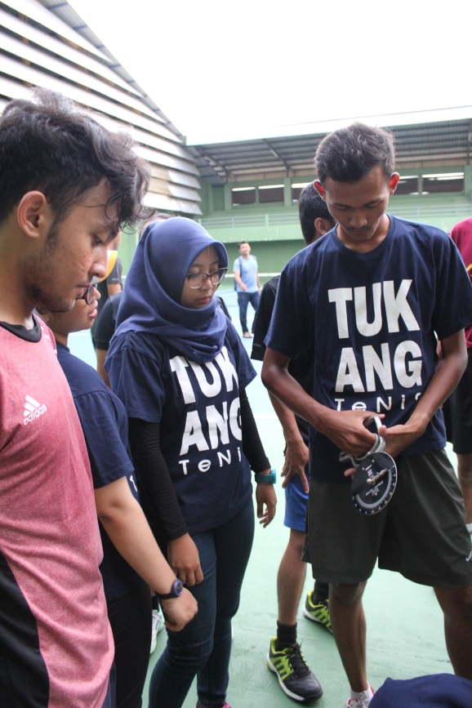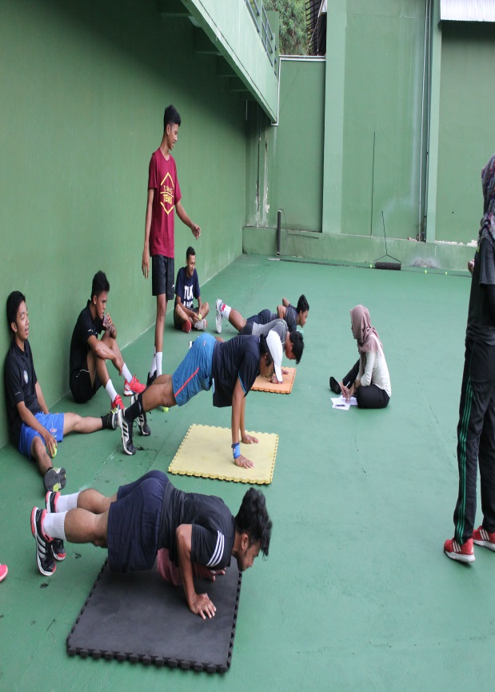
Tes kekutan perut
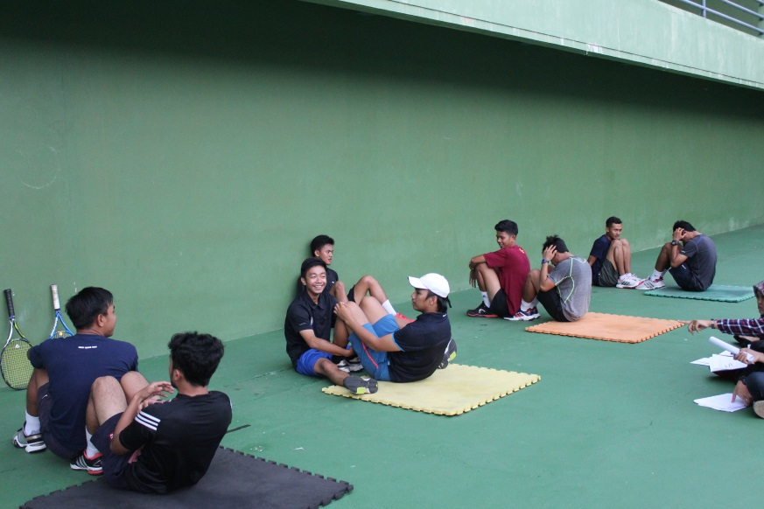

Tes kekuatan tungkai
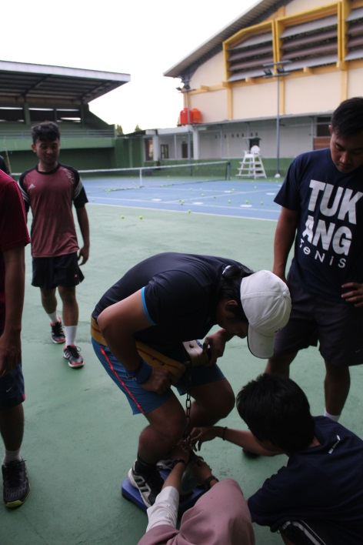
Tes akurasi
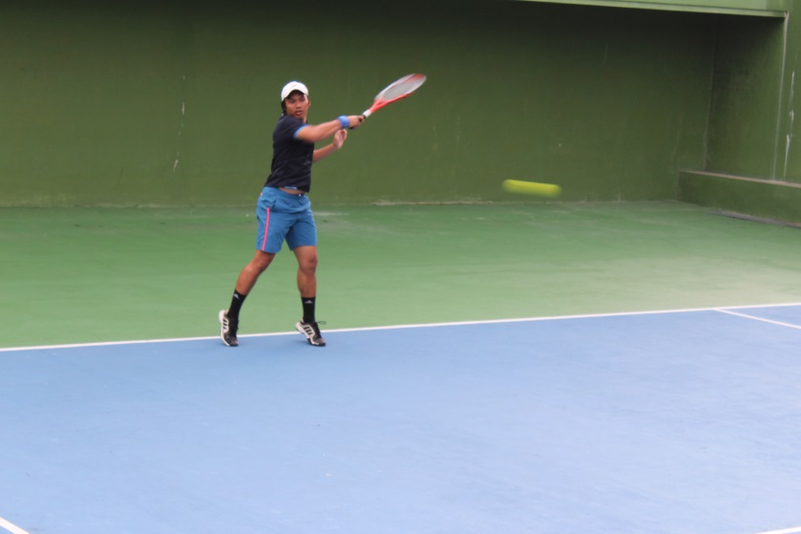
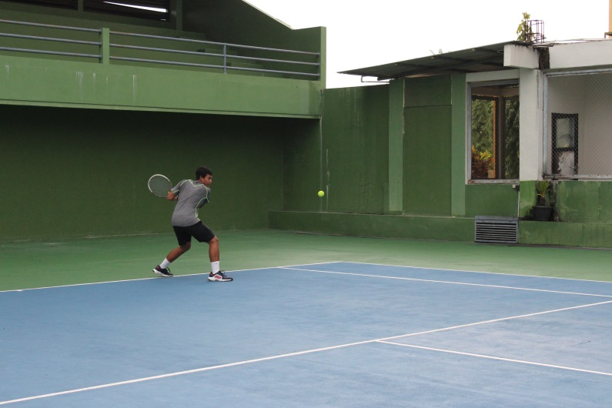
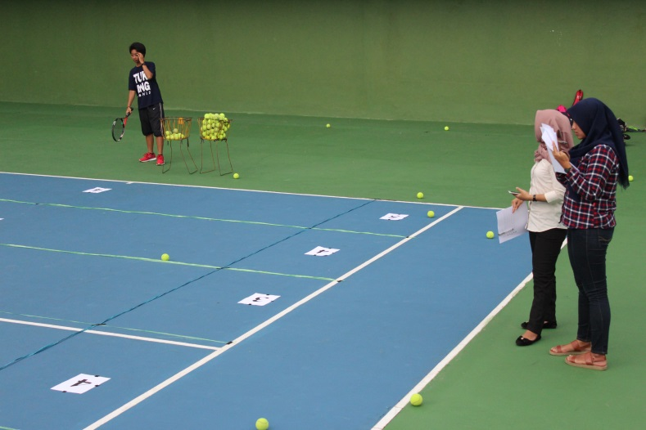
Foto bersama
