Lampiran 1. Kartu Bimbingan TAS
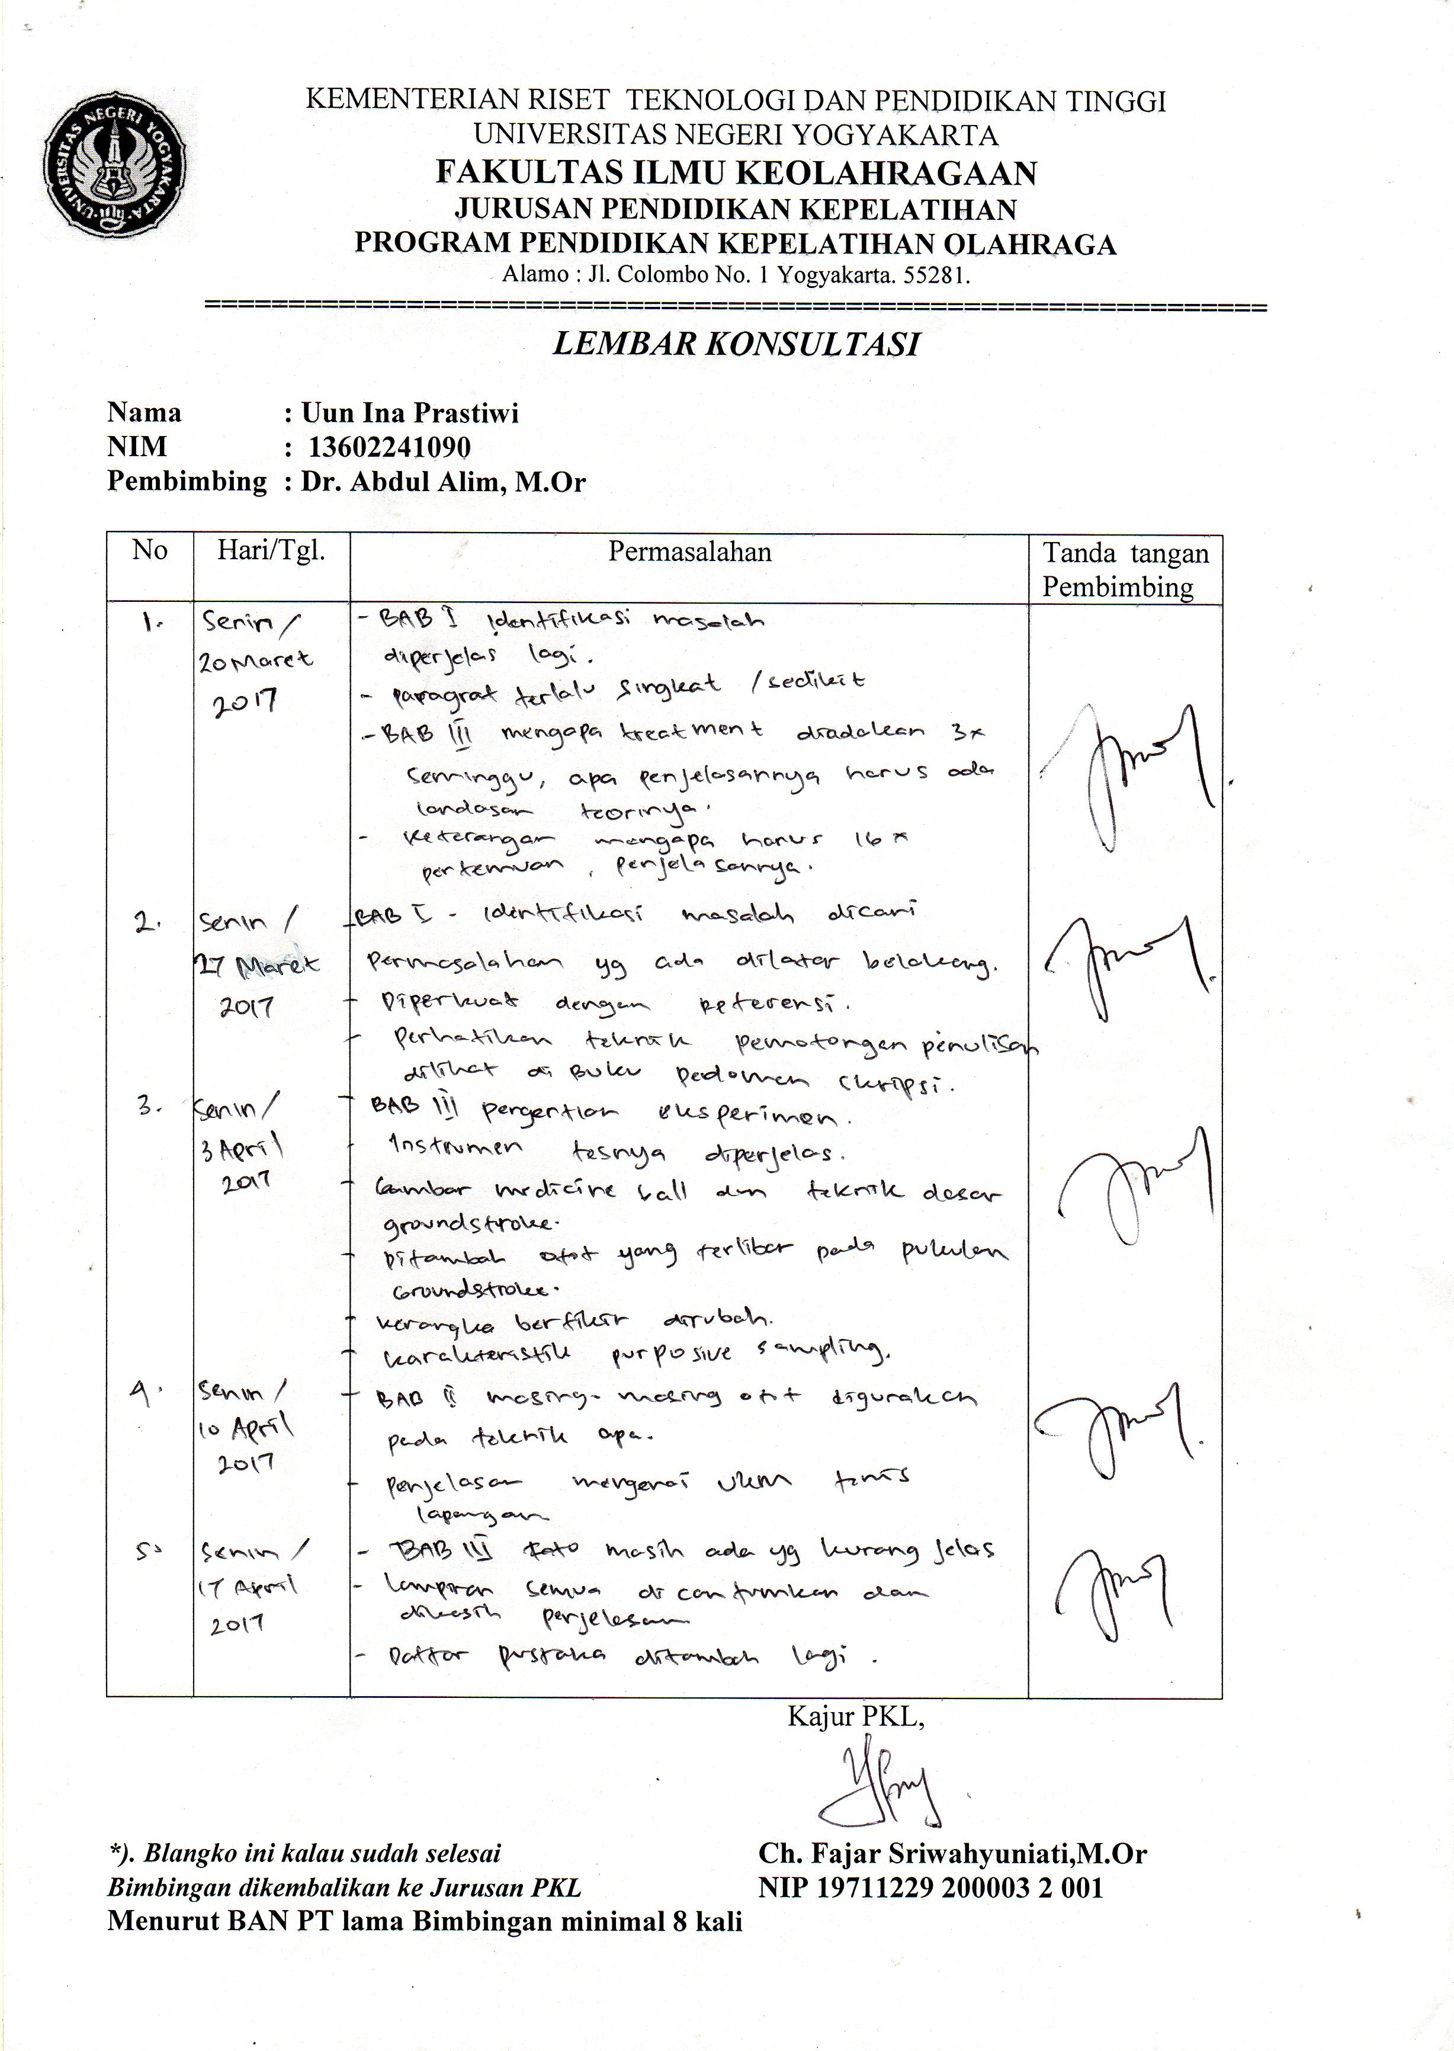

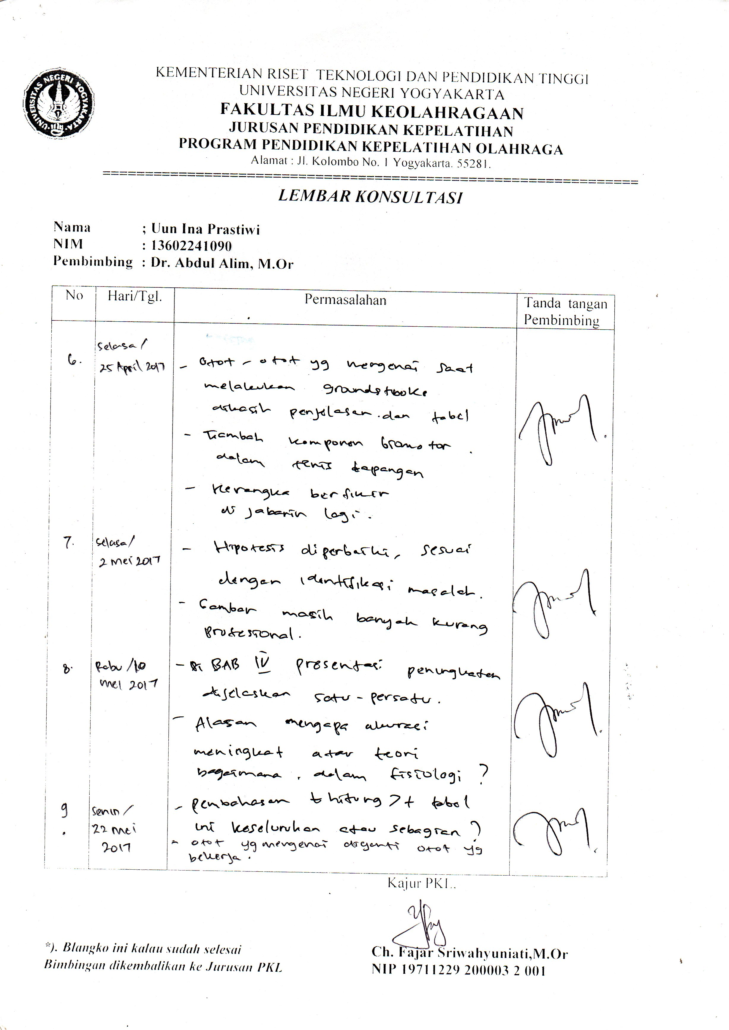

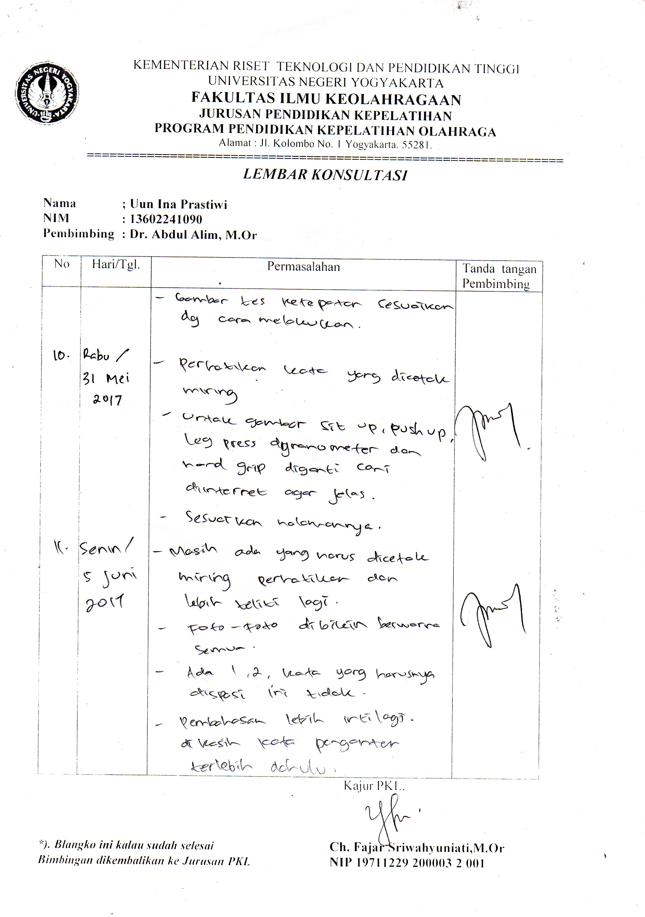

Lampiran 2. Surat Ijin Penelitian

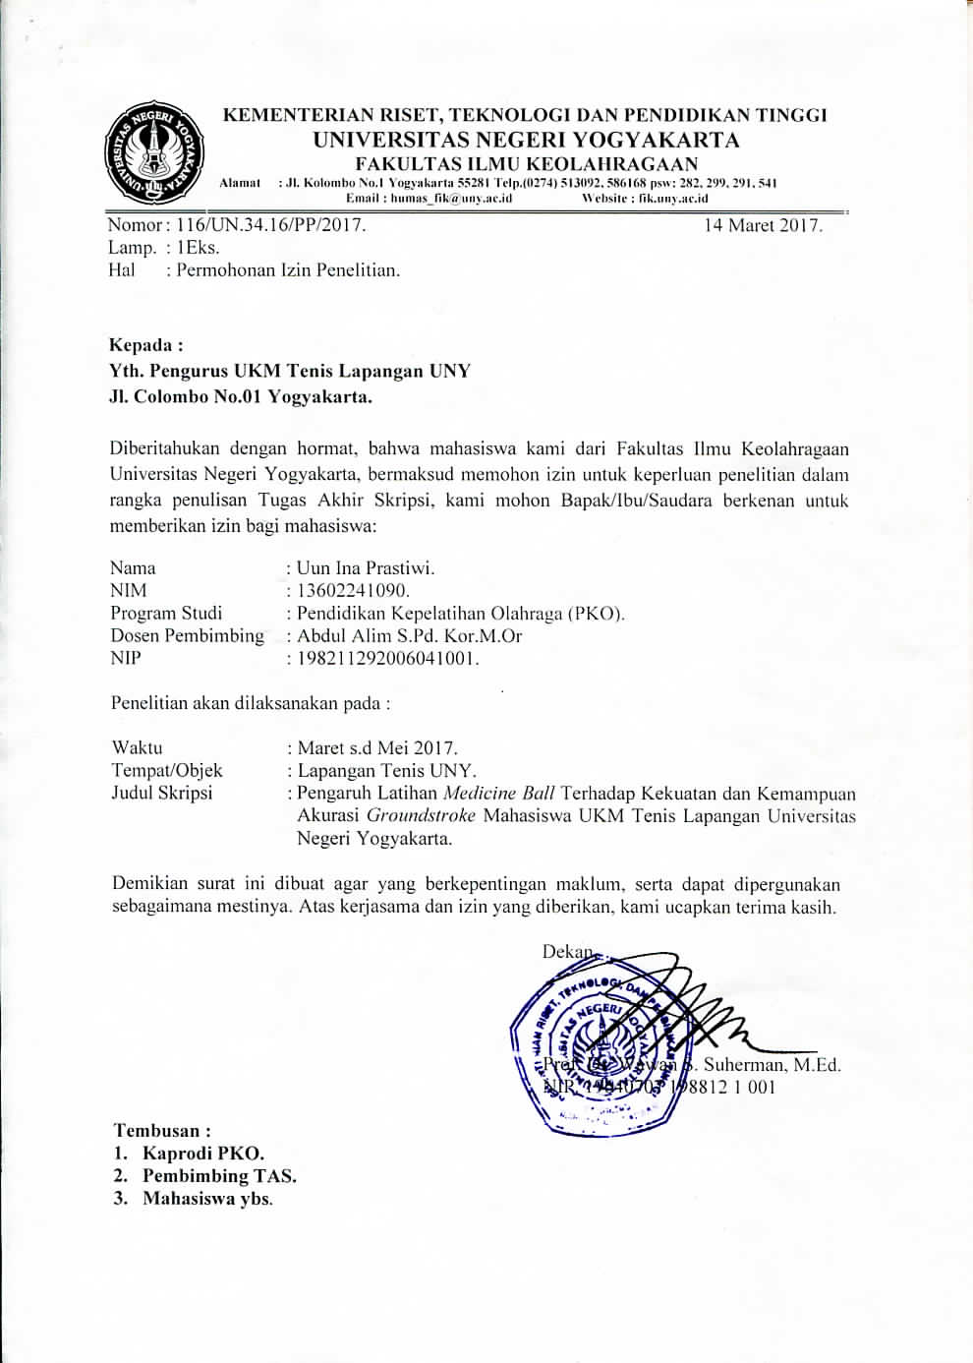

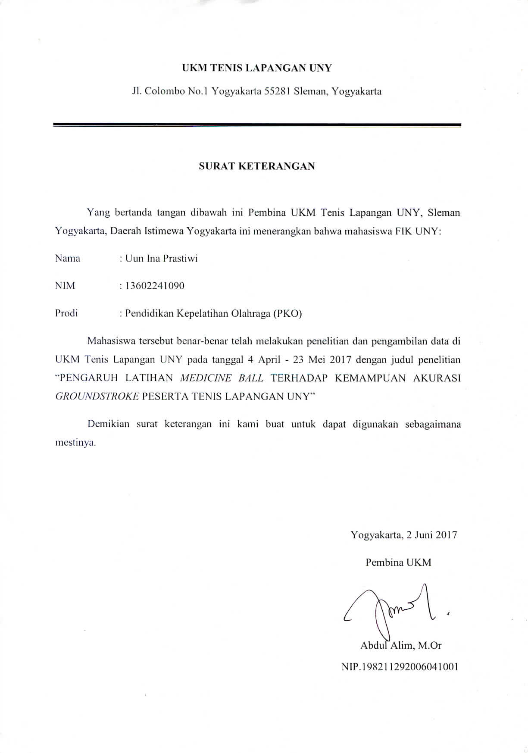

Lampiran 3. Surat Keterangan
- Surat keterangan validasi
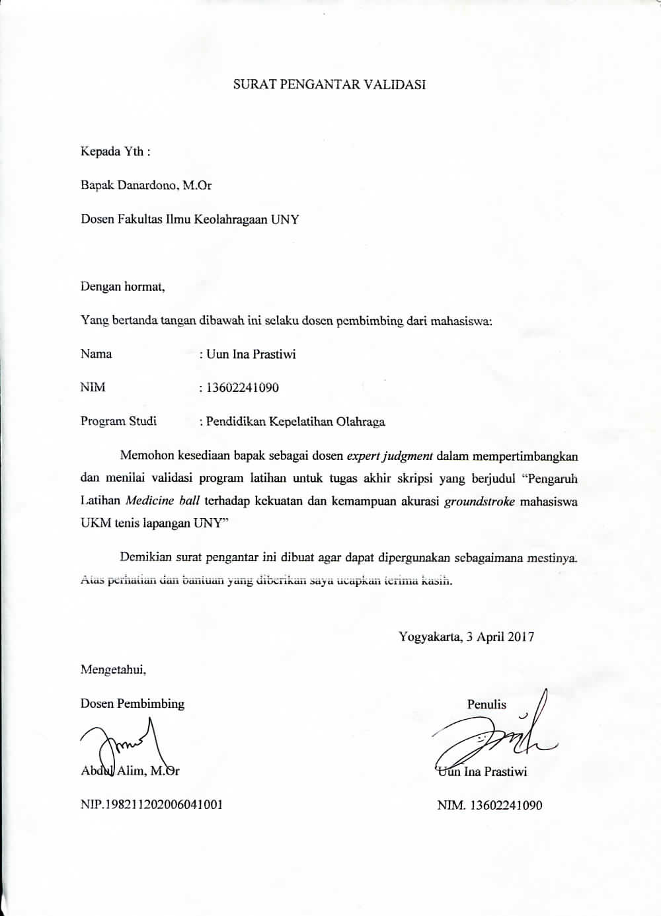

- Surat persetujuan expert judgment
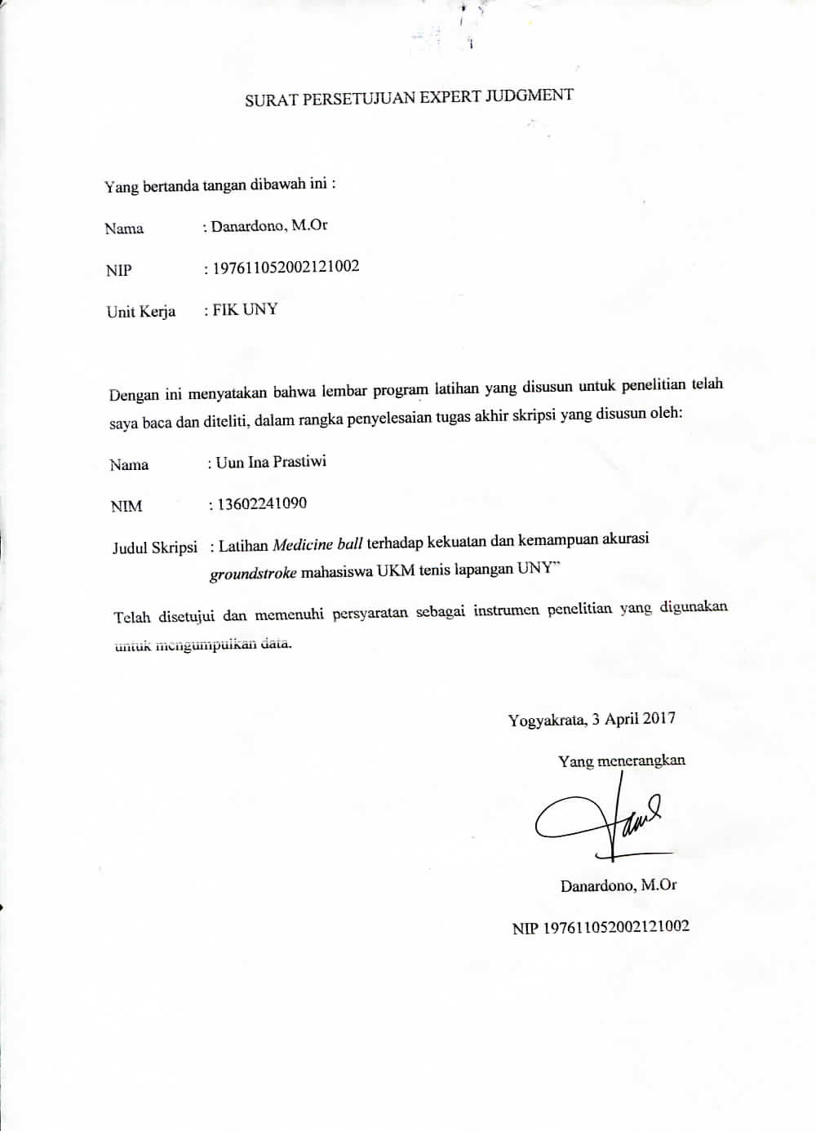

Lampiran 4. Surat Undangan Penelitian
- Pembimbing (Pretest)

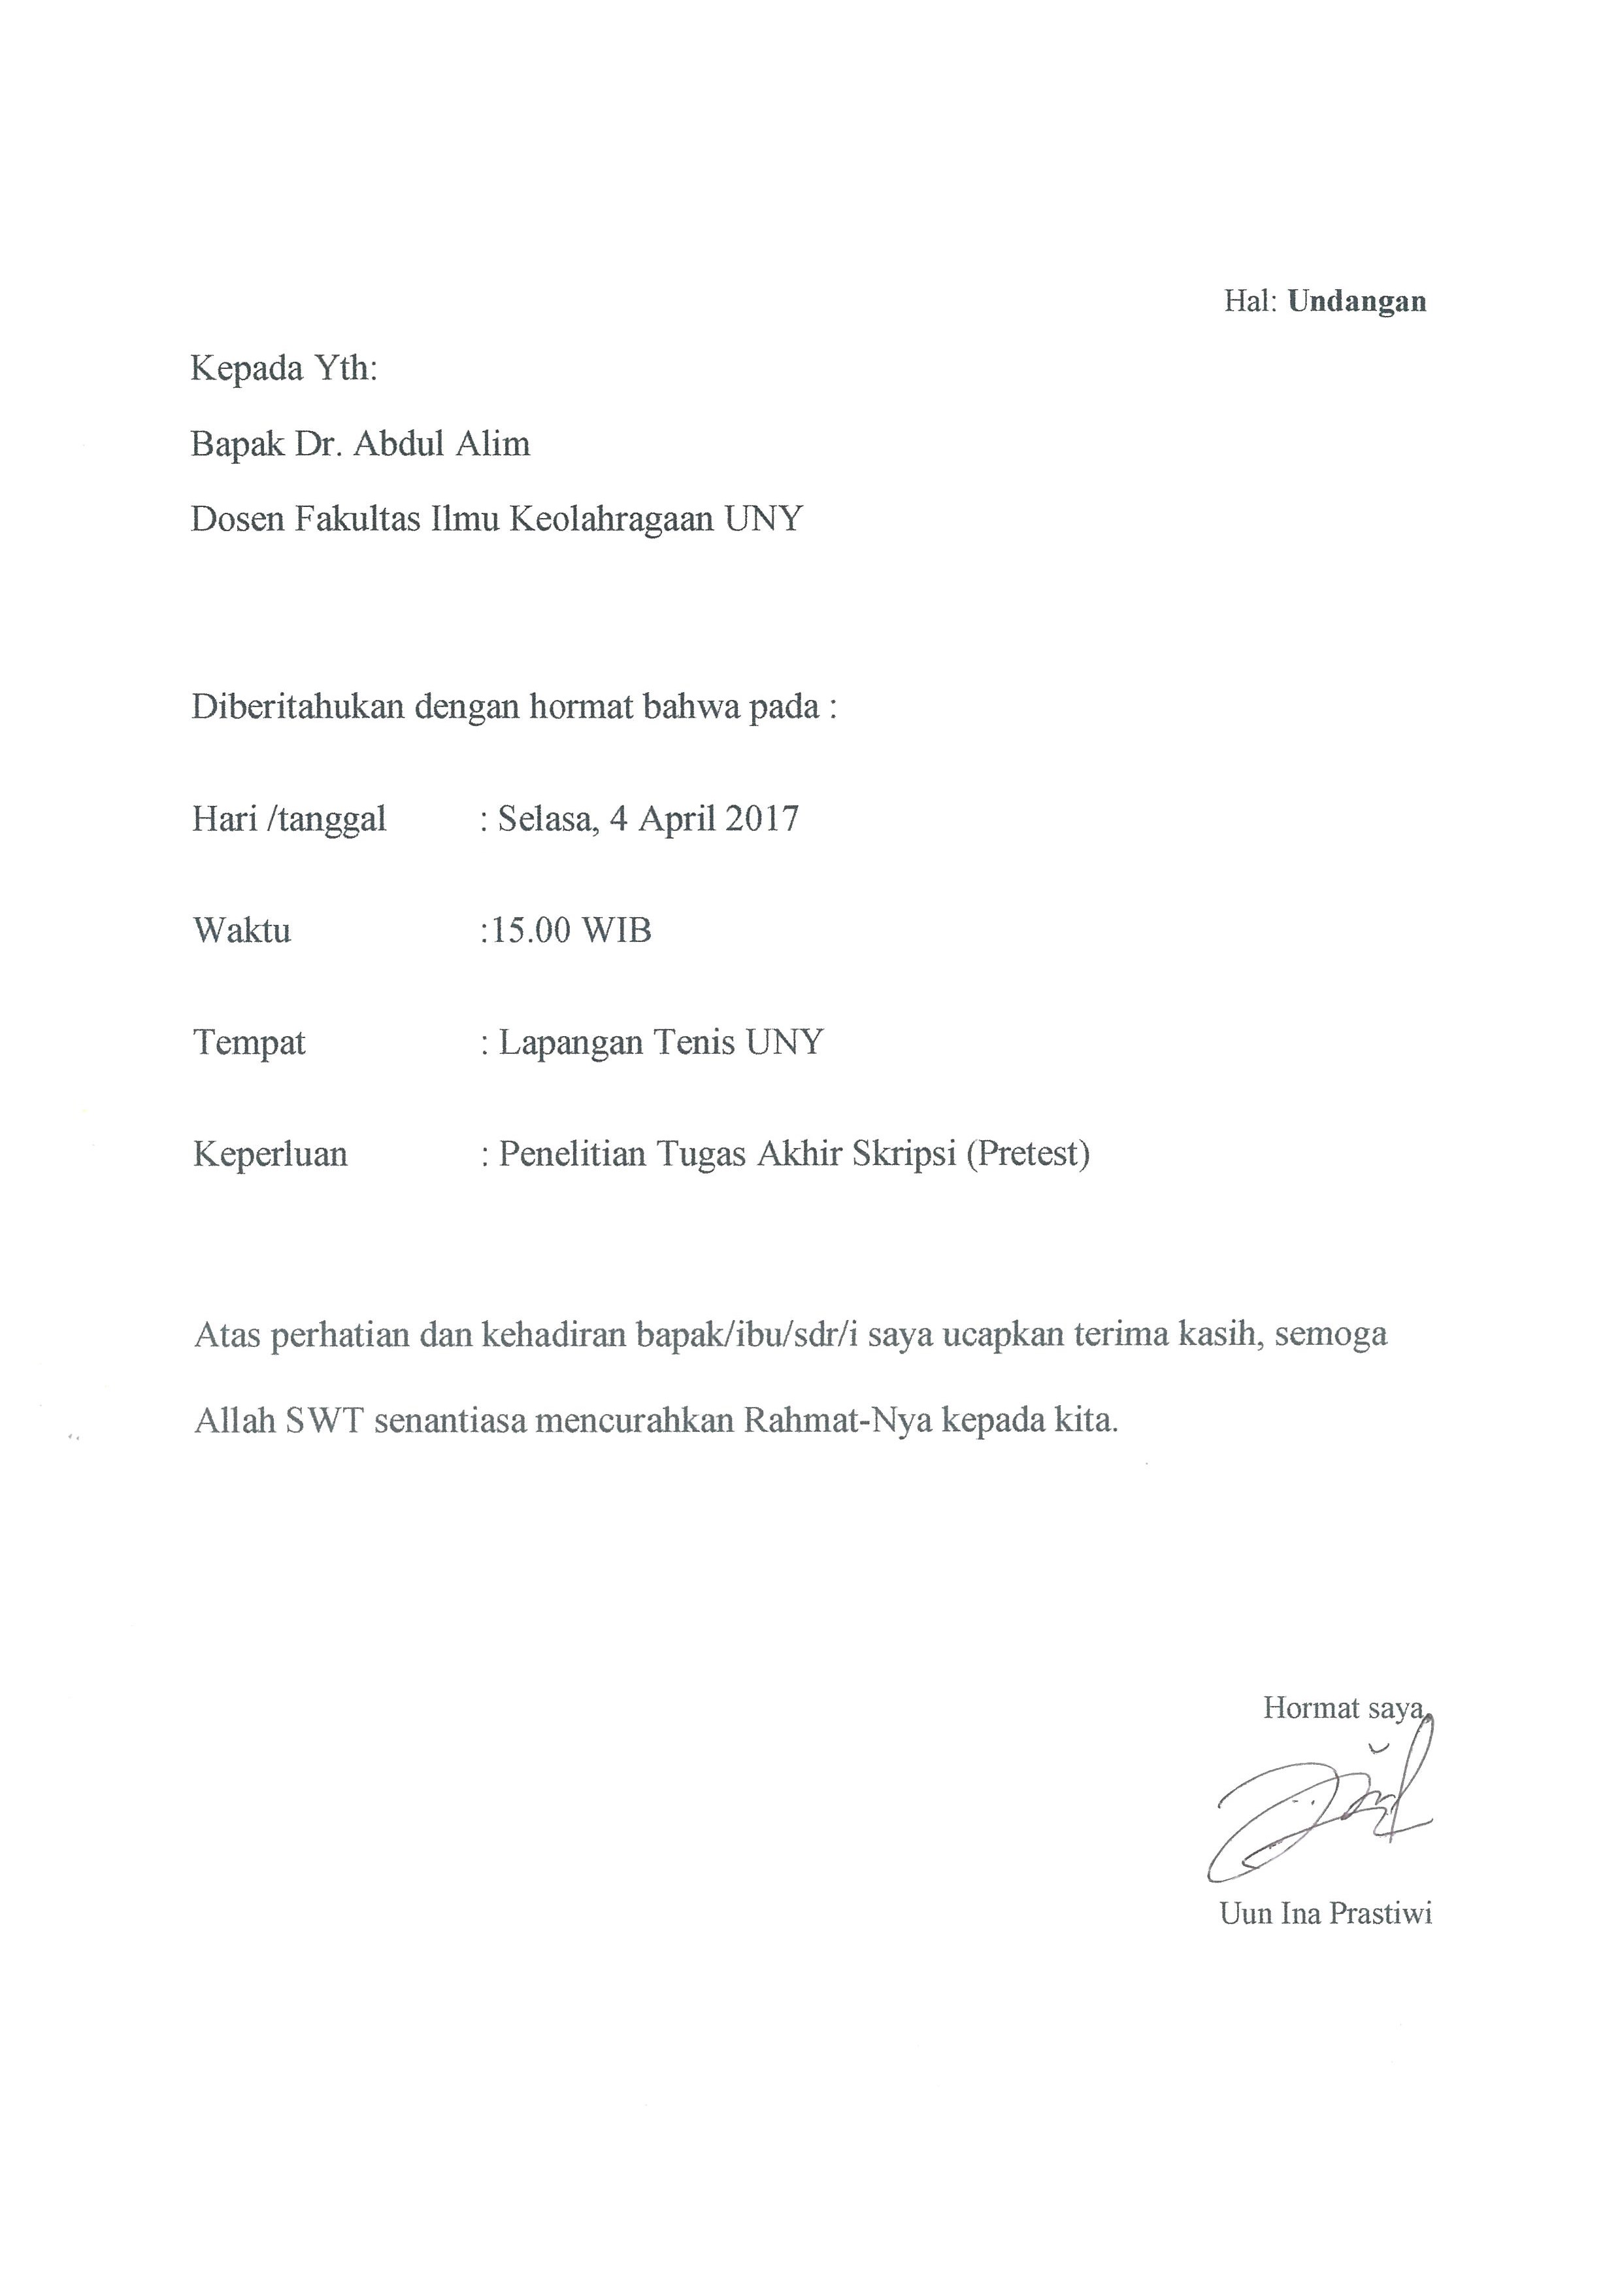
Posttest 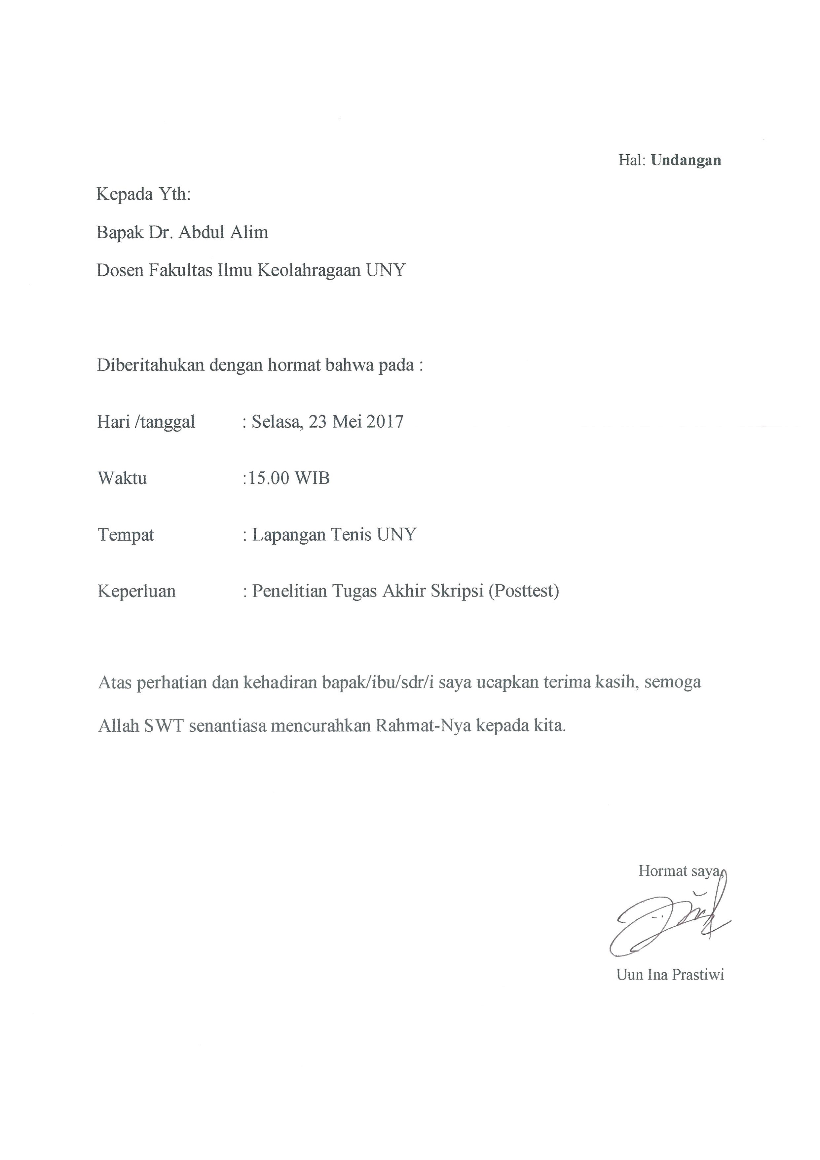

- Peserta (Pretest)
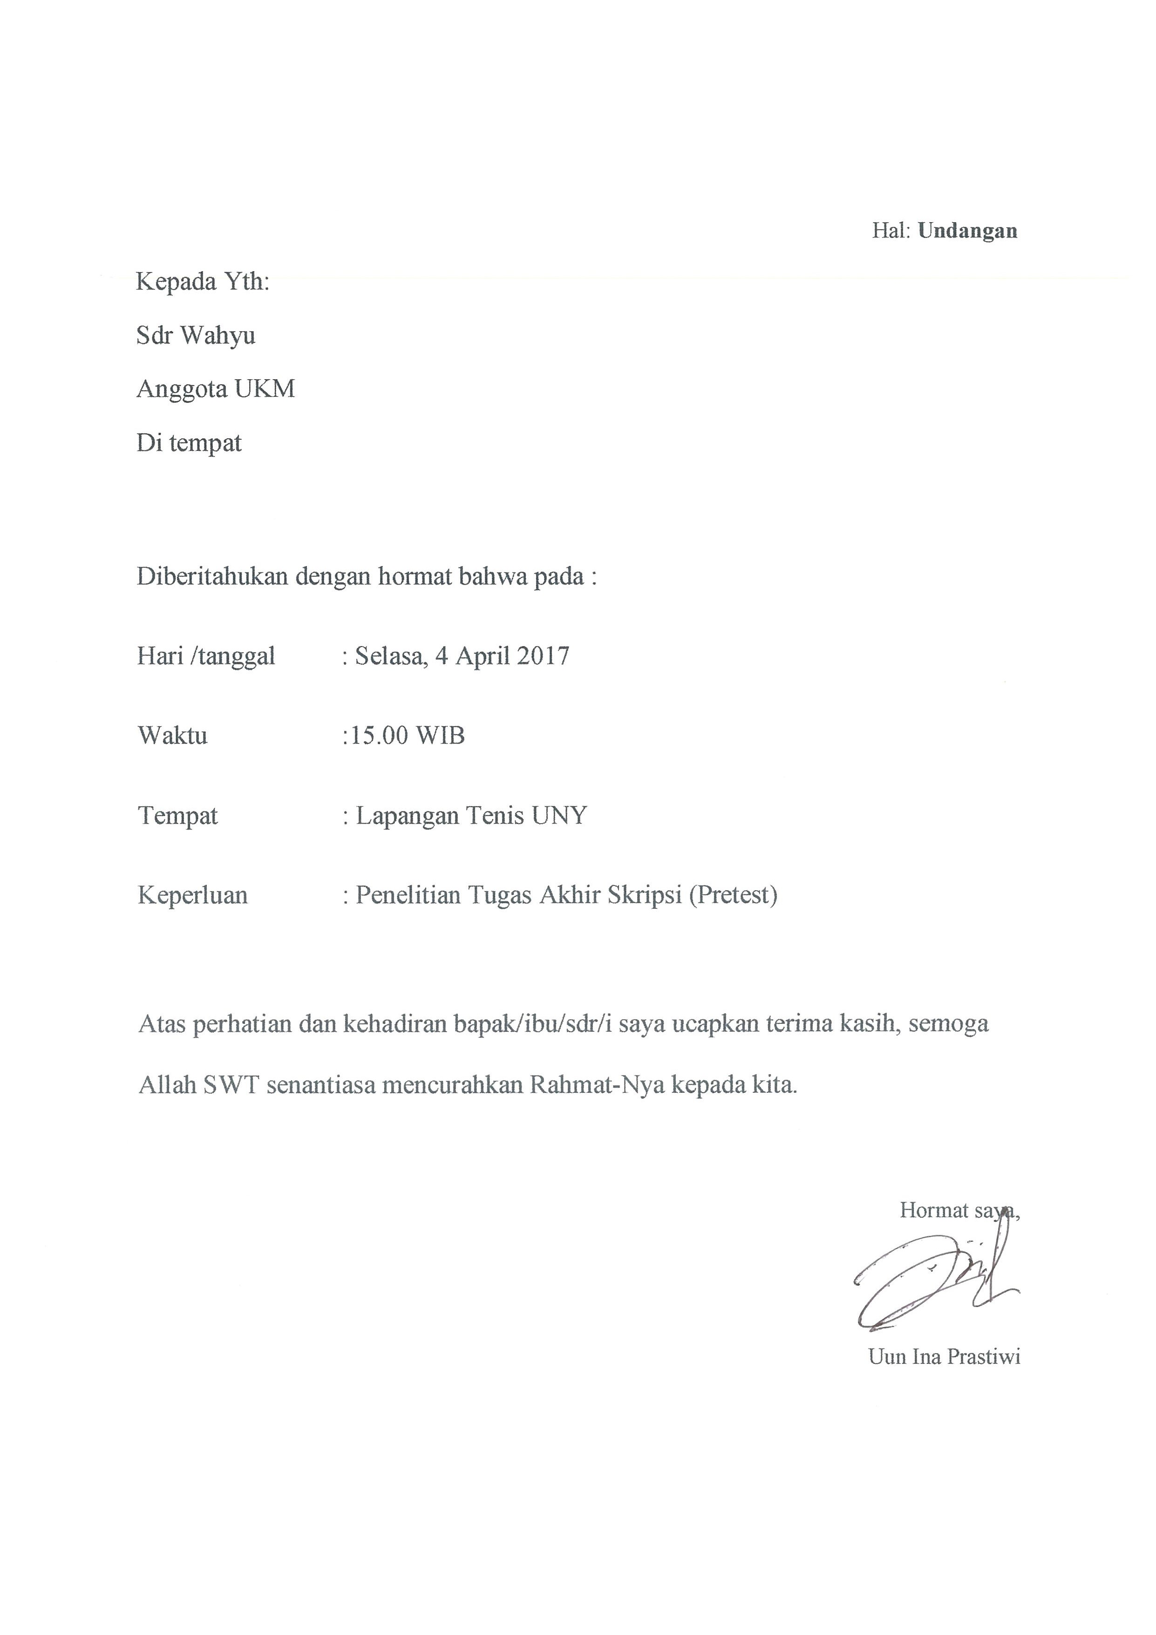

Posttest

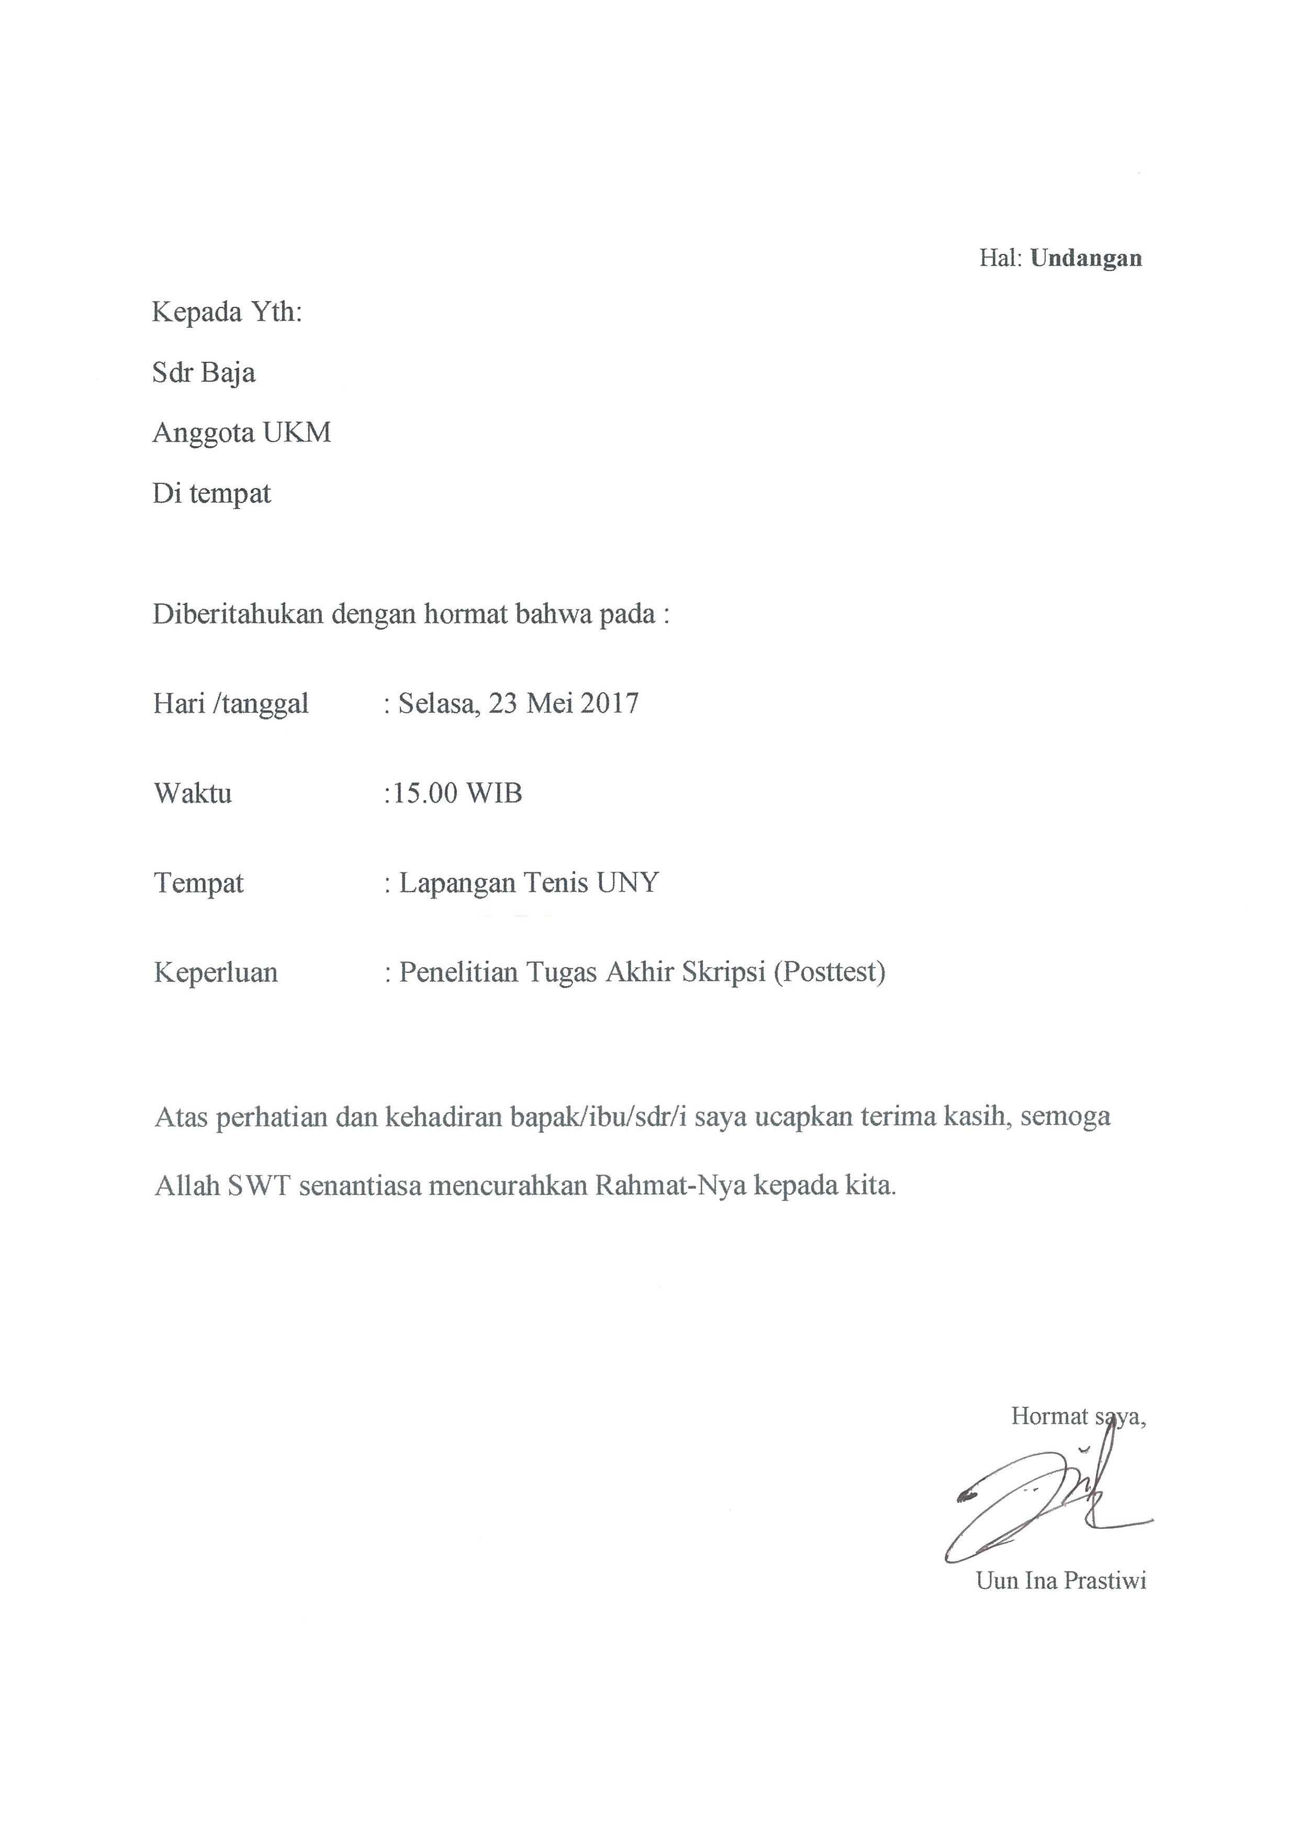

Lampiran 5. Absensi
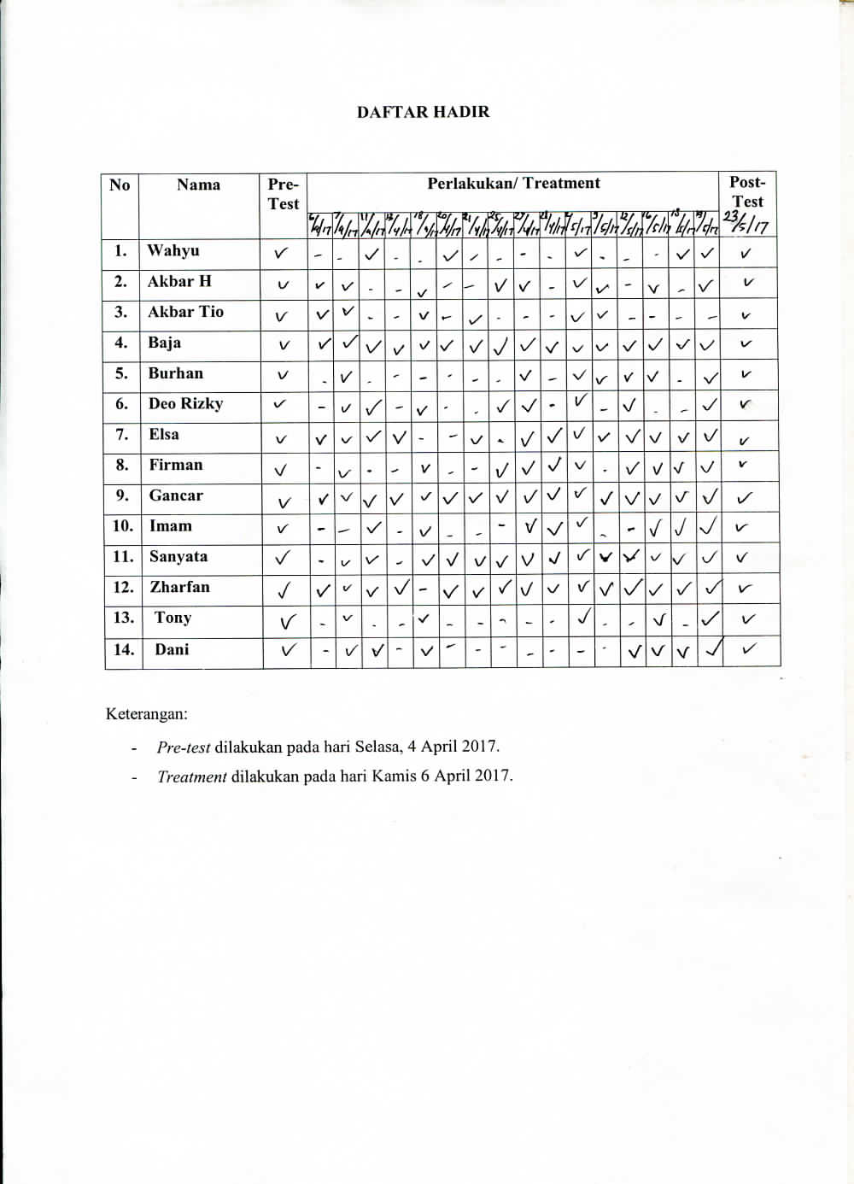

Lampiran 6. Program Latihan
PROGRAM LATIHAN
Pertemuan 1-3
Waktu | Selasa | Kamis | Jumat
15.30-17.00 | - Wr Up  - Jogging, streching dinamis dan statis  - Forehand arah lurus dan silang  - Backhand arah lurus dan silang  - Medicine ball throw  - Medicine ball lunge  - Medicine ball rusian twist  - Medicine ball X drill  - Cooling down | - Wr Up  - Jogging, streching dinamis dan statis  - Forehand arah lurus dan silang  - Backhand arah lurus dan silang  - Medicine ball lunge  - Medicine ball rusian twist  - Forehand and backhand medicine ball tosses using open  - Up and down with medicine ball  - Cooling down | - Wr Up  - Jogging, streching dinamis dan statis  - Forehand arah lurus dan silang  - Backhand arah lurus dan silang  - Medicine ball throw  - Medicine ball lunge  - Medicine ball X drill  - Forehand and backhand medicine ball tosses using open  - Medicine ball rusian twist  - Up and down with medicine ball  - Cooling down

Pertemuan 4-6
Waktu | Selasa | Kamis | Jumat
15.30-17.00 | - Wr Up  - Jogging, streching dinamis dan statis  - Forehand arah lurus dan silang  - Backhand arah lurus dan silang  - Medicine ball throw  - Medicine ball lunge  - Medicine ball rusian twist  - Medicine ball X drill  - Cooling down | - Wr Up  - Jogging, streching dinamis dan statis  - Forehand arah lurus dan silang  - Backhand arah lurus dan silang  - Medicine ball lunge  - Medicine ball rusian twist  - Medicine ball X drill  - Forehand and backhand medicine ball tosses open  - Up and down with medicine ball  - Cooling down | - Wr Up  - Jogging, streching dinamis dan statis  - Forehand arah lurus dan silang  - Backhand arah lurus dan silang  - Medicine ball throw  - Medicine ball X drill  - Medicine ball rusian twist  - Medicine ball lunge  - Forehand and backhand medicine ball tosses using open  - Up and down with medicine ball  - Cooling down

Pertemuan 7-9
Waktu | Selasa | Kamis | Jumat
15.30-17.00 | - Wr Up  - Jogging, streching dinamis dan statis  - Forehand arah lurus dan silang  - Backhand arah lurus dan silang  - Medicine ball throw  - Medicine ball lunge  - Medicine ball X drill  - Medicine ball rusian twist  - Forehand and backhand medicine ball tosses using open  - Up and down with medicine ball  - Cooling down | - Wr Up  - Jogging, streching dinamis dan statis  - Forehand arah lurus dan silang  - Backhand arah lurus dan silang  - Medicine ball throw  - Medicine ball lunge  - Medicine ball X drill  - Medicine ball rusian twist  - Forehand and backhand medicine ball tosses using open  - Up and down with medicine ball  - Cooling down | - Wr Up  - Jogging, streching dinamis dan statis  - Forehand arah lurus dan silang  - Backhand arah lurus dan silang  - Medicine ball throw  - Medicine ball lunge  - Medicine ball rusian twist  - Medicine ball X drill  - Up and down with medicine ball  - Forehand and backhand medicine ball tosses using open  - Cooling down

Pertemuan 10-12
Waktu | Selasa | Kamis | Jumat
15.30-17.00 | - Wr Up  - Jogging, streching dinamis dan statis  - Forehand arah lurus dan silang  - Backhand arah lurus dan silang  - Medicine ball throw  - Medicine ball lunge  - Medicine ball rusian twist  - Medicine ball X drill  - Forehand and backhand medicine ball tosses using open  - Up and down with medicine ball  - Cooling down | - Wr Up  - Jogging, streching dinamis dan statis  - Forehand arah lurus dan silang  - Backhand arah lurus dan silang  - Medicine ball throw  - Medicine ball lunge  - Medicine ball rusian twist  - Medicine ball X drill  - Forehand and backhand medicine ball tosses using open  - Up and down with medicine ball  - Cooling down | - Wr Up  - Jogging, streching dinamis dan statis  - Forehand arah lurus dan silang  - Backhand arah lurus dan silang  - Medicine ball throw  - Medicine ball lunge  - Medicine ball rusian twist  - Medicine ball X drill  - Forehand and backhand medicine ball tosses using open  - Up and down with medicine ball  - Cooling down

Pertemuan 13-16
Waktu | Selasa | Kamis | Jumat
15.30-17.00 | - Wr Up  - Jogging, streching dinamis dan statis  - Forehand arah lurus dan silang  - Backhand arah lurus dan silang  - Medicine ball throw  - Medicine ball lunge  - Medicine ball rusian twist  - Medicine ball X drill  - Forehand and backhand medicine ball tosses using open  - Up and down with medicine ball  - Cooling down | - Wr Up  - Jogging, streching dinamis dan statis  - Forehand arah lurus dan silang  - Backhand arah lurus dan silang  - Medicine ball throw  - Medicine ball lunge  - Medicine ball rusian twist  - Medicine ball X drill  - Forehand and backhand medicine ball tosses using open  - Up and down with medicine ball  - Cooling down | - Wr Up  - Jogging, streching dinamis dan statis  - Forehand arah lurus dan silang  - Backhand arah lurus dan silang  - Medicine ball throw  - Medicine ball lunge  - Medicine ball rusian twist  - Medicine ball X drill  - Forehand and backhand medicine ball tosses using open  - Up and down with medicine ball  - Cooling down

