Daftar Penilaian Lembar Kerja Siswa (LKS) dan Ulangan Harian
Mata Pelajaran |  | : Biologi
Kelas |  | : X MIA 4
Semester |  | : 1
Tahun Ajaran |  | : 2016/2017
No | Nama | Nilai LKS Objek Biologi dan Tingkat Organisasi Kehidupan | Nilai Laporan Eksperimen | Nilai Ulangan Harian 1
1 | ADELIA WIDYAWATI | 95 | 78 | 85
2 | ALFINA DYAH TITISARI | 95 |  | 80
3 | AMALIA KUSUMA SARI | 98 | 78 | 95
4 | ANI AHMIDAH | 98 |  | 70
5 | ANISA SAFITRI | 98 |  | 70
6 | ARDHIKA AKBAR KURNIAWAN | 98 |  | 70
7 | BAGAS AFIANTA | 95 |  | 85
8 | DELA SEPTIANA DEVI | 95 | 78 | 80
9 | ELAIS NUR FAUZIA QODIM | 98 |  | 90
10 | FAIZAL AKBAR PURWADI | 98 |  | 80
11 | FAJAR SRI UTAMI | 95 | 71 | 80
12 | FARHAN KURMIAWAN | 95 |  | 50
13 | JUAN AHMAD PRAVITAMA | 98 | 71 | 80
14 | KHOIRULIA ZIDNI ISNAINI | 98 | 71 | 75
15 | KIKI DWI NURAINI | 98 | 77 | 85
16 | LINDA KHOIRUNNISA | 95 | 71 | 90
17 | MARYAM SARI | 98 | 77 | 55
18 | NABILLAH YUMNA MURRAHMAH | 95 | 77 | 70
19 | NURROHMAN TRI NUGROHO | 98 | 78 | 70
20 | REYNA PUTRI MEGISTA | 98 | 78 | 75
21 | RIZAL HERNAWAN | 98 |  | 75
22 | RYAN WIBISONO | 95 | 78 | 50
23 | SALMA NUR AINI | 95 |  | 60
24 | TESSA RINDIANI | 95 |  | 80
25 | THEOFANI RAKHEL | 98 | 71 | 95
26 | YULIANTI | 98 | 77 | 85
27 | YULIATIN MUSYAROFAH | 98 | 77 | 90
28 | ZELIDAR ANNISA | 95 | 77 | 75
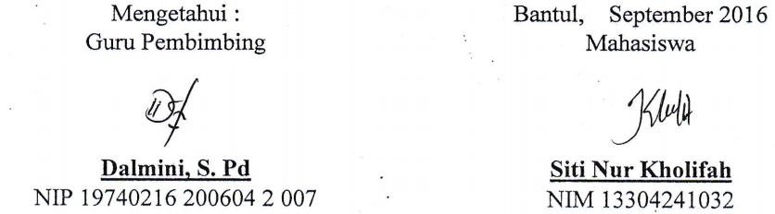  Mengetahui : |  | Bantul, September 2016
Guru Pembimbing |  | Mahasiswa
Dalmini, S. Pd |  | Mahasiswa
NIP 19740216 200604 2 007 |  | NIM 13304241032

DAFTAR HADIR SISWA KELAS X MIA 4
TAHUN PELAJARAN 2016/2017
No | Nama | Tanggal
No | Nama | 26/07/2016 |  | 02/09/2016 |  | 09/09/2016
1 | ADELIA WIDYAWATI | √ |  | √ |  | √
2 | ALFINA DYAH TITISARI | √ |  | √ |  | √
3 | AMALIA KUSUMA SARI | √ |  | √ |  | √
4 | ANI AHMIDAH | √ |  | √ |  | √
5 | ANISA SAFITRI | √ |  | √ |  | √
6 | ARDHIKA AKBAR KURNIAWAN | √ |  | √ |  | √
7 | BAGAS AFIANTA | √ |  | √ |  | √
8 | DELA SEPTIANA DEVI | √ |  | √ |  | √
9 | ELAIS NUR FAUZIA QODIM | √ |  | √ |  | √
10 | FAIZAL AKBAR PURWADI | √ |  | √ |  | √
11 | FAJAR SRI UTAMI | √ |  | √ |  | √
12 | FARHAN KURMIAWAN | √ |  | √ |  | √
13 | JUAN AHMAD PRAVITAMA | √ |  | √ |  | √
14 | KHOIRULIA ZIDNI ISNAINI | √ |  | √ |  | √
15 | KIKI DWI NURAINI | √ |  | √ |  | √
16 | LINDA KHOIRUNNISA | √ |  | √ |  | √
17 | MARYAM SARI | √ |  | √ |  | √
18 | NABILLAH YUMNA MURRAHMAH | √ |  | √ |  | √
19 | NURROHMAN TRI NUGROHO | √ |  | √ |  | √
20 | REYNA PUTRI MEGISTA | √ |  | √ |  | √
21 | RIZAL HERNAWAN | √ |  | √ |  | √
22 | RYAN WIBISONO | √ |  | √ |  | √
23 | SALMA NUR AINI | √ |  | √ |  | √
24 | TESSA RINDIANI | √ |  | √ |  | √
25 | THEOFANI RAKHEL | √ |  | √ |  | √
26 | YULIANTI | √ |  | √ |  | √
27 | YULIATIN MUSYAROFAH | √ |  | √ |  | √
28 | ZELIDAR ANNISA | √ |  | √ |  | √
Mengetahui : |  |  | Bantul, September 2016
Guru Pembimbing |  |  | Mahasiswa
Dalmini, S. Pd |  |  | Mahasiswa
NIP 19740216 200604 2 007 |  |  | NIM 13304241032

