INSTRUMEN PENGETAHUAN 1 – GREETINGS AND LEAVE-TAKINGS

INSTRUCTIONS:

Dialogue 1:
Mirna : Good afternoon Lena
Lena : ......................., Mirna.
Mirna : Is that your new dress?
Lena : Yes, It is.
Mirna : You look beautiful with your new dress.
Lena : ................................., Mirna.
Mirna : ......................

Dialogue 2:
Adnan : Hi, good morning Ozan.
Ozan : ..........., Adnan, where are you going?
Adnan : I am going to the Bank, but I don’t know the way.
Ozan : Can I help you?
Adnan : Sure.
Ozan : Follow me! I will show you the way.
Adnan : ..................,
Ozan : ....................,

Dialogue 3:
Kasih : .................., Mila.
Mila : Good evening.
Kasih : Mila,.......... .I missed your birthday party yesterday.
Mila : ..................Why didn’t you come?
Kasih : my mother was sick.

Dialogue 4:
Lisa : ............, Listy.
Listy : Good morning.
Lisa : Listy,............... I’m late. I had to water the plant first.
Listy : ................., But next time please tell me first.
Lisa : of course. Let’s go now.

INSTRUMEN PENGETAHUAN 2 – THANKING AND APOLOGIZING

EXAMPLE

INSTRUCTIONS:
- Work in pairs
- Write a dialogue (free) which use thanking and apologizing expressions

INSTRUMEN PENGETAHUAN 3 – INTRODUCING SELF AND OTHERS

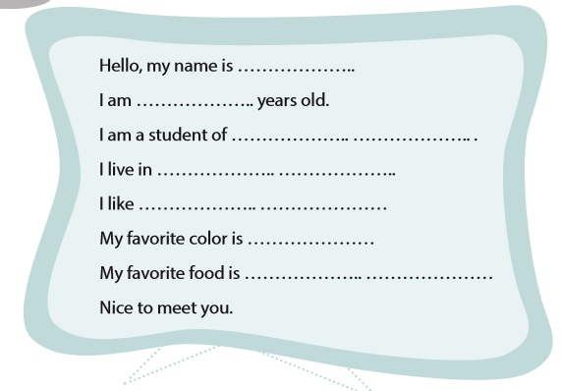

INSTRUCTIONS:
- Take a look at ‘When English Rings the Bell’ page 25 about introducing self
- Open page 26 and write down your own introduction on your book.

INSTRUMEN PENGETAHUAN 4 – DAYS AND MONTHS

INSTRUCTIONS:

- It’s a quiz.
- Prepare a blank paper as your answer sheet.
- Listen to your teacher and answer the questions given.
- The teacher will only repeat the questions 3 times so listen carefully.

QUESTIONS:
- When do you have English subject?
- When do you have flag ceremony?
- What is your favorite day?
- When do you have to wear Scout uniform?
- When do you have ‘Koin untuk ESSAKA’ collection?

INSTRUMEN PENGETAHUAN 5 – DATES AND HOURS

INSTRUCTIONS:
- It’s a quiz.
- Prepare a blank paper as your answer sheet.
- Listen to your teacher and answer the questions given.
- The teacher will only repeat the questions 3 times so listen carefully.

QUESTIONS:
- What time do you usually wake up?
- What time do you usually go to school?
- What time do you usually go home from school?
- When is your birthday?
- When do we celebrate Indonesian Independence Day?

