INSTRUMEN KETERAMPILAN 1 – GREETINGS AND LEAVE-TAKINGS

INSTRUCTIONS:

Dialogue 1:
Mirna : Good afternoon Lena
Lena : ......................., Mirna.
Mirna : Is that your new dress?
Lena : Yes, It is.
Mirna : You look beautiful with your new dress.
Lena : ................................., Mirna.
Mirna : ......................

Dialogue 2:
Adnan : Hi, good morning Ozan.
Ozan : ..........., Adnan, where are you going?
Adnan : I am going to the Bank, but I don’t know the way.
Ozan : Can I help you?
Adnan : Sure.
Ozan : Follow me! I will show you the way.
Adnan : ..................,
Ozan : ....................,

Dialogue 3:
Kasih : .................., Mila.
Mila : Good evening.
Kasih : Mila,.......... .I missed your birthday party yesterday.
Mila : ..................Why didn’t you come?
Kasih : my mother was sick.

Dialogue 4:
Lisa : ............, Listy.
Listy : Good morning.
Lisa : Listy,............... I’m late. I had to water the plant first.
Listy : ................., But next time please tell me first.
Lisa : of course. Let’s go now.
INSTRUMEN KETERAMPILAN 2 – THANKING AND APOLOGIZING

INSTRUCTIONS:
- Work in pairs.
- After learning how to say thanks and apologize, now make your own dialogue consisting thanking and apologizing expressions
- Practice it in front of class with your pair.

INSTRUMEN KETERAMPILAN 3 – INTRODUCING SELF AND OTHERS
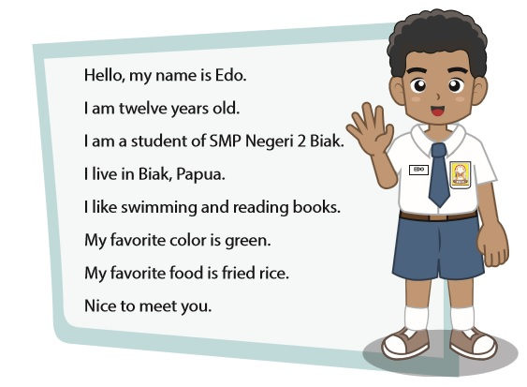
INSTRUCTIONS:
- Take a look at page 25 of your book, ‘When English Rings the Bell’
- After learning about how to introduce ourselves, now start imagining yourself as your favorite person/character.
- Write down your introduction as your favorite character.

INSTRUMEN KETERAMPILAN 4 – INTRODUCING SELF AND OTHERS

- Practice your introduction as idol in front of the class.

INSTRUMEN KETERAMPILAN 5 – DAYS AND MONTHS

INSTRUCTIONS:
- Make your own class schedule using English
- Refer to your book page 47
- Use Asturo paper
- Be creative and do your best!

INSTRUMEN KETERAMPILAN 6 – DATES AND HOURS
A LETTER FROM THE FUTURE
YOU ARE A
COUNTER TERRORIST
YOU ARE A
COUNTER TERRORIST
YOU ARE A
COUNTER TERRORIST
YOU ARE A
COUNTER TERRORIST
YOU ARE A

TERRORIST
YOU ARE A

TERRORIST
YOU ARE A

TERRORIST
YOU ARE A

TERRORIST
YOU ARE A
COUNTER TERRORIST
YOU ARE A

TERRORIST
YOU ARE A

ZOMBIE
YOU ARE A

ZOMBIE
YOU ARE A

ZOMBIE
YOU ARE A

ZOMBIE

YOU ARE A

ZOMBIE

YOU ARE A

ZOMBIE KILLER
YOU ARE A

ZOMBIE KILLER
YOU ARE A

ZOMBIE KILLER
YOU ARE A

ZOMBIE KILLER
YOU ARE A

ZOMBIE KILLER
YOU ARE AN

ALIEN
YOU ARE AN

ALIEN
YOU ARE AN

ALIEN
YOU ARE AN

ALIEN
YOU ARE AN

ALIEN
YOU ARE AN

ALIEN HUNTER
YOU ARE AN

ALIEN HUNTER
YOU ARE AN

ALIEN HUNTER
YOU ARE AN

ALIEN HUNTER
YOU ARE AN

ALIEN HUNTER

YOU ARE A

MONSTER
YOU ARE A

MONSTER
YOU ARE A

MONSTER
YOU ARE A

MONSTER
YOU ARE A
MONSTER HUNTER
YOU ARE A
MONSTER HUNTER
YOU ARE A
MONSTER HUNTER
YOU ARE A
MONSTER HUNTER
YOU ARE A
MONSTER HUNTER
YOU ARE A

MONSTER

TERRORIST | ZOMBIE | ALIEN | MONSTER
COUNTER TERRORIST | ZOMBIE KILLER | ALIEN KILLER | MONSTER HUNTER

INSTRUCTIONS:
- The teacher gives the introduction (story) to the student. There are two affiliations (big groups)
- The cards are given randomly to each student.
- Students should make a group according to the small group name. Elect one leader
- All students should write down the dates and hours in the paper given to each small group
- The answer should be written orderly and in the modified form. Example: ‘Six Forty Five’ is written as ’06.45’
- The teacher correct the answer in front of the class and sum the points.
- The highest point of each affiliation (Good or Evil) wins

