Title:
Successful of the Briggs Plan on Counterinsurgency in Malaya

By:
Amer Fawwaz Mohamad Yasid

Amer Fawwaz is a Master of Arts (Strategic Defence and Security Studies) students in the Department of International Relations and Strategic Studies with a specialization of Insurgency and Security Studies at University of Malaya. He is interested in the research of Malaysia Insurgencies experience on eliminating the CPM insurrection respectively.

Abstract
The First Malayan Emergency (1948-1960) was the turning point for the British military forces counterinsurgency doctrines as they were facing a traditional type of war, particularly the guerrilla warfare which was triggered by the Communist Party of Malaya (CPM) in June 1948. It was a new challenge for the British since during World War 2 ; most of their campaign was focused on the conventional warfare. It was a huge significance to the military development of the British, in assessing their forces’ effectiveness in dealings with the insurgency. Eventually in Malaya, the British came out with the idea to “winning hearts and mind” of the Malayan citizen through the implementation of “The Briggs Plan” which was founded by Lieutenant General Sir Harold Briggs. This paper will briefly explain the importance of the British counterinsurgency doctrine development in Malaya through the manifestation of the Briggs Plan and its significance towards the beginning of the effective countermeasures in dealing with the CPM armed insurrections. Furthermore, there has been limited credits given to Briggs on the success of his plan even though we knew that the plan was carried out in just 18 months: a tight window for the time of execution. The Briggs Plan somehow shows the importance of the Civil-Military coordination in their war against the Communist insurrection in Malaya thus justifying the military intervention as inadequate to hunt down the Communist guerrillas successfully without a good coordination and cooperation from the civil administrative. The conclusion will include the effective outcomes of the Briggs Plan as the pioneer of the future British counterinsurgency programs in Malaya respectively. It is not unwarranted if some historians highlighted that Sir Harold Briggs was the British “saviour” in the early Malaya.
Keywords: Counterinsurgency, doctrine, Civil-Military coordination.
Introduction
Since early 1950, the campaign against Communist forces was controlled by the Commissioner of Police, acting on the advice of members of the three Armed Services, but he had insufficient power to ensure its effective direction. Lieutenant General Sir Harold Briggs was therefore appointed Director of Operations to coordinate the activities of all SF on behalf of the British High Commissioner in Malaya. Soon after his appointment, he directed operations in Malaya through the Federal War Council, whose members included the Chief Secretary of the Federation, the General and Air Officers commanding in Malaya, the Commissioner of Police and the Secretary for Defence. From November 1950, the High Commissioner presided over the War Council, which assumed overriding powers in all matters affecting the Emergency. Briggs was quick to realize that what was lacking in Malaya was coordinated civil and military plan to fight and defeat the Communist insurgency. Even by April 1950, the extent of the Communist threat to Malaya was not fully appreciated by the British Government, which was slow to provide financial and military support to the degree that was needed to counter it effectively (Comber, 2008).
The formula devised by Lt. General Sir Harold Briggs soon after his appointment- the so called “Briggs Plan” Greene (1967), was to remain as keystone of anti-terrorist operations until the end of the Emergency. One of the most pressing problems that had to be dealt with was to isolate the enemy from all sources of supply and intelligence outside the jungle. In an attempt to achieve this aim, the Federal Government had passed the Emergency Regulation Bill on 5 July 1948, giving the authorities sweeping powers which included the right to issue detention orders, declare protected or prohibited areas, seize property, control movement on the roads, disperse assemblies, impose curfews, control food distribution, and impose severe penalties on any persons giving assistance to the Communist insurgents. (Jackson, 1991).

Resettlement Plan Programmes for the Malayan Citizen
In 1949, further regulations were promulgated which enabled the authorities to resettle squatter communities in areas that could be properly administered and policed. The squatter problem had existed since 1930s and had been greatly aggravated during the Japanese occupation, when large numbers of unemployed Chinese had taken up land for food cultivation in order to support themselves and their families. It is a big problem for the British as stated by Nagl (2005) that a note from J. Strachey, the Secretary of State for War affirms: “The struggle is, in one important aspect, a struggle for the support of the Chinese rural squatters. This seems to suggest that we ought to be exceedingly careful to avoid punitive measures that hit the Chinese squatter population indiscriminately. It suggest that it is of importance for us always to appear in the role of protectors of the populations against the Communists and their destructive and terrorist activities”.

Because they had no title over the land, these squatters usually chose to settle in remote and inaccessible areas on the fringe of the jungle. By 1948, there were an estimated 300,000 of them, and in the post-war turmoil the authorities had been unable to establish any measures of control over them. There was however, a tendency to tolerate them because they were an economic asset, being self-sufficient and producing a surplus for sale in the towns as well as providing a reservoir of labour for estates, mines and urban industries. Under the Briggs Plan, Chinese squatters and others exposed to the Communist threat were moved to the new settlement or regrouped in the same locality.

The old settlements replaced by “New Villages” were protected by barbed wires and police stations. By the end of 1950, over 117,000 people had been resettled in 140 New Villages which were defended by the Malay Police and the Chinese Home Guard. The cost of the two-year resettlement operation was high and because of the speed which it was carried out, there was understandably widespread discontent at first. The sites of the New Villages were sometimes chosen with more regard to their defensibility than to agricultural and economic considerations, but as time went by the mistakes were gradually rectified. The squatters were given leases of land, some of the villages were provided with a piped water supply, electric light, school, community centres and other facilities. The inhabitants were allowed to manage their own affairs, and for the first time the Chinese squatters were integrated into the Malayan political and social system early (Ching, 2000).

Civil-Military Coordination plan
According to Mans (1967), one of the most important steps taken by Briggs in May 1950, was to establish a Federal Joint Intelligent Advisory Committee. The function of this committee was to coordinate all intelligence activities of the security forces and Civil Departments, to supervise the collation, evaluation and dissemination of strategic and tactical information, and to advise the Director of Operations on Emergency intelligence matters. Meanwhile Comber (2008), describes that from 1951, this intelligence organization played a considerable part in enabling the authorities to implement a vigorous food denial campaign, which combined the disruption of the CPM supply lines with a sustained military effort to seek out and destroy their jungle cultivation plots. These measures were generally a success, forcing the Communist forces to split up into a smaller groups and progressively weakening their morale as starvation set in. Nagl (2005) emphasizes that the Joint Intelligence Advisory Committee has the importance of coordinating the collection, analysis, and distribution of intelligence on insurgent locations, activities and plans from whatever source either civil, police, or military. The Briggs Plan of June 1950 completely altered this state of affairs.

Under a revised scheme, relatively small number of troops, working in close collaboration with the police forces, were deployed throughout the Federation to guarantee the population security against terrorist attack. Larger military forces were sent into the jungle to interdict the Communist supply lines, forcing the communist insurgent to risk contact if they tried to get their supplies through, or alternatively to flee to other areas. Having created an instrument to ensure the strategic direction of the war, Briggs now turned to the question of what is the direction he should go. The Formula Briggs designed focused on the need to separate the communist insurgents from their sources of supply and recruits in the population as Briggs stated that “In the early days, we didn’t grasp how important the support of local people was. But it wasn’t until we understood that the Communist got all their support: food, supplies, intelligence from the local people”. Later, he recognized that these objectives could not be achieved immediately but would have to be achieved in small sections of the country first (Nagl, 2005).

Nagl (2005) added that General Briggs carried out the plan ordering that the Malaya Peninsula must be cleared from the CPM insurrection “step by step. From South to North” by dominating the populated areas and building up a feeling of complete security in them, with the object of obtaining a steady and increasing flow of information from all sources, breaking up the Min Yuen within the populated areas, thereby isolating the bandits from their food and information supply organisation in the populated areas and finally destroying the bandits by forcing them to attack the SF on our own grounds. We can see that the priority is placed on winning the support of the population rather than defeating the insurgents by force of arms in reinforced the specific instructions to military forces, in which the army is again listed after the police and is ordered not only to deploy its forces “in close conjunction with the police” but also to “cover those populated areas which the Police cannot themselves adequately cover.

In fact, striking forces to take offensive actions against the Communist guerrillas are instructed to establish headquarters in populated areas to ensure the close coordination with the people, reorganized as the main source of intelligence on future insurgents operations. However intelligence was an issue for the British Military Forces in their early days in Malaya. The failure of the troops to come to terms with the enemy was largely a result of not being able to find them, the population refused or was too frightened to give the SF information on the Communist whereabouts and activity. Hence, Briggs began to appreciate that the problem was more difficult than he had thought: without intelligence on the Communists “Malaya is like a sponge and would engulf any number of extra battalions”.

The establishment of the New Village Programmes
Briggs personally fought against the organizational culture of the British Army. Harry Miller (1972) in his book “Jungle War in Malaya: The Campaign against Communism 1948-1960 describes an incident when he and Briggs were standing on a road in Selangor and the latter said with a grin “You know, some brigadiers and battalion commanders aren’t going to like what I’m going to tell them: that they won’t be able to use battalions or companies in sweeping movements any more. They’ll have to reconcile themselves to war being fought by the junior commanders down to lance corporals who will have the responsibility to make decisions on the spot if necessary. We’ve got to look for the Communists now, send small patrols after them, and harass them. Flexibility of operations in the jungle must be the keynote”.

The answer to the problem was the creation of “New Villages” settlements for the Chinese squatters, estate workers, and villagers which protected them behind chain link and barbed wire fences lit with floodlights and patrolled by Chinese Auxiliary Police Forces. More than merely concentration camps, the New Villages would include schools, medical aid stations, community centres, village cooperatives, and even Boy Scout troops. As the local gained confidence in the determination of the government to protect them, they would progress from serving in unarmed Home Guard through to keeping shotguns in their homes, ready for instant action. These New Village were the heart of the Briggs Plan and they have a decisive impact on the course of the Emergency. Short (1975), describes the impact on the Communist Forces as “For the guerrilla it meant that the tide was going out, that he could no longer move among the people as the fish moves through the water, and that when he was now forced to go close inshore he not only gave away his position but ran the risk of being caught in the shallows”.

Briggs sought to cut off the supplies to the insurgents by a series of measures, one of which was building new villages to keep the inhabitants away from being intimidated or supporting the rebels Hack (2009). The Briggs plan in Malaya sought to ensure that the population not only took an active part in their own defence, but also devised a vast strategy to keep the insurgents away from their sources of sustenance; both physical and ideological. The construction of New Villages, which housed over half a million Chinese keeping them safe and secure from intimidation as well as proving them with welfare services; was fundamental to this approach as highlighted by Ucko (2010) and improved administration, economic management and education were further tools to aid this process as stated by Rid (2010).
Population is central to the whole effort. Furthermore, interpretation of these plan indicates the aim of counterinsurgency is to gain the support of the population rather than control over territory. The majority of the population will try to remain neutral in the conflict; from bitter experience they know being on the wrong side can mean death. The fear of retribution remains constant amongst the population. They will only give their support to the government if they know they will be protected, this support is fickle and quickly lost if they see any sign of weakness or resolve. Achieving order and support of the population can only be done by progressively removing armed opponents from the district; thus securing the area. Building infrastructure and strengthening positions will assist in creating long-term relationships with the population; this must be done area by area. (Artelli, 2007), (Galula,1964).
Thus to control the population, law must be enacted and implemented strictly to ensure the population will conform to the government. These included provisions for communal punishment, curfews, the control over individual and mass movements of people, the confiscation of property and land, the imposition of special taxes, the issuance of special documentation and passes, the censorship and banning of publications, the control and disposition of labour, the suspension of due process, and detention without trial (Elkins,2005). It was the only to maintain the population from being harmed by external threats created from inside or outside the perimeter compartment.
In the meantime, even with the creation and protection of the New Villages, the support of the population for the CPM continued. Sir Henry Gurney, the High Commissioner was downcast about the prospects for success in a memorandum he wrote on 4 October 1951: Three years ago it was made clear to the Malayan Chinese Association (MCA) leaders that unless they provided an alternative standard to which local Chinese would rally, the Communists would win. The answer was that the rural Chinese, the peasants who are the real target, must first be protected. With the help of the MCA the whole vast scheme of resettlement has now been almost finished and labour forces regrouped. Into these settlements and into trade unions and into schools the CPM are trying hard to penetrate and are succeeding. If they are allowed to continue thus unopposed by any Chinese effort whatever, the whole of the Chinese rural population will soon come under Communist domination (Short, 1975)”.

Eventually, two days after this report was written by Gurney, he was shot to death by the CPM guerrillas ambush while he was en route to his weekend resort in Cameron Highlands. Gurney death marked the low point of the Emergency, in fact, the loss was made worse when Briggs retired from his positions. At first, it seemed that there was no hope for the British Administration in Malaya to have a successful conclusion on their battle of insurgency in Malaya. However, their gamble on Malaya was paid when there was a “saviour” later on as The Briggs Plan was continued by General Sir Gerald Templer after Lieutenant General Sir Harold Briggs died in 1952 (Jackson, 1991). It might be the turning point for the British on their perspective over the Malayan Emergency Campaign which was continued until the end of 1960.

Conclusion
From this paper, we can conclude that General Sir Harold Briggs had played an important role in developing British counterinsurgency doctrines. Briggs has clearly distinguished and briefly explained the importance of civil-military coordination in their counterinsurgency plan as a level where the civil cooperation may enhance the effectiveness of the integration between the military body and the government agencies. This is so that the country can be continuously developed while the military carry out their duties .The cooperation of civil agencies was the main agenda for the British to let the Malayan feel that their country was not governed totally by the outsiders but also included the local natives in making their decision for the nation by regrouping them into the same boat. The war against the guerrilla warfare cannot be defeated by the use of military forces blindly without the trust from the citizen. The citizen must be under control to ensure that they will not be harmed and indoctrinated by the Communist propaganda. Thus, the New Village programme was the most appropriate measure taken by the British in order to ensure the population is safe and secure. Once the population was alienated from the outside world through the resettlement programmes, with the strict regulations of law that was imposed on the settlers such as daily curfew hour and food rationing programme, it was almost impossible for the citizen to provide their supports to the CPM guerrillas which operated in the jungle fringes as the citizen was heavily guarded and under the microscope of the Malayan Security Forces in their security compound. Before this, the CPM guerrillas thought that the village and their surrounding was a haven for them while operating their missions and resupplies easily from the nearby villagers. However, the CPM was under the pressure and hard reality that their supplies and logistics had been cut off by the government through the New Village Programs, thus it will lead them into a devastation, as starvation and hunger was their enemy which heavily affected their troops fighting morale. Hence, mutiny and desertions was common among the guerrillas to get their self-back into society through “Self- Renew”. Can we say that the Briggs Plan was a successful blueprint of the British military forces early counterinsurgency doctrines in Malaya? My answer would be ‘Yes’. Unfortunately for General Briggs, he only had 18 months to carry out his plan until his resignation. However, for one and half year period, Briggs had performed well in putting his ideas into theory and obviously he was very energetic and dedicated when he was in command. We know that an ordinary person could not achieve what Briggs had accomplished. The “Supremo” had a good General-ship when he commanded Malaya to a point that the regular British Military Forces was able to eliminate and overwhelmed the Communist insurgents. Even though he knew that during the period, the British was outmanoeuvred by their superior enemy: since the CPM guerrilla forces had experience in guerrilla warfare against the Japanese Imperial Army during the Occupation period (1942-1945) in the early Malayan Emergency. If somehow Briggs had more time and energy, he might do even better in designing the British counterinsurgency doctrine in Malaya until the end of Emergency. However he did not have the chance. At least Briggs had left a legacy which became a blueprint for his future successor: General Sir Gerald Templer, to stop the CPM insurrections in Malaya.

Picture 1
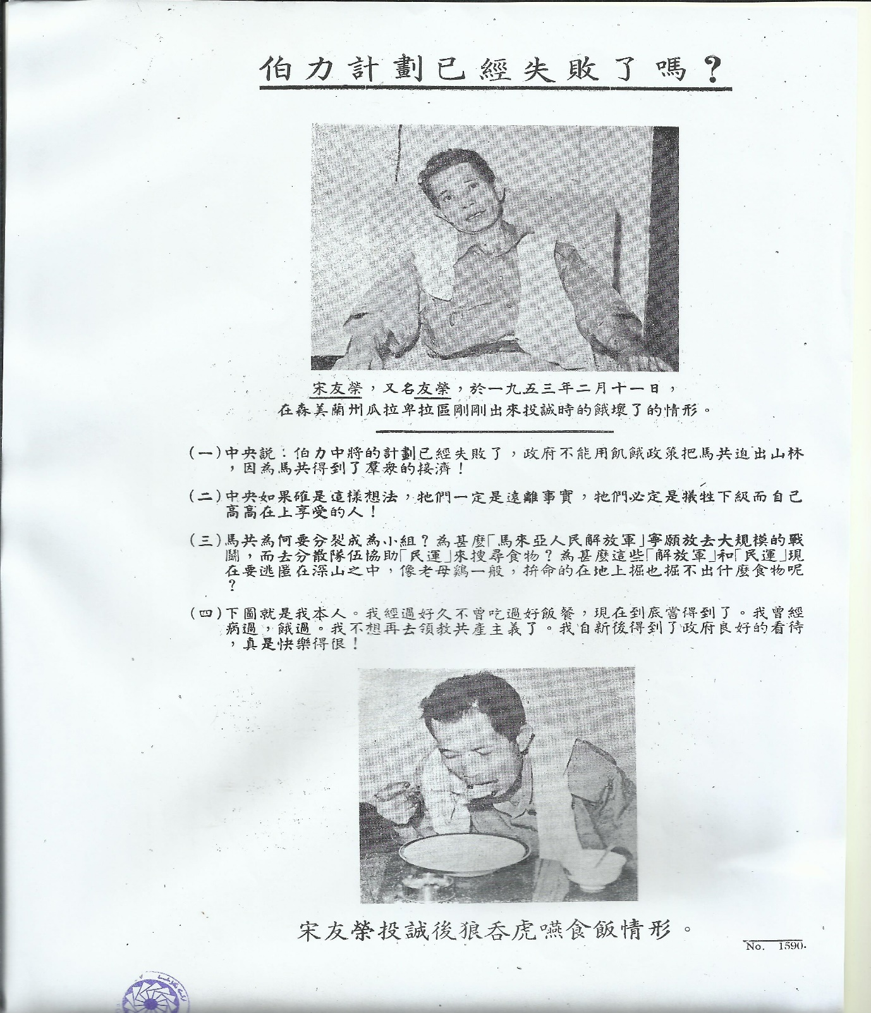
Picture 1 shows a British Propaganda leaflets that interviewed the Surrender Enemy Personnel whose “Self -renewed” into the New Village Programs under the Briggs Plan. The Leaflets was describing the man who was well fed by the Government under the scheme and does not wrongly imagined by the CPM propaganda that the Briggs Plan was partly of a concentration camp!

Sources: National Archives of Malaysia

Bibliography
Artelli, M. J. (2007). Modeling and analysis of resolve and morale for the `Long War'. Ph.D Doctorial, Air Force Institute of technology Wright-Patterson, Dayton, OH.
Ching, Oong, H. (2000). “The Chinese Politics in Malaya 1942-1955: The Dynamics of British Policy”. Bangi, Selangor: Penerbit Universiti Kebangsaan Malaysia.
Comber, Leon. (2008). “Malaya’s Secret Police 1945-1960: The Role of the Special Branch in the Malayan Emergency”. Singapore: Institute of Southeast Asian Studies.
Galula, D. (1964). “Counterinsurgency Warfare”. New York: Frederick A. Praeger.
Greene, T. N. (1967).” The Guerrilla and How to Fight Him”. New York: Frederick A. Praeger Publishers.
Elkins, C. (2005). Imperial reckoning: The untold story of Britain's gulag in Kenya. New York: Henry Holt and Co.
Hack, K. (2009). The Malayan Emergency as c ounter-insurgency paradigm. Journal of Strategic Studies, 32(3), 383-414. doi: 10.1080/01402390902928180
Jackson, Robert. (1991). “The Malayan Emergency: The Commonwealth Wars 1948- 1966”.New York: Routledge.
KEMENTAH (2001). “Tentera Darat Menentang Insurgensi Komunis 1968-1989”. Markas Tentera Darat, Kuala Lumpur.
Mans, Rowland S.N. (1967).” Victory in Malaya”, in Greene, “The Guerrilla and How to Fight Him”. New York: Frederick A. Praeger Publishers.
Miller, H. (1972). “Jungle War in Malaya: The Campaign against Communism 1948-1960”. Kuala Lumpur: Eastern Universities Press Sdn. Bhd.
Nagl, John, A. (2005) “Learning to Eat Soup with a Knife: Counterinsurgency Lessons from Malaya and Vietnam”. USA: University of Chicago Press.
Navaratnam, A.V. (2001). “The Spear and The Kerambit: The Exploits of VAT 69, Malaysia’s Elite Fighting Force 1968-1969”. Kuala Lumpur: Utusan.

Rid, T. (2010). The Nineteenth Century origins of counterinsurgency doctrine. Journal of Strategic Studies, 33(5), 727-758. doi: 10.1080/01402390.2010.498259
Short, Anthony. (1975). “The Communist Insurrection in Malaya: 1942-1948”. Oxford University Press. Singapore.
Ucko, D. (2010). The Malayan Emergency: The legacy and relevance of a counterinsurgency success story. Defence Studies, 10(01-02), 13-39. doi: 10.1080/14702430903377944

According to T. N. Greene, The Briggs Plan had three main aims: (1) To bring the population especially the isolated sections under effective administration and protection, this include the resettlement of “squatter” communities, (2) To expand the Malayan Police and The Security Forces, (3) To establish a unified civilian, police, and military system of command and control for all anti-subversive operations. See T. N. Greene (1967), “The Guerrilla and how to fight him” Praeger, New York, pg. 120-123.
See John A, Nagl (2005). “Learning to Eat Soup with a Knife: Counterinsurgency Lessons in Malaya and Vietnam”. USA: University of Chicago Press. Pg.71.
The Chinese squatter considerable a potential threat to the British Government due to some of the squatter is believe to be the hard-core supporters and sympathizers to the Communist movement or, under the duress situation. They provides foods and other basic necessity to the CPM work force or Min Yuen Units., Thus, as a preventive countermeasures, in the first nine months of 1949, 6,343 squatters were detained under the new regulations, 1,226 later being released and resettled in areas where they would not be the subjected to Communist influence and 9,062 people were repatriated to China and further 460 to India. See Jackson (1991), “The Malayan Emergency: The Commonwealth’s War 1948-1966, pg. 20
The number of the New Village under the Briggs Program were increased as 429 New Villages containing 385,000 people were built in 1951 and the number is increasing to 509 settlements with a population of 461,822 at the end of 1952. See Oong Hak Ching “Chinese Policy in Malaya 1942-1955”, UKM, Bangi, 2000, pg.181-182.
. A Director of Intelligence Services (DIS) was appointed in August 1950 and by 1953, the DIS the was coordinating with the Federal Intelligence Committee and Combined Intelligence Staff, which included representatives of all agencies engaged in intelligence work in Malaya. See Rowland S.N. Mans “Winning in the Jungle: Malaya” in T. N. Greene, “The Guerrilla and how to fight him” Praeger, New York, pg. 122-124.
See John A, Nagl (2005). “Learning to Eat Soup with a Knife: Counterinsurgency Lessons in Malaya and Vietnam”. USA: University of Chicago Press. Pg.71,
Lieutenant General Sir Harold Briggs, Report on the Emergency in Malaya from April, 1950 to November 1951 (Kuala Lumpur: H.T. Ross, 1951), TDRC Index No. 953, 16, in Nagl, “Learning to Eat Soup with a Knife: Counterinsurgency Lessons in Malaya and Vietnam”. Pg.74.
Harry Miller (1972). “Jungle War in Malaya: The Campaign against Communism 1948-1960”. Kuala Lumpur: Eastern Universities Press Sdn. Bhd, pg. 72.
Short, Anthony. (1975). “The Communist Insurrection in Malaya: 1942-1948”. Oxford University Press. Singapore, pg. 293.
The Malayan Chinese Association (MCA) was, its name suggests, a political organization of the most influential Chinese members of Malayan society, its support was crucial to the defeat of the guerrilla insurgents. See Short, “The Communist Insurrection in Malaya: 1942-1948”, pg. 302.

