INTEGRATING LOCAL AND FOREIGN CULTURES
IN THE ENGLISH TEACHING LEARNING PROCESS:
A WAY OF MAINTAINING LOCAL CULTURES

Siti Sudartini

Email: ssudartini@yahoo.com

ABSTRACT
The need to participate in the global communication has put English as one of the most important international languages. Mastering English becomes one of the most important thing most people want. This has led to the increasing demand of English language teaching practices. Considering the importance of mastering English, the Indonesian government has considered English as one of the most important foreign languages to be taught in schools. It has been taught from elementary school as local content and even in some parts of this country it has been taught in kindergartens. On the other hand, it is commonly believed that the practice of English language teaching will not be well conducted without teaching the accompanied cultural beliefs and values. Meanwhile those foreign cultural beliefs and values may not be in line with our local and national cultural beliefs and values. Therefore, it will be a very great challenge for those who are actively involved in the practice of English language teaching to take this fact into their consideration. This particular study has a closer look on this particular problem and wherever possible proposes an alternative solution to overcome this problem for the sake of maintaining the nation identity and culture. Therefore, this study focuses on identifying the foreign cultural believes and values commonly found in some English textbooks for Junior High Schools used in the English teaching and learning process and describing one alternative way of teaching English with its accompanied cultural beliefs and values and at the same time maintaining the local and national cultural beliefs and values.
Keywords: culture, English teaching, learning process, local culture.

INTRODUCTION
Jandt (2010: 6) states that as we live in an interconnected global economy-global trade, migration, environtmental sustainability, the challenge facing the world at the beginning of the 21st century is to seek global solutions. To meet these challenges will require us to learn how to better communicate with one another regardless of where we live, of our economic status, and of our identity. One of the effective ways to get connected with other people in this world is by using one of the international languages. One of the international language having an important position in the global communication is English.
In line with the role of English as one of the mostly used international languages in the world, mastering English becomes an urgent need for most countries, not to mention this country, Indonesia. Considering the need to participate in global communication, English has been considered as one of the most important foreign language to be taught at schools starting from elementary up to the tertiary education in this country. English has even been considered is one of the important keys to get success not only in educational field but also in other fields. It has been used widely as an important language in businesses, advertisements, entertainments, sports, and many more. It seems that mastering English becomes every body’s ticket to get success in any field of their lives in this country or even in every country in this world. Mckay (2002:128) mentions that one of the primary reasons for learning English today is to access and contribute to the large amount of information that is available in the language.
Therefore, it is commonly believed that the teaching and learning of English will not be successfully carried out without teaching its culture. Brown in Richards and Renandya (2002:12) even mentions that “whenever you teach a language, you also teach a complex system of cultural customs, values, and ways of thinking, feeling, and acting”. Since language can be said to be one of the important factors determining the identity of a nation, it is considered as one part of culture that makes a country different from others. Foley (2001:19) claims that language is the unseparable sub system of culture. He mentions that:
Language is often treated theoretically as a sub system of culture within cognitive anthropology but in practice and structure of language as revealed by modern linguistics has generally served as the paradigm for analyzing other aspects of culture.

Language, however, can be treated as a cultural activity and, at the same time, an instrument for organizing other cultural domains (Sharifian & Palmer, 2007:1). Language needs to be seen as integral part of culture. It is through language, that culture can be expressed. Guirdham ( 2005:46) mentions the following.

Culture is about ‘shared meanings’. Meanings are produced and exchanged through language, which is the medium through which we ‘make sense’ of things. Meanings can only be shared through language. Thus, ‘to say that two people belong to the same culture is to say that they interpret the world in roughly the same ways and can express themselves, their thoughts and feelings about the world, in ways which will be understood by each other’.

As language is one of the cultural representations, learning a language, not to mention, English, cannot be separated from learning its accompanied culture. By this statement, it is clearly seen that all English learners need to develop an awareness that cultural factors do play a role in rhetorical development and that those texts that conform to their own rhetorical paterns will be easier to process (Mckay, 2002:128). This concept of cultural awareness is proven to be very significant and need to be one of the essential part of English learning and teaching (Tanaka, 2006:37).
As learners may also bring their own culture while learning English, the approaches to the teaching of English as international language need above all to be culturally sensitive to the diversity of contexts in which English is taught and used and in terms of materials, the prevalent use of western cultural content in ELT texts needs to be examined. The use of source or learners culture content not only minimizes the potential of marginalizing the values and lived experiences of the learners but also encourage learners to gain a deeper understanding of their own culture so that they can share these insights when using English with individuals from other cultures (McKay, 2002).
In line with this, it seems necessary to conduct a study related the topic of using the local cultural content in the practice of English language teaching. This particular study focuses on identifying the foreign cultural beliefs and values commonly found in some English textbooks for Junior High Schools used in the English teaching and learning process in Indonesia and describing one alternative way of teaching English with its accompanied cultural beliefs and values and at the same time maintaining the local and national cultural beliefs and values for the sake of maintaining nation identity and culture.

CULTURAL CONTENT IN ENGLISH TEXTBOOKS
This study, in particular, is a critical analysis of two junior high school English textbooks mostly used in Yogyakarta Special Region. Those books are Real Time (Erlangga Publishing), and English on Sky (Erlangga Publishing). The following are the general description and the cultural content found in those books.

- Real Time: An Interactive English Course for Junior High School Sudents Year VII

The cultural contents are both explicitly and implicitly inserted within the book. The explicit insertion is done by giving a certain section in every unit called Cultural Notes aimed at introducing the Western culture. This section is found in every unit/chapter of the book with various topics, namely: Foreign Culture, Tips for Studying Abroad, Bedtime Stories, Sport Leagues, Barbeque, Transportation in America, and Dining Out. Besides this section, there is also a section called Did You Know, which can be found in some of the units, consisting of additional explanation on certain Western culture being introduced in that unit/chapter.
On the other hand, the implicit insertion is done through the use of figures, either those used as ilustrations or those function as main figures or input texts for some of the tasks/ exercises. The illustration figures commonly show the Western setting (like some places in Western countries), figures of Western peoples, and some other cultural behaviour commonly done in Western countries. The use of these can be said as implicit insertion of Western culture since those items are not in particular discussing the Western culture. Their main function is to give illustration of some other parts of the book. Take for example, on page 8, there is a text talking about family members and there is an illustration of a family foto showing an example of a Western family.

Figure 1. My Family (taken from Nina Bates. 2007, 8)
Some figures also used as the main input texts of this book. Most of those figures show Western culture. By using those figures, it seems like readers (learners) are supposed to think that the Western culture is better than their own culture. The folowing are some examples of figures used as the input texts that show Western culture superiority.
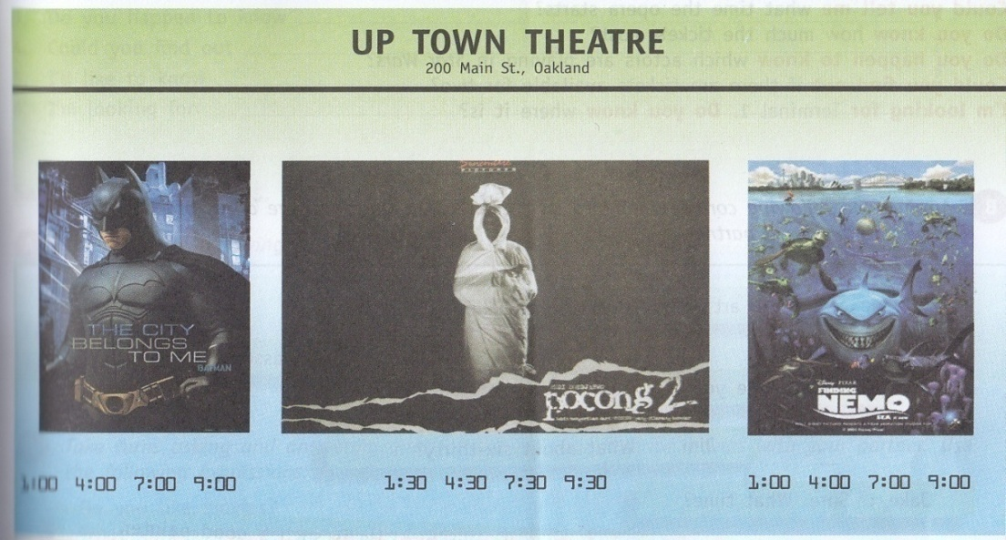
Figure 2. Movies (Taken from Nina Bates. 2007, 59)

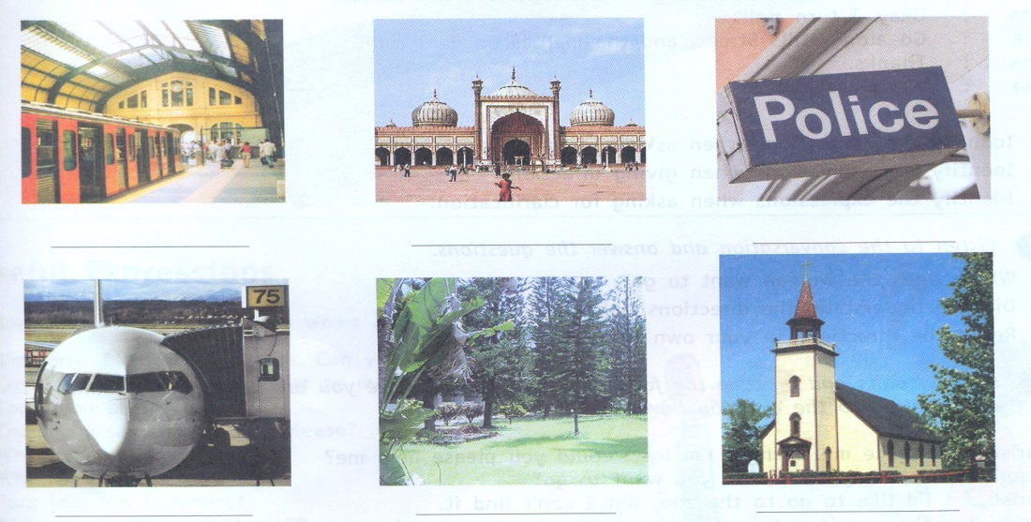
Figure 3. Public Places (Taken from Nina Bates. 2007, 100)


Figure 4: Food (Taken from Nina Bates. 2007, 109)

By looking at those two figures, the learners may think that Western food is better than their own food and that those public places are better palces than those found in their own country. Even that Western movies are better than the local movies. There are also some figures showing Western patern of behaviour that may not be in line our cultural values and norms. The examples can be found on page 34 and 115.
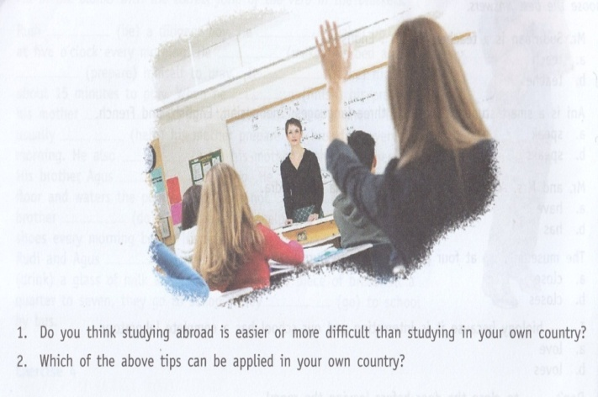
Figure 5. Classroom Activities (Taken from Nina Bates. 2007, 34)
This figure show a classroom setting when a teacher is explaining something and one of the students wants to ask a question by raising her left hand. This cultural behaviour may not be accepted in Indonesian culture since Indonesian students tend to use their right hand whenever they want to ask a question.

Figure 6. Ordering Take Out Food (taken from Nina Bates.2007, 115)
Similarly figure 6 shows a boy who receives the return money by using his left hand. This cultural behavior also may not be in line with Indoensian cultural behavior. Looking at these figures, teachers need to be aware of this different cultural behaviours and wherever possible give explanation to their students.
- English on Sky 1 for Junior High School Year VII
Similar with the first book, this book also contains Western cultural values and behaviour. The main different of this book compared to the first one is on the way the cultural conten inserted in the content. Unlike the first book, most of the cultural content are implicitly inserted in this book through texts and figures (either those used as the main input or illustration). Some cultural behaviour found in this books are in terms of addressing system, time, schools activities, foods, and some other related cultural behaviours. This book not only contain Western cultural values and behaviour, it also covers some Indonesian cultural behaviours although there is a different proportion the use of these two cultures. The figures as well as texts used in this book show the Western superiority over Indonesian. Take for example, what can be found in an activity on page 86. This activity is called Talking about Job. The input text for this activity is a set of figures showing people’ occupation. This figures give an illustration of some occupation. Most of the models in this set of figures are Western people except those showing the occupations of a farmer and a policeman.
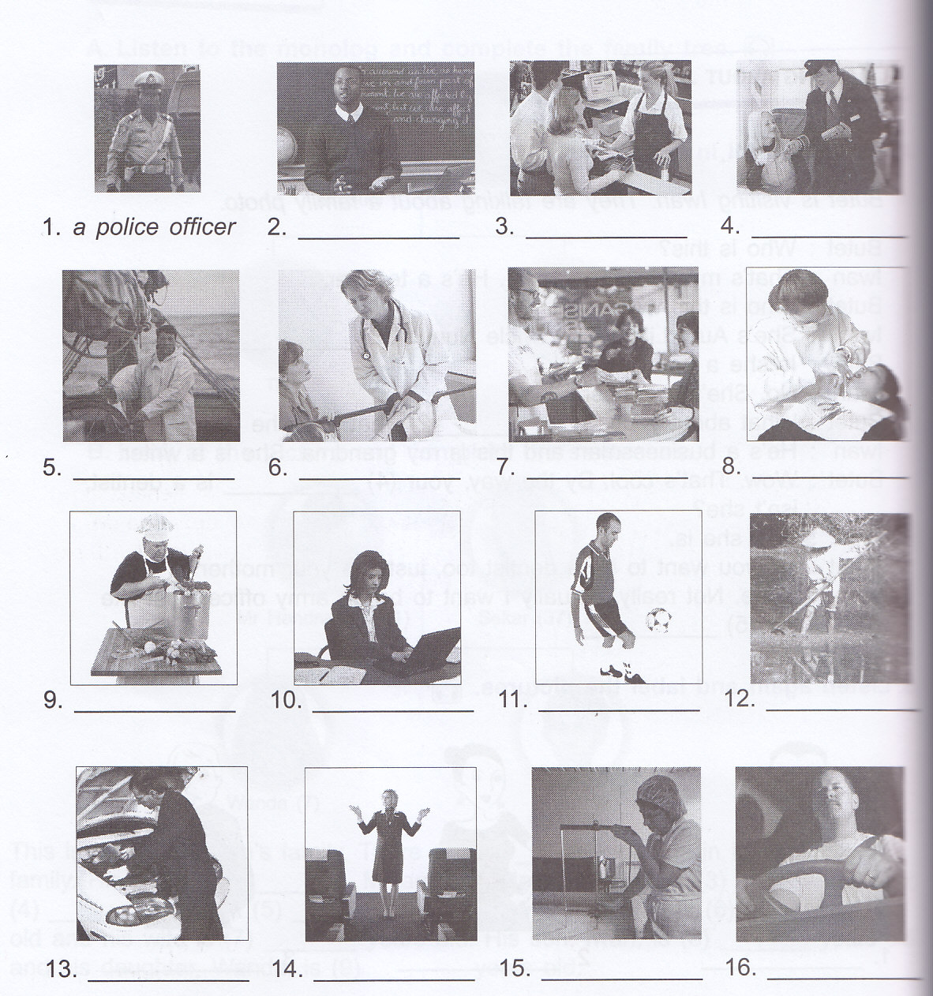
Figure7. Talking About Jobs (Taken from Mukarto, et al., 2007, 86).
Above al, these two books are merely some examples of those used in the practice of English teaching and learning in the classroom. Looking through these two books, the need to introduce Indonesian cultural values and norms in the English textbooks is unavoidable. English teachers need to have an additional as well as alternative source materials to conduct their teaching while keep maintaining their cultural awareness towards the insertion of Werstern cultural values and patterns of behaviours commonly found in the English textbooks.

INTEGRATING LOCAL AND FOREIGN CULTURE IN ELT PRACTICES
The fact that the foreign cultural values and behaviours, that is, the Western cultural values and behaviours are commonly found in English textbooks, needs to be anticipated by those involved in the practice of teaching and learning the language. English needs to be seen as an international language, a means of communicating among people in the world. It doesn’t belong to certain country, and it can cover cultural contents which are not specific to that country. Indeed, it will be much beneficial to integrate local as well as foreign culture, that is, the source culture as well as the learners culture in the practice of teaching and learning the language.
Consequently, textbook-writers need to consider this fact and wherever possible try to integrate both the Western aand the Indonesian culture in their textbooks. The government has provided opportunities for English scholars to develop English textboks either for Junior High Schools, Senior High Schools as well as for Vocational Schools, through conducting a program aimed at providing cheap textbooks called BSE (Buku Sekolah Elektronik). This is a very good step not only to provide cheap resources for students but also to give opportunities for scholars to develop resources that hopefully will fit the students need as well as maintaining the nation identity, by means of integrating both the foreign and Indonesian cultural values and patterns of behaviours as well as cultural representations. A brief look at some of the English BSE books for Junior High Schools, has shown that these books, in general, present not only foreign culture but also Indonesian cultural values, patterns of behaviour, as well as some cultural representations.
The following are some cultural contents found in one of the BSE books for Junior High School, entitles English in Focus 1; for Grade VII Junior High School written by Wardiman et.al. in 2008.
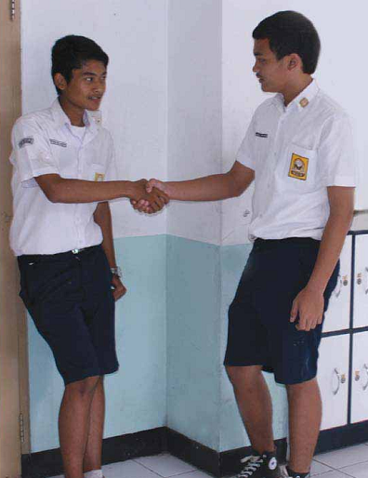
Figure 8. Meeting Someone for the First Time (Taken from Wardiman, A., Jahur, M.B., dan Djusma, M.S, et al., 2008, 1).

By using the picture, the writers implicitly introduce of Indonesian patterns of behaviours, related to the activity that Indonesian students commonly do when they meet their new friend. It is clearly seen that the writers want to show the Indonesian setting through the use of Indonesian model and also the way they perform, that is, showing the two junior high schools wearing their school uniform.

Figure 9. My Family (Taken from Wardiman, A., Jahur, M.B., dan Djusma, M.S, et al., 2008, 83).
Similarly, this picture also implicitly shows the Indonesian setting through the use of Indonesian models and dressing style as it is used to give an illustraton on topic my family.
These pictures present examples of integrating foreign and Indonesian culture in the practice of English Language teaching, that is through inserting local/ national cultural values and patterns of behaviours in English textbooks. This could be a agood initial step in integrating foreign and local, that is, Indonesian cultures in the practice of English language teaching. In turn, this may be a good solution to maintain the nation identity. Our students may learn foreign cultural values and pattern of behaviours but they need also to understand their own cultural values and patterns of behaviours
Unfortunately, not all of the schools and English teachers use the BSE books. Some of them consider these kinds of books not interesting since most of the BSE books are not presented as interesting as other books published by private publishers. Some other teachers said that most of the BSE books are not written by native speakers of English that they consider them having lower quality compared to those published by private company. Therefore, this could an additional task for the government and those concern with providing resources for our students to improve the quality of BSE books. Besides, it will be also a big challenge to those interested in developing English learning resources and concerned with the idea of maintaining the nation identity in the ELT practices to develop English textbooks which could meet the learners’ need that is to learn the language together with its related culture and at the same time, maintain the learners’ understanding towards their own culture.
Therefore, it seems necessary to change the common view of English as the ‘foreign language’ but it must be considered as an ‘International language’ that no longer belongs only to a particular country. Thus, whenever someone learns English it doesn’t mean that he needs to learn all aspects of that culture, internalize it and even forget his or her own culture.
CONCLUSION
In summary, learning language will be considered effective when it accompanied by learning its culture, not to mention English. It is therefore, will be a very great challenge for those involved in the practice of English languagge teaching in terms of cultural contents owing to the facts that Western cultural values and patterns of behaviours may not be in line with Indonesian. This particular study has found some examples of Western cultural values and patterns of behaviors which may not be applicable in Indonesian context. This also provides examples of the insertion of Indonesian cultural values and pattern of behaviours in English textbooks. It is clearly seen that this insertion does not reduce the content of the books.
Consequently, it will be a great challenge to undergo similar steps as one of the initial steps in integrating foreign and Indonesian cultures in the practice of English language teaching. This will be an important step to maintain the nation identity. Therefore, I do agree with an idea saying that we need to think globally but act locally (McKay, 2002). This idea needs to be the one of the underlying principles in teaching English in our beloved country.

REFERENCES

Bates, Nina. 2007. Real Time: An Interactive English Course for Junior High School Students Year VII. Jakarta: Erlangga.
Mukarto, et al. 2007. English on Sky 1 for Junior High School Year VII. Jakarta: Erlangga.
Foley, W. A. 2001. Anthropological Linguistics: An Introduction. Oxford: Blackwell Publishers Inc.
Guirdham, Maureen. 2005. Communicating Across Cultures at Work Second Edition. New York: Palgrave. Macmillan.
Jandt, Fred E.2010. An Introduction to Intercultural Communication: Identities in a Global Community. Thousand Oaks, California: Sage Publication, Inc.
McKay, Sandra Lee. 2002. Teaching English as an International Language. New York: Oxford University Press.
Richards, J. C. and Renandya, W. (eds). 2002. Methodology in Language Teaching: An Anthology of Current Practice. Cambridge: Cambridge University Press.
Sharifian, F. & Palmer, G. B. 2007. Applied Cultural Linguistics Implications for Second Language Learning and Intercultural Communication. Amsterdam/Philadelphia: John Benjamins Publishing Company.
Tanaka, S. 2006. “English and Multiculturalism—from the Language User’s Perspective “, in RELC Journal, Singapore (2006; 37), 47.
Wardiman, A., et al. 2008. English in Focus 1: for Grade VII Junior High School. Jakarta: Pusat Perbukuan, Depdiknas.

ABOUT THE WRITER

Siti Sudartini, born in Yogyakarta on March 11th, 1976. Graduating the S1 degree at English Education from Yogyakarta State University. Teaching at English Education Department of Yogyakarta State University from January 2005. Having the Master Degree of Linguistics Study Program of UGM Yogyakarta in 2009. Actively joining some seminars and writing journals related to education, particularly the teaching of English as Foreign Language in Indonesia. Email address: ssudartini@yahoo.com. Contact Number: 08156877141.

Artikel ini telah dipresentasikan dalam The 4th International Graduate Student Conference in Indonesia yang diselenggarakan leh Sekolah Pascasarjana, UGM pada tanggal 30 dan 31 September 2012.
An Educatonal Staff of Faculty of Languages and Arts, Yogyakarta State University.

