Bidang Ilmu: Teknik

LAPORAN PENELITIAN KERJASAMA INTERNASIONAL

TAHUN ANGGARAN 2012

ANAEROBIC TREATMENT OF SEPTIC TANKS’ SLUDGE WITHIN THE FRAME OF INTEGRATED WATER RESOURCE MANAGEMENT
- A Study in RSUD Wonosari and Pucanganom Village, Gunung Kidul, Yogyakarta –



OLEH :

Didik Purwantoro, S.T., M.Eng.
Dr.-Ing. Satoto E. Nayono, M.Eng., M.Sc.
Retna Hidayah, S.T., M.T., Ph.D.

Bekerjasama dengan:

Dr.-Ing. Stephan Fuchs (KIT Germany)
Dipl.-Ing. Susanne Fach (KIT Germany)

Dibiayai dengan dana hibah Kerjasama Penelitian Internasional UNY
Nomor: 021/Subkontrak-Kerjasama Internasional/UN34.21/2012

LEMBAGA PENELITIAN DAN PENGABDIAN KEPADA MASYARAKAT
UNIVERSITAS NEGERI YOGYAKARTA
TAHUN 2012
Lembar Pengesahan

LAPORAN PENELITIAN KERJASAMA INTERNASIONAL

- Judul Penelitian :
Anaerobic Treatment of Septic Tanks’ Sludge within the Frame of IWRM: A Study in RSUD Wonosari and Pucanganom, Gunung Kidul, Yogyakarta

- Ketua Peneliti
  - Nama Lengkap : Didik Purwantoro, M.Eng
  - Jenis Kelamin : Laki-laki
  - NIP Lama dan NIP. Baru : 132206663 19730130 199802 1 001
  - Pangkat/gol : Penata / III c
  - Jabatan Struktural : Koordinator Program Studi D3 Teknik Sipil
  - Jabatan Fungsional : Lektor
  - Fakultas/Jurusan : Teknik/ Pendidikan Teknik Sipil dan Perenc.
  - Pusat Penelitian : -
  - Alamat : Manding Serut No.1 RT 2 Sabdodadi Bantul Yogyakarta
  - Telpon/Faks : 0274-9285063
  - Alamat Rumah : Manding Serut Sabdodadi Bantul Yogyakarta
  - Telpon/E-mail/HP : 0274-9285063 / didik_purwantoro@yahoo.co.id

3. Skim Penelitian : Penelitian Kerjasama Internasional

4. Bidang Ilmu : Teknik

5. Mitra Kerjasama Internasional
a. Nama : Dr.-Ing. Stephan Fuchs
b. Institusi : Karlsruhe Institute of Technology, Germany

6. Jangka Waktu Penelitian : 1 Tahun

7. Rencana Pembiayaan :

Jumlah biaya yang dibutuhkan : Rp. 230.000.000,00
Jumlah biaya yang disediakan oleh mitra : Rp. 130.000.000,00
Jumlah biaya yang diajukan ke UNY : Rp. 100.000.000,00
Mengetahui, Yogyakarta, 13 Desember 2012
Dekan Fakultas Teknik Ketua Peneliti,

( Dr. Moch. Bruri Triyono ) (Didik Purwantoro,M.Eng) NIP 19560216 198603 1 003 NIP 19730130 199802 1 001
Mengetahui,
Ketua LPPM - UNY

Prof. Dr. Anik Ghufron
NIP. 19621111 198803 1 001

ANAEROBIC TREATMENT OF SEPTIC TANKS’ SLUDGE WITHIN THE FRAME OF INTEGRATED WATER RESOURCE MANAGEMENT
- A Study in Gunung Kidul, Yogyakarta
Didik Purwantoro
Satoto E. Nayono
Retna Hidayah

Abstract
Gunung Kidul district in Yogyakarta Special Province, Indonesia undergoes an acute water shortage despite receiving high amounts of precipitation during the rainy season. Since this area is a karst region, water normally infiltrates into the ground, flows through the underground caves and finally ends up in the Indian Ocean. In general, sanitation systems in Gunung Kidul consist of either pit latrines or pour-flush toilets (latrines). Pit latrines are commonly found in rural areas while in urban areas, pour flush latrines take the lead. As a case for this study is Wonosari hospital (RSUD Wonosari. This hospital is largest public hospital found in Wonosari, Gunung Kudul region. With a capacity of about 115 beds, the hospital has about 351 staff, of which 160 are non-medic and 191 are medic staff. In regard to sanitation, the hospital currently has a kind of central wastewater disposal system with a subsequent biological treatment plant. This wastewater treatment plant is however not in the good condition and operation. Most of the wastewater resulted from hospital’s activities which is treated in this plant is not treated in the wastewater plant and even the treated wastewater is not really sufficiently purified. This lack of treatment can be indicated by the high BOD and COD value of the treated wastewater which does not meet the criteria that has been issued by the government of Indonesia.
As an effort to promote sustainable sanitation and to have better results of wastewater treatment plants, a two-step anaerobic technology will be tested at the hospital area. The most suitable mode of operation is currently being tested in Germany after which the facility will be re-located to Indonesia. The first operation step of this digester is to treat sludge sediment from the hospital’s septic tanks which is not further treated and disposed properly in solid waste disposal (sanitary landfill).
The main goal of this research is to optimize the operation performance of two-step anaerobic reactor treating septic tanks‘ sludge, either by investigating the maximum organic loading rate or by co-digestion with other types of wastes for more resources recovery. This goal leads to a promotion of affordable sanitation technologies, which have the ability to recover valuable material from wastewater, especially for the less developed countries.
Keywords: anaerobic treatment, biogas, septic tank sludge, resources recovery, sustainable sanitation

I. INTRODUCTION
1.1 Background Information: Current Sanitation Situation in Gunung Kidul
Gunung Kidul district in Yogyakarta Special Province, Indonesia undergoes an acute water shortage despite receiving high amounts of precipitation during the rainy season. Since this area is a karst region, water normally infiltrates into the ground, flows through the underground caves and finally ends up in the Indian Ocean. Since inception of the IWRM-Indonesia research project in 2002, Karlsruhe Institute of Technology has been working closely with partners from academia and industry to supply the region with drinking water from the underground caves as well as provide sustainable waste and wastewater disposal solutions. In the frame of this project, the department of Aquatic Environmental Engineering of the Institute for Water and River Basin Management (IWG-SWW) is responsible for the development and realization of customized technologies for waste water and solid waste treatment within the Integrated Water Resources Management (IWRM) program which started in August 2008.
In general, sanitation systems in Gunung Kidul consist of either pit latrines or pour-flush toilets (latrines). Pit latrines are commonly found in rural areas while in urban areas, pour flush latrines take the lead (Mueller, 2009). Open defecation only happens at a low scale in the rural areas (Insani, 2009). Faecal waste in the pit latrines is simply deposited in a pit whereas for the pour-flush latrines, faecal waste is flushed off into a pit or septic tank. Although the health authority Dinas Kesehatan recommends construction of septic tanks with drainage trenches (Mueller, 2009), the fact that each household has to bear the cost leads to construction of unsealed septic tanks without drainage trenches. The liquid phase infiltrates into the ground and the septic tanks are hardly ever emptied, thus posing an evident contamination potential to groundwater in this karst region.
Gunung Kidul region is characterized by substantial economical and technological differences between the rural and urban areas. Therefore, spatial differentiated solutions and an emphasis on decentralized as well as semi-centralized waste water and solid waste treatment are inevitable. Research and development of such focus mainly on:
- urban area – City of Wonosari
- rural area – Gunung Sewu karst region
According to the usage patterns and settlement systems in both areas various starting-points for the development and realization of customized concepts can be found. For the urban area these are:
- public buildings, schools, hospitals
- commercial and industrial zones
- the local hospital
On the countryside approaches are worked out for:
- settlements
- market towns
Optimal solutions for the above named fields of application shall be found by using different technological approaches. The aim is to treat wastewater and organic waste in a way that the recirculation of nutrients and the energetic use of biogas can be achieved while protecting and saving scarce water resources. Technical feasibility and a maximization of the multiplier effect are thereby essential points for defining a specific working area. Development and introduction of new sanitary technologies go along with a program to enhance public acceptance of the systems and to advocate understanding of the systematic correlations between water supply and waste water disposal. Realization of the developed concepts shall boost and ensure further economical advancement of the whole region by saving natural resources.

1.2 Resources-recovery-based Sanitation Technology: Case Study of RSUD Wonosari and Pucanganom Village
In an effort to promote sustainable sanitation and to have better results of wastewater treatment plants, a two-step anaerobic technology will be tested at RSUD Wonosari area. The most suitable mode of operation is currently being tested in Germany after which the facility will be re-located to Indonesia. The first operation step of this digester is to treat sludge sediment from the hospital’s septic tanks which is not further treated and disposed properly in solid waste disposal (sanitary landfill).
A new concept of sanitation technology will also be introduced to the villagers of Pucanganom in Ponjong, Gunung Kidul. This new concept is also based on resource recovery of wastes. A mixed treatment of domestic waste and animal waste will be applied in the area.
1.3 Goal and Objectives of the Research
The main goal of this research is to optimize the operation performance of two-step anaerobic reactor treating septic tanks‘ sludge, either by investigating the maximum organic loading rate or by co-digestion with other types of wastes for more resources recovery. This goal leads to a promotion of affordable sanitation technologies, which have the ability to recover valuable material from wastewater, especially for the less developed countries.
In order to reach the goal, this research will comprise several objectives as follows:
- to examine the sanitation plant of a public space, in this case is RSUD Wonosari,
- to evaluate the operation performance of two-step anaerobic reactor treating the septic tank sludge,
- to determine the potential biogas production of anaerobic degradation of septic tank sludge and potential improvement of biogas if the sewage sludge is co-digested with other types of waste namely cow dung,
- to examine the stability of cow dung if they are used as a co-substrate in anaerobic digestion of septic tank sludge, and
- to evalauate the possible application of new technology innovation in a village in order to promote higher sanitation standard.
1.4 The Importance of the Research
As a consequence to the increasing number of population and the improvement of living quality since the past three decades, the total amount of municipal wastewater is continuously rising. The trend of increasing municipal wastewater amounts is also observed in the other part of the world. Consequently, there are millions of tons of sludge resulting from wastewater being produced every year which have to be disposed. Especially in the less developed countries, caused by the lack of know-how and financial support, most of the sludges are treated and disposed improperly. These practices lead to several problems such as aesthetical problems (odour nuisance, turbid water, etc.), health problems (skin infection, diarrhoea, breeding of pathogenic vectors, etc.) and environmental problems (damage to surface or ground water due to leachate production, eutrophication, soil contamination, air pollution due to improper incinerator or “smoking-landfills”, etc.).
Compared to composting or other aerobic treatment, anaerobic digestion of sewage sludge has several advantages, such as better handling of wet waste, the possibility of energy recovery in the form of biogas, less area requirement and less emission of bad odor and green house gasses (Baldasano and Soriano, 2000; Hartmann and Ahring, 2006). Furthermore, if the digestate of an anaerobic digester has to be disposed in a landfill, anaerobic digestion has advantages such as: minimization of masses and volume, inactivation of biological and biochemical processes in order to avoid landfill-gas and odor emissions, reduction of landfill settlements, and immobilization of pollutants in order to reduce leachate contamination (Fricke et al., 2005).
Scientifically, with all rationales mentioned above, it is really important to develop an appropriate anaerobic treatment technology in order to solve the problem caused by increasing volume of sewage sludge. This research stressed its goal to achieve a better sanitation solution as its importance; therefore it can be seen as our contribution toward a better environment within the frame of sustainable development.
Institutionally, for Yogyakarta State University, research collaboration with prominent international higher education can be seen as an initial step toward our vision as a world class university. If this proposal is approved, it can be followed by other collaborative activities in order to enhance the quality of higher education in YSU.

II. LITERATURE REVIEW
The history of anaerobic treatment can be traced back 2000 years by the anaerobic digestion of animal manure in China and India (Veenstra, 2000). In modern age, after the discovery of methane emissions from natural anaerobic habitats by Volta in 1776, people started to collect the natural biogas and used it as a fuel, basically for lighting. However, it took until the end of the 19th century until anaerobic digestion was applied for the treatment of wastewater and solid waste (Gijzen, 2002). The first digestion plant was reported to have been built at a leper colony in Bombay, India in 1859. Anaerobic digestion reached England in 1895, when biogas was recovered from a sewage treatment facility to fuel street lamps in Exeter (Residua, 2009). The application of anaerobic digestion with the main purpose to reduce and stabilize solid waste gained its popularity after the large-scale introduction of activated sludge systems in the mids of 20th century. Until now, anaerobic digestion of sewage sludge is still a standard practice for modern activated sludge plants.
2.1 Microbiological Process in Anaerobic Treatment
Anaerobic digestion, specifically methane fermentation, is both an effective and simple method for stabilizing sludge. Optimizing process efficiency for increased biogas production, however, is complex because it relies heavily on microbial activity. Anaerobic digestion is described as a series of processes involving microorganisms to break down biodegradable material in the absence of oxygen. The overall result of anaerobic digestion is a nearly complete conversion of the biodegradable organic material into methane, carbon dioxide, hydrogen sulfide, ammonia and new bacterial biomass (Veeken et al., 2000; Kelleher et al., 2002; Gallert and Winter, 2005).
In the anaerobic digestion process different types of bacteria degrade the organic matter successively in a multistep process and parallel reactions. The anaerobic digestion process of complex organic polymers is commonly divided into three inter-related steps: hydrolysis, fermentation (also known as acidogenesis), ß-oxidation (acetogenesis) and methanogenesis which are schematically illustrated in Figure 2.1 (modified from Stronach et al., 1986; Pavlosthatis and Giraldo-Gomez, 1991).

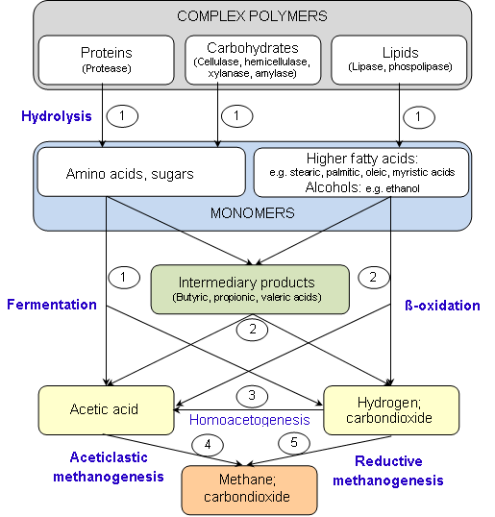
Figure 2.1 Schematic diagram of complete anaerobic digestion of complex polymers. Names in brackets indicate the enzymes excreted by hydrolytic bacteria. Numbers indicate the bacterial groups involved:
1. Fermentative bacteria
2. Hydrogen-producing acetogenic bacteria
3. Hydrogen-consuming acetogenic bacteria
4. Aceticlastic methanogenic bacteria
5. Carbon dioxide-reducing methanogenic bacteria
Hydrolysis. In the first step, complex organic polymers such as polysaccharides, proteins, and lipids (fat and grease) are hydrolyzed by extra-cellular enzymes into soluble products. The size of these soluble products must be small enough to allow their transport across the cell membrane of bacteria. Hydrolysis is a rather slow and energy-consuming process and is normally considered as the overall rate-limiting step for the complete anaerobic digestion of complex polymers (McCarty and Mosey, 1991; Pavlosthatis and Giraldo-Gomez, 1991; Gallert and Winter, 1999).
Fermentation (acidogenesis). The monomers produced from the hydrolysis process are then degraded by a large diversity of facultative anaerobes and anaerobes through many fermentative pathways. The degradation of these compounds results in the production of carbon dioxide, hydrogen gas, alcohols, organic acids, some organic-nitrogen compounds, and some organic-sulfur compounds. The most important of the organic acids is acetate since it can be used directly as a substrate by methanogenic bacteria.
Acetogenesis. Acetate can be produced not only through the fermentation of soluble organic compounds but also through acetogenesis. In this step low molecular weight volatile fatty acids are converted into acetate, hydrogen gas and carbon dioxide by acetogenic bacteria. This conversion process can only be thermodynamically favoured if the partial hydrogen pressure is kept low. Thus efficient removal of the produced hydrogen gas is necessary (Pavlosthatis and Giraldo-Gomez, 1991; Veenstra, 2000; Gerardi, 2003).
Methanogenesis. Finally, methane gas is produced by methane producing bacteria. Methane is formed around 66 % from acetate by means acetate decarboxylation proceeded by acetoclastic methanogenic bacteria (e.g.: Methanosaeta spp. and Methanosarcina spp.) and 34 % from carbon dioxide reduction by hydrogen, catalysed by hydrogen utilizing (hydrogenophilic) methanogenic bacteria. In particular, hydrogen utilizing methanogenic bacteria maybe responsible for the low partial pressure of hydrogen gas in anaerobic reactors, thus they create optimal conditions for acetogenic bacteria to breakdown the hydrolyzed organic compounds other than CO₂, H₂ and acetate into substrates for methanogenic bacteria (Veenstra, 2000; Metcalf & Eddy Inc., 2003). Alternatively sulphate-reducing bacteria or autotrophic acetogenic bacteria may also use hydrogen for sulphate reduction or acetate production from CO₂ + H₂ and thus decrease the hydrogen partial pressure. Table 2.1 presents the types of bacteria involved in each step of polymeric organic material digestion.

Table 2.1 Types of bacteria involved in each step of polymeric organic material digestion
Degradation process | Bacterial group | Type of conversion | Type of bacteria
Hydrolysis | Hydrolytic bacteria | Proteins to soluble peptides and amino acids | Clostridium, Proteus vulgaris, Peptococcus, Bacteriodes, Bacillus, Vibrio
Hydrolysis | Hydrolytic bacteria | Carbohydrates to soluble sugars | Clostridium, Acetovibrio celluliticus, Staphylococcus, Bacteriodes
Hydrolysis | Hydrolytic bacteria | Lipids to higher fatty acids or alcohols and glycerol | Clostridium, Micrococcus, Staphylococcus
Fermentation | Acidogenic bacteria | Amino acids to fatty acids, acetate and NH₃ | Lactobacillus, Escherichia, Staphylococcus, Bacillus, Pseudomonas, Desulfovibrio, Selenomonas, Sarcina, Veillonella, Streptococcus, Desulfobacter, Desulforomonas
Fermentation | Acidogenic bacteria | Sugars to intermediary fermentation products | Clostridium, Eubacterium limosum, Streptococcus
Acetogenesis | Acetogenic bacteria | Higher fatty acids or alcohols to hydrogen and acetate | Clostridium, Syntrophomonas wolfeii
Acetogenesis | Acetogenic bacteria | Volatile fatty acids and alcohols to acetate or hydrogen | Sytrophomonas wolfei, Sytrophomonas wolinii
Methanogenesis | Carbon dioxide-reducing methanogens | Hydrogen and carbon dioxide to methane | Methanobacterium, Methanobrevibacterium, Methanoplanus, Methanospirillum
Methanogenesis | Aceticlastic methanogens | Acetate to methane and carbon dioxide | Methanosaeta, Methanosarcina,
Modified from: Stronach et al., 1986
2.2 Important Parameters in Anaerobic Digestion
Several factors can affect the performance of the anaerobic digestion, either by process enhancement or inhibition, influencing parameters such as specific growth rate, degradation rates, biogas production or substrate utilisation. This proposal will briefly discuss those factors namely: pH, temperature, substrate, retention time, organic loading and mixing condition.
2.2.1 pH
The pH value of the digester content is an important indicator of the performance and the stability of an anaerobic digester. In a well-balanced anaerobic digestion process, almost all products of a metabolic stage are continuously converted into the next breaking down product without any significant accumulation of intermediary products such as different fatty acids which would cause a pH drop.
Alkalinity and pH in anaerobic digestion can be adjusted using several chemicals such as sodium (bi-) carbonate, potassium (bi-) carbonate, calcium carbonate (lime), calcium hydroxide (quick lime) and sodium nitrate. Addition of any selected chemical for pH adjustment should be done slowly to prevent any adverse impact on the bacteria. Because methanogenic bacteria require bicarbonate alkalinity, chemicals that directly release bicarbonate alkalinity are preferred (e.g. sodium bicarbonate and potassium bicarbonate are more preferred due to their desirable solubility, handling, and minimal adverse impacts). Lime may be used to increase digester pH to 6.4, and then either bicarbonate or carbonate salts (sodium or potassium) should be used to increase the pH to the optimum range (Gerardi, 2003)
2.2.2 Temperature
Temperature is one of the major important parameters in anaerobic digestion. It determines the rate of anaerobic degradation processes particularly the rates of hydrolysis and methanogenesis. Moreover, it not only influences the metabolic activities of the microbial population but also has a significant effect on some other factors such as gas transfer rates and settling characteristics of biosolids (Stronach et al., 1986 and Metcalf & Eddy Inc., 2003). Anaerobic digestion commonly applies two optimal temperature ranges: mesophilic with optimum temperature around 35 °C and thermophilic with optimum temperature around 55 °C (Mata-Alvarez, 2002, see also Figure 2.2). The biphasic curve typically is a result of insufficient adoption nd selection time by increasing the mesophilic and lowering the thermophilic temperature and not awaiting several retention times. If enough adaptation time in fed-batch and continuous cultivation is allowed, the selected populations at 30,37,45, 50 and 55 °C will produce biogas at similar rates (Figure 2.2 dotted line), with slightly lower residual fatty acid concentrations at the lower temperatures.

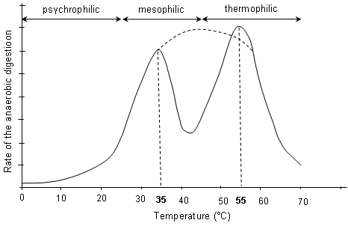
Figure 2.2 Influence of temperature on the rate of anaerobic digestion process. Optimum temperature for mesophilic around 30 – 40 °C and for thermophilic 50 – 60 °C
(Source: Mata-Alvarez, 2002)
Mesophilic bacteria are supposed to be more robust and can tolerate greater changes in the environmental parameters, including temperature. Smaller digesters, poorly insulated digesters, or digesters in cold climates are susceptible for extreme temperature fluctuations thus these would be beneficial if the digester is being run in the mesophilic range to minimize system crashing. Although it requires longer retention time, the stability of the mesophilic process makes it more popular in current anaerobic digestion facilities (Zaher et al., 2007).
Thermophilic process offers faster kinetics, higher methane production rates and pathogen removal. This method, however, is more sensitive to toxic substances and changes of operation parameters (Mata-Alvarez, 2002). A study comparing the performance of thermophilic and mesophilic treating mechanically sorted municipal solid waste (Cecchi et al., 1991) found that thermophilic process yielded 100 % more methane production and better volatile solids elimination compared to mesophilic process. However, thermophilic process is sometimes considered as less attractive from the energy point of view since it requires more energy for heating (Zaher et al., 2007).
The most common method for maintaining the temperature in anaerobic digester is an external heat exchanger. This method has the benefit of enabling to mix recirculating digestate with raw slurry before heating, and in seeding the raw slurry with anaerobic micro-organisms. Among three types of external heat exchangers frequently used (i.e. water bath, tubular and spiral exchangers), both tubular and spiral exchangers are mostly preferred for their countercurrent flow design and heat transfer coefficients. The hot water used in the heat exchangers is commonly produced in a boiler fueled by biogas that comes from the digester. At the start-up and/or under conditions of insufficient biogas production, an alternative fuel source such as natural gas must be provided (Appels et al., 2008).
2.2.3 Substrate characteristics
The characteristics of solid wastes determine the successful anaerobic digestion process (e.g. high biogas production potential and degradability). In municipal waste, substrate characteristics may vary due to the method of collection, weather season, cultural habits of the community etc. Substrate characteristics such as its composition, C/N ratio and particle size will be briefly discussed in this sub-chapter.
The degradability and biogas production potential from solid waste in an anaerobic digester are dependent on the amount of the main components: lipids, proteins, carbohydrates such as cellulose and hemicelluloses as well as lignin (Hartmann and Ahring, 2006). Among them lipids are the most significant substances in the anaerobic digestion, since the methane yield from lipids is higher than from most other organic materials. The theoretical gas yield of glyceride trioleate is, for example, 1.4 m³ per kilogram of oil with a methane content of 70%. Although organic waste with a high content of lipids is an attractive substrate for biogas production, Neves et al. (2008) reported that the lowest hydrolysis rate constants were obtained in the assays fed with kitchen waste that contained an excess of lipids. This was presumably due to a synergetic effect on the degradation of the other components since lipids adsorb onto solid surfaces and may delay the hydrolysis process by reducing the accessibility of enzyme attack. Lignocellulosic (cellulose and hemicelluloses which are tightly bound to the lignin) waste can be found in abundant amount in the form of garden waste, paper residue or agricultural waste. Due to the presence of lignin, lignocellulosic waste is considered to be quite resistant to anaerobic digestion and hydrolysis is the rate limiting step in the overall process. In order to improve the rate of enzyme hydrolysis and increase yields of fermentable sugars from cellulose or hemicellulose in lignocellulosic waste, several pretreatment methods such as thermal (steam or hot water), chemical (acid, lime or ammonia addition) or combination of both methods were proposed by several researchers.
2.2.4 Hydraulic retention time and organic loading rate
The hydraulic retention time (HRT) is a measure to describe the average time that a certain substrate resides in a digester. In a digester with continuous mixing, the contents of the reactor have a relative uniform retention time. In this system, the minimum HRT is dictated by the growth rate of the slowest growing, essential microorganisms of the anaerobic bacterial community. If the HRT is shorter, the system will fail due to washout of the slowest growing microorganisms that are necessary for the anaerobic process (Zaher et al., 2007). Shortening the HRT consequently reduces the size of the digester, resulting in capital cost savings. Furthermore, a shorter HRT yields a higher biogas production rate, but less efficient degradation of organic matter (as volatile solids or COD), associated with less process stability must be anticipated.
The organic loading rate (OLR) is defined as the amount of organic matter (expressed as volatile solids or COD of the feeding substrate) that must be treated by a certain volume of anaerobic digester in a certain period of time. The value of the OLR is mostly coupled with the HRT value. If the concentration of organic matter in the feedstock substrates is relatively constant, the shorter the HRT the higher value of OLR will be achieved. On the other hand, the value of the OLR will vary at the same HRT if there is a variation of organic matter concentration in the feeding substrate. The potential danger of a rapid increase in the OLR would be that the hydrolysis and acidogenic bacteria would produce intermediary products rapidly. Since the multiplication time of methanogenic bacteria is slower, they would not be able to consume the fatty acids at the same rate. The accumulation of fatty acids will lead to a pH drop and hampering the activity methanogenic bacteria, causing a system failure.
2.2.5 Mixing condition
Although there were several contradictions, researchers agreed that mixing plays an important role in anaerobic digestion of waste. Mixing provides an adequate contact between the incoming fresh substrate and the viable bacterial population and also prevents the thermal stratification and the formation of a surface crust/scum buildup in an anaerobic reactor. Furthermore, mixing ensures that solids remain in suspension avoiding the formation of dead zones by sedimentation of sand or heavy solid particles. Mixing also enables the particle size reduction as digestion progresses and the release of produced biogas from the digester contents.
2.2.6 Inhibitory substances
Inhibition in anaerobic digestion process by the presence of toxic substances can occur to varying degrees, causing upset of biogas production and organic removal or even digester failure (Stronach et al., 1986). These kinds of substances can be found as components of the feeding substrate (biogenic solid waste) or as byproducts of the metabolic activities of bacteria consortium in the digester. Previous publications on anaerobic digestion show a wide variation in the inhibition/toxicity levels for most substances. The main reason for these variations is the significant influence by microbiological mechanisms such as acclimation, antagonism, and synergism (Chen et al., 2008). Acclimation is the ability of microorganism to rearrange their metabolic resources to overcome the metabolic block produced by the inhibitory or toxic substances when the concentrations of these substances are slowly increased within the environment. Antagonism is defined as a reduction of the toxic effect of one substance by the presence of another, whereas synergism is an increase in the toxic effect of one substance by the presence of another. Several substances with inhibitory/toxic potential to anaerobic digestion, such as ammonia, sulfide, light metal ions, heavy metals and organic substances, will be briefly presented in this sub-chapter.
Ammonia. Ammonia is a hydrolysis product formed during anaerobic digestion of solid waste by degradation of nitrogenous matter in the form of proteins, phospholipids, nitrogenous lipids and nucleic acid (Kayhanian, 1999; Sung and Liu, 2003). The inhibition mechanisms of ammonia are presumably due to the change of intracellular pH, the increase of maintenance energy requirement to overcome the toxic conditions, and inhibition of specific enzyme reactions (Whittmann et al., 1995). In a solution, ammonium exists in the form of ammonium ion and free ammonia. Free ammonia is reported to have a more pronounced inhibition effect since it is freely membrane-permeable and may diffuse passively into the cell, causing proton imbalance and/or potassium deficiency (Eldem et al., 2004; Gallert et al., 1998).
Sulfide. The formation of hydrogen sulfide in anaerobic digestion is the result of the reduction of oxidized sulfur compounds and of the dissimilation of sulfur-containing amino acids such as cysteine by sulfate reducing bacteria. The reduction is performed by two major groups of SRB including incomplete oxidizers, which oxidize compounds such as lactate to acetate and CO₂ and complete oxidizers (acetoclastic SRB), which completely convert acetate to CO₂ and HCO₃⁻. Both groups utilize hydrogen for sulfate reduction (Hilton and Oleszkiewicz, 1988). Inhibition caused by sulfate reduction can be differentiated into two stages. Primary inhibition is indicated by lower methane production due to competition of SRB and methanogenic bacteria to obtain common organic and inorganic substrates. Secondary inhibition results from the toxicity of sulfide to various anaerobic bacteria groups (Chen et al., 2008).
Light metal ions. The light metal ions including sodium, potassium, calcium, and magnesium are commonly present in the digestate of anaerobic reactors. They may be produced by the degradation of organic matter in the feeding substrate or by chemicals addition for pH adjustment. Moderate concentrations of these ions are needed to stimulate microbial growth, however excessive amounts will slow down growth, and even higher concentrations can cause severe inhibition or toxicity. Salt toxicity is primarily associated with bacterial cells dehydration due to osmotic pressure (Chen et al., 1999). Although the cations of salts in solution must always be associated with the anions, the toxic action of salts was found to be predominantly determined by the cation. The role of the anions was relatively minor and largely associated with their effect on properties such as the pH of the media. If compared on a molar concentration basis, monovalent cations, such as sodium and potassium, were less toxic than the divalent cations, such as calcium and magnesium (McCarty and McKinney, 1961).
Heavy metals. Similar with light metal ions, the presence of heavy metals in trace concentration will stimulate the growth of anaerobic digester’s flora. However, unlike other toxic substances, heavy metals are not biodegradable and can accumulate to potentially toxic concentrations. An extensive study on the performance of anaerobic reactors found that heavy metal toxicity is one of the major causes of anaerobic digester upset or failure (Swanwick et al., 1969 in Chen et al., 2008). The toxic effect of heavy metals is attributed to their ability to inactivate a wide range of enzyme function and structures by binding of the metals with thiol (sulfhydryl) and other groups on protein molecules or by replacing naturally occurring metals in prosthetic groups of enzymes (Sanchez et al., 1996; Chen et al., 2008). The toxicity of heavy metals in anaerobic digestion depends upon the various chemical forms which the metals may assume under anaerobic conditions at the temperature and pH value in the digester. For instance, heavy metals in the precipitated form have little toxic effect on the biological system (Angelidaki and Westermann, 1983).
Organic substances. Many organic compounds were reported to have a inhibitory potential to anaerobic digestion processes. The accumulation of hydrophobic organic pollutants in bacterial membranes causes the membrane to swell and leak, disrupting ion gradients and eventually causing the breaking of cellular membranes (Heipieper et al., 1994; Sikkema et al., 1994 in Chen et al., 2008). The toxicity concentration of organic compounds ranges vary widely and is affected by many parameters, including toxicant concentration, biomass concentration, toxicant exposure time, cell age, feeding pattern, acclimation and temperature (Yang and Speece, 1986). Several important organic substances which are inhibitory to anaerobic digestion are: chlorophenols, halogenated aliphatic, nitrogen-substituted aromatic, long-chain fatty acids and lignins/lignin related compounds.
Several strategies to minimize the effect of inhibitory substances can be summarized as follows (Angelidaki and Ahring, 1993; Wittmann et al., 1995; Kayhanian, 1999; Bashir and Matin, 2004; Angelidaki et al., 2006; Zaher et al., 2007):
- Removal of potential inhibitory/toxic substances from the feeding substrate.
- Dilution of the feeding substrate in order to reduce the concentration of inhibitory substances below the threshold.
- Addition of chemicals to precipitate or insolubilize the inhibitory substances.
- Change of the chemical form of inhibitory substances through pH control.
Addition of material that is antagonistic to the inhibitory substances in order to counteract the inhibitory effect.
2.3 Types of Anaerobic Reactors
Typically anaerobic reactors or processes can be distinguished into several types, mostly according to the feeding mode (continuous mode: single stage, two stages and batch mode) and the moisture content of the substrate (wet or dry digestion). Furthermore with those basic types, the anaerobic reactors can be arranged according to the digestion process temperature (mesophilic or thermophilic) and the shape of the reactors (vertical or horizontal).
2.3.1 Wet and dry anaerobic digestion
Anaerobic digestion processes can be termed as “wet” and “dry” digestions depending on the total solids concentration of the feed substrate. Anaerobic digestion is defined as a wet process if the total solids concentration of the substrate is less than 15% and as a dry process if the concentration reaches 20 – 40% (Lissens et al., 2001).
In wet digestion processes, the substrate has to be conditioned to the appropriate solids concentration by adding process water either by recirculation of the liquid effluent fraction, or by co-digestion with a more liquid waste. The latter is an attractive method to combine several waste streams like sewage sludge or manure. Reactors used in wet digestion processes generally are referred to as continuous stirred tank reactors (CSTR), with application of mechanical mixers or a combination of mechanical mixing and biogas injection. The application of a wet digestion process offers several advantages such as dilution of inhibitory substances by process water and requirement of less sophisticated mechanical equipments. However, disadvantages, such as complicated pre-treatment, high consumption of water and energy for heating and the reduction of working volume due to sedimentation of inert materials have to be taken into account (Vandevivere et al., 2002).
The reactors used in dry anaerobic digestion processes generally do not apply mechanical mixers and may use biogas injection to perform mixing of the digester content (Luning et al., 2003). However, using this technique, complete mixing of the digestate is almost impossible; thus, the ideal contact of microorganisms and substrate cannot be guaranteed. As a consequence, individual processes may run in different parts of the reactor, which limits an optimal co-operation of the microbial groups involved in the digestion process (Hartmann and Ahring, 2006). Thus, the digesters used in dry anaerobic digestion can be considered as plug flow reactors (Luning et al., 2003). Dry anaerobic digestion offers less complicated pre-treatments and higher loading rate (10 kg VS· m⁻³ ·d⁻¹ or more). However, the systems require more sophisticated mechanical equipments (Lissens et al., 2001) and less possibility to dilute the inhibitory substances (Vandevivere et al., 2002).
2.3.2 Batch and continuous feeding systems
Two feeding modes are generally used in anaerobic digestion of waste: the batch system and the continuous system. In the batch system, digesters are filled once with fresh feedstock, with or without addition of inocula, and sealed for the complete retention time, after which it is opened and the effluent removed. In the continuous system, fresh feedstock continuously enters the digester and an equal amount of digested material is removed.
As has been discussed previously, the anaerobic digestion of organic wastes is accomplished by a series of biochemical processes. These processes can be separated into two main stages: the first stage where hydrolysis, acidification and liquefaction take place and the second stage where acetate, hydrogen and carbon dioxide are converted into methane. Concerning these processes, the continuous system can be further divided to one-stage and two/multi-stage system. (Lissens et al., 2001; Vandevivere et al., 2002).
In one-stage systems, all biochemical processes take place simultaneously in a single reactor. The major drawback of single-stage digester systems is that these processes are required to proceed under the same operating conditions despite differences in growth rates and optimal pH of the microbial groups involved in each step. This is the reason why single-stage systems are more easily to upset compared to multi-stage systems. This disadvantage is substantial especially in the case of substrates where degradation is limited by methanogenesis rather than by hydrolysis, e.g. cellulose-poor kitchen wastes. These wastes, being very rapidly acidified, tend to inhibit the methanogenesis when the feedstock is not adequately mixed, buffered and dosed (Vandevivere et al., 2002; Gerardi, 2003).
The concept of two/multi-stages systems offers optimization of the digestion conditions by providing separate reactors for each step. The conditions in the first reactor are adjusted to favor the growth of organisms that are capable of breaking down biopolymers and releasing fatty acids (hydrolysis/acidification). The product of the first reactor is then passed to the second reactor, where methanogenesis occurs. The potential drawback of two/multi-stages systems is the decrease of biogas yield due to solid particles removal from the feedstock to the second stage (Vandevivere et al., 2002).
2.3.3 Commercial processes of anaerobic digestion of biogenic solid waste
Stimulated by the increasing demand of anaerobic digester for biogenic solid wastes, several commercial anaerobic digester plant designs have been developed over the past two decades. Especially in European countries, there are many different processes available on the market. The processes are patented according to several basic characteristics as previously discussed (batch or continuous feeding, number of stages, total solids content of waste and operating temperature). Mixing methods (gas injection or mechanical stirrers), reactor type (vertical or horizontal, rectangular or cylindrical) and process flow (completely mixed or plug-flow) are also parameters to obtain patent rights. Figure 2.3 presents the available anaerobic digestion technology for solid waste treatment especially in the European market.

Anaerobic digestion of solid waste
One-stage continuous process
Multi-stage continuous process
Batch process
Wet digestion
Dry digestion
Wet digestion
Dry digestion

Wet digestion
Dry digestion

Substrate input mode
Solids content of substrate
- Waasa/Vagron
- BTA-single stage
- Dranco
- Valorga
- Kompogas
- Schwarting-Uhde
- BTA-two stages
- Linde-BRV
Not available
- Biocel
Examples of technology/method available

Figure 2.3 Various anaerobic digestion methods available in the market

Digestate recirculation
Digestate effluent
Fresh wastes
Biogas
Biogas
Fresh wastes
1st stage (mesophilic)
2nd stage (thermophilic)
Sediment
Effluent
Fresh wastes
Biogas
Process water
Effluent
Dewatering
Leachate recirculation
Biogas
Fresh wastes
Effluent

Biogas
Biogas recirculation
(A)
(B)
(C)
(D)
(F)
(E)
Biogas
Fresh wastes
Effluent

Figure 2.4 Simplified diagram of different designs of anaerobic digesters. (A) BIOCEL, (B) KOMPOGAS, (C) Valorga, (D) Schwarting-Uhde, (E) DRANCO and (F) Linde-BRV.
Several patented processes have been successfully proven their reliable performance in full-scale plants. More detailed concepts of processes namely BIOCEL (batch system), DRANCO, Valorga, KOMPOGAS (one-stage dry system), Waasa, BTA (one-stage wet system), Schwarting-Uhde (two-stage wet system) and Linde-BRV (two stage dry system) are briefly presented in this sub-chapter.
BIOCEL. The system is based on a batch-wise dry anaerobic digestion. The total solids concentration of biogenic solid wastes as feeding substrate is maintained at 30–40% dry matter (w/w). The process is accomplished in several rectangular concrete digesters at mesophilic temperature. The floors of the digesters are perforated and equipped with a chamber below for leachate collection. Prior to feeding, fresh biowaste substrate and inocula (digestate from previous feeding) are mixed then loaded to the digester by shovels. After the loading is finished, the digesters are closed with air tight doors. In order to control the odor emission; the system is housed in a closed building that is kept at a slight under-pressure. The temperature is controlled at 35–40ºC by spraying leachate, which is pre-heated by a heat exchanger, from nozzles on top of the digesters. Typical retention time in this process is reported to be 15 – 21 days (ten Brummeler, 2000). A full-scale BIOCEL plant is reported to have successfully treated vegetable, garden and fruit wastes with the capacity of 35,000 tons/year. Approximately 310 kg of high-quality compost, 455 kg of water, 100 kg of sand, 90 kg of biogas with an average methane content of 58% and 45 kg of inert waste are produced from each ton of waste processed (CADDET, 2000).
DRANCO. The DRANCO (dry anaerobic composting) process employs a one-stage anaerobic digestion system, which is followed by a short aerobic maturation phase. Although mostly operated under thermophilic temperature (reportedly to be 50-55 °C), mesophilic operation (35-40 °C) can also be applied for specific waste streams (de Baere, 2008). The DRANCO process is typically a vertical plug-flow reactor. The digester is fed from the top of the reactor and the digested slurry is removed from the bottom at the same time. Usually one part of the digested slurry is used as inoculum and mixed with six to eight part of fresh substrate. A small amount of steam is introduced to the mixture in order to maintain the temperature. The pre-heated mixture is then pumped to the top of the reactor through feeding tubes. There are no mixing devices needed in the reactor other than the natural downward movement of the waste caused by fresh feeding and digestate withdrawal (Vandevivere et al., 2002; Edelmann and Engeli, 2005; de Baere, 2008). The rest of the digested slurry is dewatered and the solid residue from the process is then stabilized and sanitized aerobically during a period of approximately two weeks. The DRANCO process is considered to be effective for treatment of solid wastes with 20-50 % TS. The typical retention time is 15 to 30 days, and the biogas yield ranges between 100 and 200 m3/ton of input waste (Nichols, 2004).
Valorga. The Valorga system is a one-stage dry anaerobic digestion process which uses a vertical cylindrical reactor which can be operated at both, mesophilic and thermophilic temperature. In order to obtain a horizontal plug-flow process, the digester is equipped with a vertical median partition wall on approximately 2/3 of their diameter. The biowaste substrate is fed through a port placed on one side of the partition wall and the digestate withdrawal port is placed on the other side. The vertical mixing is performed by internally recirculated high-pressure biogas injection every 15 minutes. The pre-treatments prior to feeding include: dry ballistic separation to remove the heavy fraction and other contaminants, crushing of biowaste to obtain particle size < 80 mm, adjustment of solids content to 25 -32 % by mixing with process water, and pre-heating by steam injection (Fruteau de Laclos et al., 1997; Karagiannidis and Perkoulidis, 2009). The retention time of this system is typically 18 – 25 days at mesophilic temperatures with a biogas yield of 80 to 160 m3/ton of feedstock, depending on the type of solid waste (Nichols, 2004). One technical drawback of the system design is that gas injection ports are easily clogged when treating relative wet (< 20 % TS) feed stock (Vandevivere et al., 2002). Edelmann and Engeli (2005) reported that the operation of a thermophilic Valorga digester in Switzerland was stopped for a relatively long time because of large quantities of sediments (sand, gravel etc.) in the base of the digester, hampering the function of the mixing equipment and reducing the active volume of the digester significantly.
KOMPOGAS. The KOMPOGAS system is a one-stage dry anaerobic digestion process. The fermentation process takes place in a horizontal plug-flow reactor at thermophilic temperature (typically 55-60 °C). The reactor is equipped by slowly rotating and intermittently acting impellers to ensure mixing and help the re-suspension of heavier materials. Prior to feeding, the solid waste is mechanical pre-treated in order to remove the impurities and reduce the size of the substrate (KOMPOGAS, 2007). A total solids content adjustment by addition of process water is done to have a TS concentration to around 23 to 28 %. If the TS values are lower than this range, heavy particles such as sand and glass tend to sink and accumulate inside the reactor while higher values can cause excessive resistance to the flow (Chavez-Vazquez and Bagley, 2002). The retention time of the system ranged from 15 – 20 days. Due to mechanical constraints, the volume of the KOMPOGAS reactor is limited. If the solid waste generation is relatively high, the capacity of the plant can be facilitated by installing several reactors in parallel, each with a capacity of either 15,000 or 25,000 tons/year (Nichols, 2004). The KOMPOGAS system is reported to run very stable, however, it has to be stressed that it is important to feed an appropriate mixture of wastes. A KOMPOGAS plant which was run exclusively with protein-rich food wastes first experienced an inhibition due to high ammonia concentrations (Edelmann and Engeli, 2005). Nishio and Nakashimada (2007) reported that three types of waste (i.e., garbage and rejects from hotels, yard waste, and old paper) were mixed at various ratios to control the C/N ratio before feeding to the KOMPOGAS plant. The plant ran at stable operation for at least two years and generated biogas at a rate of about 820 m3/ton of VS.
Waasa. The Waasa process is a wet, one-stage anaerobic digestion system and is operated at both, mesophilic and termophilic temperatures. This completely mixed process is maintained in a vertical reactor which is subdivided internally to create a pre-digestion chamber by which the possibility of short-circuiting should be prevented. A relatively complex pre-treatment including mechanical sorting and waste washing has to be done prior to feeding. The sorting facility produces by-products such as relatively high-calorie RDF (Refuse-Derived Fuel) stream, ferrous/non-ferrous metal fractions, paper and plastic fraction. The washing process comprises a wet separation process that removes coarse inert materials and sand from the organic fraction. Process water is added to fresh substrate to the desired concentration of total solids (10-15% TS). The slurry is mixed with small amount of inocula, pre-heated with steam injection and pumped to the pre-chamber which is operated in a plug-flow mode with retention times of one or two days before digestion in the main reactor. The mixing in the digester is performed by mechanical impellers and injection of a portion of the biogas into the bottom of the digester tank (Williams et al., 2003). Nichols (2004) reported a full-scale Waasa process plant which was run at both temperatures parallelly. The thermophilic process required a retention time of 10 days compared to 20 days in the mesophilic process. A modified Waasa process (Vagron) treating the mechanically separated organic fraction of municipal solid waste in Groningen, the Netherlands was reported to reach a stable operation at an OLR of 7.7 kg VS ·m-3 ·d-1 (Luning et al., 2003). The biogas production was reported within the range of 100-150 m3/ton of feedstock with 20-30% internal biogas consumption for the pre-heating of the feeding substrate. The volume reduction reached approximately 60%, and the weight reduction was about 50-60% (Williams et al., 2003).
BTA. The BTA process consists of two major steps: the hydro-mechanical pre-treatment and the anaerobic digestion processes. During the hydro-mechanical pre-treatment the solids are diluted in hydropulpers with recirculated process water in order to obtain a maximum solids content of 10%. The light impurities like plastics, foils, textiles, wood etc as well as heavy impurities like stone, batteries, metals etc are removed by means of a rake and a heavy fraction trap. This process results in a thick, pumpable suspension that is fed to the digester. The grit removal system can be optionally added in order to separate the remaining finest matter like sand, little stones and glass splinters. Although commonly applied as single-stage system, BTA also offers a multi-stages system depending on the size of the plant. Single-stage systems are mainly for relatively small, decentralized waste management units whereas multi-stages systems are mainly for plants with capacities of more than 50,000 tons/year. The temperature in BTA process is maintained in the mesophilic range, normally at 35 °C and the digester is considered as a completely mixed reactor. Mixing is performed by biogas injection. The digestion residue is dewatered by a decanter centrifuge and generally sent to aerobic post-treatment. The water demand of the process is met by recirculating the process water. Depending upon the waste composition and local requirements, excess process water is sent to the sewage system, or will be additionally treated on-site before it can be discharged. The generated biogas can be recovered for use in gas engines or co-heat and power (CHP) stations. Depending on the waste composition, the gas yield ranges between 80 and 120 m3/ton of biowaste (Kübler et al., 2000; Chavez-Vazquez and Bagley, 2002; Nichols, 2004; Haines, 2008).
Schwarting-Uhde. The Schwarting-Uhde process adopts a two-stage wet anaerobic digestion process which is performed in a series of two vertical plug-flow reactors. The first reactor is operated at mesophilic temperature for hydrolysis and acidification processes while the second reactor is operated at thermophilic temperature for methanogenesis. The source-sorted biowaste is shredded to reduce the particle size and diluted to a TS concentration of around 12 %. The slurry is pre-heated to the intended temperature by heat exchangers and then pumped through a series of perforated plates placed within the reactor, which is employed to ensure the uniformity of upward movement and to maintain plug-flow conditions. Mechanical stirrers are not needed in for mixing purposes. An adequate mixing is obtained by raising and lowering the column of liquid in the tank, thus creating turbulence at the perforated plates via time-controlled impulse pumps. The retention time in both reactors is about 5 to 6 days making an overall retention time of 10 to 12 days. Biogas is collected at the top of the digesters, whereas settled heavy solids, which accumulate at the bottom of the reactors, are frequently removed via screw pumps. This process design offers an advantage in decreasing the potential formation of a thick floating scum layer which is commonly plaguing wet anaerobic digestion. However, due to the high risk of perforated plates clogging, the Schwarting-Uhde process is only suitable to treat relatively clean highly biodegradable biowastes (Lissens, et al., 2001; Vandevivere et al., 2002). A full-scale Schwarting–Uhde plant was reported to have stable operation at an OLR of up to 6 kg VS·m-3 ·d-1 (Thrösch and Niemann, 1999 in Trzcinski and Stuckey, 2009). A successful solids elimination of 55 – 60 % was reported to be achieved by a Schwarting-Uhde plant treating sludge from a wastewater treatment plant (EC, 1995).
Linde-BRV. The Linde-BRV process can be considered as two-stage dry anaerobic digestion. After pre-treatment to reduce the particle size and to remove impurities, the solids concentration of source-separated biowastes is adjusted to 34 %. The slurry is then pre-digested in an aerobic upstream stage where the organic materials are partially hydrolyzed (Vandevivere et al., 2002). After 2 days of retention time, the pre-digested slurry is pumped to a rectangular shaped concrete digester in horizontal plug-flow mode. The mixing is accomplished by several agitators of transverse paddles. The horizontal plug-flow movement is ensured by a walking floor installed on the bottom of the reactor which also functions to transport the sediments to the digester’s discharging end (Nichols, 2004; Zaher et al., 2007). The process is commonly kept at thermophilic temperature although modification to mesophilic is also possible. Some of the heating is done outside the digester with a short heat exchanger, but primarily heating occurs within the digester walls using a heat exchanger.

2.4 Process improvement and current state
Although it is quite difficult to compare due to experimental set-ups and/or materials, in the last 10 years, anaerobic digestion of solid waste has been gaining more attention from scientists and industrialists. Many researches and reports have been conducted regarding almost every aspect of anaerobic digestion of solid waste which are useful for process improvement or to actualize a more robust reactor design. Some authors focused on the kinetics of anaerobic biodegradation of complex waste such as OFMSW which is considered as a key issue for the understanding of the process and for the design of treatment units. Mata-Alvarez et al. (2000), for instance, compiled the first order kinetic constant values for hydrolysis (which is considered as rate limiting step in anaerobic digestion of solid waste) of different materials. Other papers (refer to sub-chapter 2.2 and 2.3) reported the performance of different reactor configurations (one-stage or multi-stage, dry or wet) and effects of inhibition substances, as well as effects of basic parameters such as pH, temperature, mixing, etc. This sub-chapter will briefly discuss some aspects which have not been discussed previously namely: pre-treatment for process enhancement, co-digestion OFMSW with other types of waste, and current state application of anaerobic digestion of solid waste technologies.
2.4.1 Pre-treatments for process enhancement
Due to the substrate characteristics, hydrolysis is considered as the rate limiting step in anaerobic digestion of OFMSW. Therefore, many researches were focused on the process in order to improve degradation rates and biogas yields. According to several reports, hydrolysis improvement can be achieved through proper pre-treatments which have obvious links to the increase of biogas yields. Pre-treatment methods for OFMSW can be biological, mechanical or physico-chemical (Delgenès et al., 2003).
Biological pre-treatment can be achieved by the means of for example aerobic pre-composting methods which show positive improvement of methane yields and solids reduction (Capela et al., 1999 in Mata-Alvarez et al., 2000). Miah et al. (2005) reported that addition of aerobic thermophilic sludge improves the biogas production and solids reduction, presumably that thermophilic aerobic bacteria secrete external enzymes which dissolve particulate organic matters more actively.
Mechanical pre-treatment is commonly aimed to reduce particle size. Comminution to reduce the size of waste particles provides several advantages including the increase of dissolved compounds due to cell rupture, exposition of surface areas which were previously inaccessible for microbial degradation and alteration of the sample structure such as the lignocelluloses arrangements (Palmowski and Müller, 2003).
Chemical pre-treatment can be accomplished by alkaline pre-treatment. The chemical treatment of the fibres with NaOH, NH₄OH or a combination led to an increased methane potential (Mata-Alvarez et al., 2000). The same improvement was also reported when a pre-treatment by addition of lime was done (López-Torres and Espinosa- Lloréns, 2008).
2.4.2 Co-digestion of OFMSW with other types of waste
Co-digestion of OFMSW with other types of waste is an interesting alternative to improve biogas production, to obtain a more stable process and to achieve a better handling of waste. However, some possible disadvantages (e.g transport costs of co-substrate, additional pre-treatment facilities and the problems arising from the harmonization of the waste generators) have to be taken into account (Mata-Alvarez et al., 2003). The key factor of successful co-digestion is that the balance of macro and micro nutrients can be assured by co-substrate.
A good co-substrate should fulfil several requirements, such as: i) its concentration of organic substances should be comparable with biowaste, so that addition will not significantly affect the hydraulic retention time, ii) it should consist of easily degradable organics with a high biogas production potential, iii) it may not contain any dangerous or poisonous substances, which hinder anaerobic digestion or composting, vi) it should have a content of macro and micro nutrients which have possibility to improve the characteristics of main substrate, vii) it must be available in sufficient quantities at a reasonable price and should be storable and viii) it should be pumpable without danger of clogging, thus allowing safe automatic feeding.
Various types of solid waste streams such as sewage sludge, animal manure and organic industrial waste have been proposed as co-substrate for anaerobic digestion of OFMSW. Reports on co-digestion of the organic fraction of municipal solid waste with any other waste streams, such as energy crops (Nordberg and Edström, 2005), market residues (Gallert et al., 2003), sewage sludge (Hartmann et al., 2003) and manure (Hartmann and Ahring, 2005) are existing. Sewage sludge is available in abundant quantity in line with the presence of wastewater treatment plants. Co-digestion with sewage sludge will improve the characteristics of OFMSW including its content of micro and macro nutrients, lead to a better C:N ratio and facilitate the adjustment of moisture content. The optimal mixture of OFMSW and sewage sludge depends on the specific waste characteristics and the system used in the digestion process. For wet anaerobic digestion, the best performance (in term of biogas production and VS reduction) can be achieved when the mixture of OFMSW and sewage sludge is within the range of 80:20 on TS basis or 25:75 on volume basis (Hartmann et al., 2003).
It has been discussed previously that animal manure has being used as a substrate for anaerobic digestion since more than 2000 years ago. The advantages of using animal manure as co-substrate in anaerobic digestion of OFMSW are: its abundant availability and its high buffer capacity mainly due to its ammonia content. Furthermore, animal manure has low TS content which can be used to adjust the moisture of OFMSW and wide variety of nutrients which are necessary for optimal bacterial growth. Macias-Corral et al. (2008) reported that co-digestion of OFMSW and cow manure resulted in higher methane gas yields and promoted synergistic effects resulting in higher mass conversion and lower weight and volume of digested waste.
Full-scale applications of solid waste co-digestion have been reported by several authors. Angelidaki and Ellegaard (2003) reported that in 2001, Denmark had already 22 large-scale centralized biogas plants operated under co-digestion mode and treating mainly manure together with other organic waste such as industrial organic wastes, source sorted household waste, and sewage sludge. Positive results including the increase of energy production and degradation efficiency from a full-scale co-digestion of sewage sludge and OFMSW in Velenje, Slovenia were also reported (Zupančič et al., 2008). Despite the positive results from laboratory experiments and/or full-scale experience, in Europe co-digestion is less applied than it was expected. It is quite common that an organic solid co-substrate is added to manure digesters in small amounts, but often these co-substrates are high-energy yielding industrial sludge and only quite exceptionally, solid waste from households or market waste is added. Among the biogas plants identified, only about 9.7 % of the organic solid waste treated was done by means of co-digestion, mostly with liquid manure. The percentage of installed co-digestion plants has dropped from 23% in the period 1990–1995 to 5% in the period 2006–2010. However, due to the high prices for agricultural crops, many energy crop digestion plants are looking for organic waste feedstock (de Baere, 2008).
2.4.3 Economical aspects and current state application
In industrial terms, anaerobic digestion of solid waste can be considered as a mature technology. A wide range of technologies and researches are available together with holistic methods of decision support system. Many comparison or feasibility studies were carried out in order to define the optimum strategy of municipal solid waste management.
Murphy and McKeogh (2004) conducted a study comparing four technologies which produce energy from municipal solid waste (MSW): incineration, gasification, generation of biogas and utilization in a combined heat and power (CHP) plant, generation of biogas and conversion to transport fuel. The authors concluded that biogas technologies require significantly less investment costs than the thermal conversion technologies (incineration and gasification) and also have smaller gate fees. However, for biogas conversion to transport fuel, a shortcoming of only 50 % of biogas produced available for CH₄ enrichment has to be taken into account. In term of operating parameters, Hartmann and Ahring (2006) performed an extended cost-benefit calculation of the anaerobic digestion of OFMSW and found that the highest benefit can be achieved in an operation with lower OLR and longer HRT rather than when only the biogas production rate is regarded.
De Baere (2008) reported that initially in 1990 there were only three anaerobic digestion plants in Europe (each treated more than 3,000 tons/year) with a total capacity of 87,000 tons/year. Since then, the capacity has greatly increased. However, the increase in additional digestion capacity was initially rapid but has leveled off during the past five years. Schu and Schu (2007) reported that many suppliers of anaerobic digestion technologies in the market over the last ten years are now insolvent or no longer active in anaerobic digestion because of the high-risk associated with digestion of waste. The current situation is that there will be 171 plants with a total installed capacity of 5,204,000 tons/year by the end of 2010 spread over 17 European countries (de Baere, 2008).

2.4 Contribution of this Research
There are many researches regarding anaerobic digestion for domestic organic waste already conducted and published. However, researches which focused on septic tank’s sludge (especially sludge from hospital’s septic tank) are very few. Therefore, this research will contribute to knowledge of using septic tank’s sludge as a substrate for anaerobic digester. This will initiate a wide application of sanitary technology which gives a room for resources recovery such as energy and fertilizer.
Moreover, although theoretically two/multi-stage systems have the advantage in the increase of both rate of conversion and extent of utilization of polymeric biomass material, the full-scale application is very moderate. The decision makers and industrialists prefer one-stage systems because they have simpler designs, suffer less frequent technical failures and have smaller investment costs. Therefore, the results of this research can be also used as a base for further improvement of anaerobic digestion in the frame of promoting sustainable technology for sanitation.
III. RESEARCH METHODOLOGY
3.1 Materials
3.1.1 Anaerobic digester
This research is based on experimental works conducted in a pilot plant at RSUD Wonosari, Gunung Kidul. In cooperation with KIT, Hans Huber AG Berching, Germany delivered a two-step anaerobic fully automated technology as a pilot plant in a container (6 x 2,5 m). The pilot plant consists of two reactors installed in series. The first reactor acts as a hydrolysis compartment while the other one acts as acidification and methanogenesis compartment. The total volume of the anaerobic reactor is approx. 1,000 liter with a capacity to treat sewage sludge up to 100 population equivalent.
3.1.2 Substrates
The main substrate of this research is sewage sludge from septic tank treating wastewater from hospital wards. The sewage sludge is pumped from the bottom of septic tank every one hour to the hydrolysis tank. After hydrolysis process is completed, the sewage sludge is then pumped to acidogenesis/methanogenesis tank.
In order to improve biogas production and optimize the operation of the reactor, the main substrate is co-digested with other types of waste with presumably have a lot of organic content. The first type of waste which is indicated to have high organic content and presumably suitable as co-substrate is waste collected from kitchen activities of the hospital. This type of waste has to be minced to have smaller size in order to accelerate the process of hydrolysis.
The second potential co-substrate is cow dung. The cow dung is collected from household-level cow farms which are easily found near the hospital. The neighborhood households of the hospital are commonly found to have 2-5 cows; therefore cow dung can be supplied with enough quantity. The application of cow dung has been observed by many researched to have improved biogas production due it its relatively complete nutrients, organic matters and enough methanogenic bacteria already present.
3.2 Design of the Experiment
Initially the reactor was fed with only sewage sludge from septic tank at HRT of 20 days and after reaching the steady-state, all of the sludge parameter (inlet and outlet) are measured. After that phase, cow dung with low quantity is fed to the reactor to examine the effect to the hydrolysis process and biogas production. The quantity of cow dung is gradually increased to examine the maximum organic loading rate can be handled by the reactor. The sewage sludge feeding was maintained at regular feeding assuming that the full-scale reactor treats relative constant amount of sewage sludge.
Together with cow dung, kitchen waste is also added to the reactor with the same procedure in order to utilize other stream of waste to produce biogas. Additional substrates such as cow dung or kitchen waste as co-substrates were added to the sewage sludge suspension before the feeding and mixed well. The increment of co-substrate was done when the performance of the reactor in each increment was considered to be in a steady state condition. The reactor was fed with the substrate mixture thrice a day at 09.00 a.m, 12.00 am and 16.00 p.m. The sequence of processes and sampling of the research can be depicted in Figure 3.1 for sole substrate digestion with sewage sludge and Figure 3.2 for multi-substrate digestion with cow dung and kitchen waste.
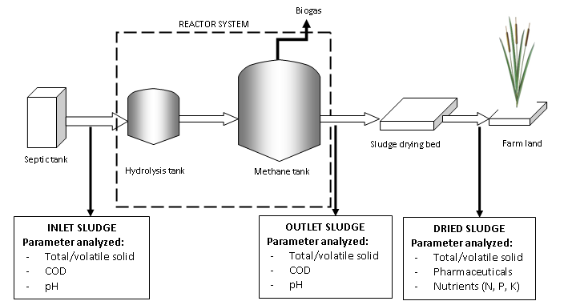
Figure 3.1 Sequence and sampling procedure for sole substrate digestion
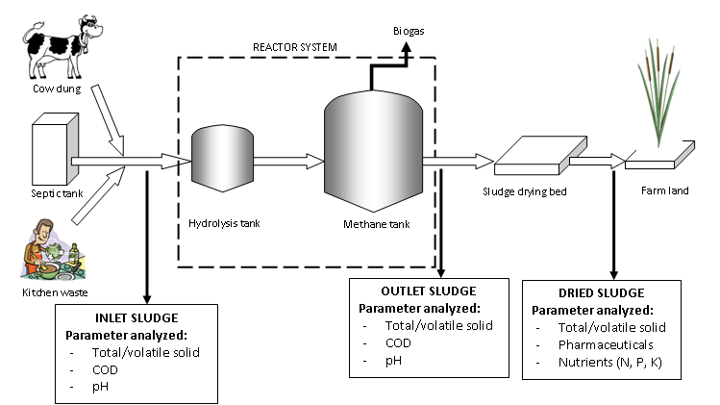
Figure 3.2 Sequence and sampling procedure for multi substrate digestion

3.3 Analytical methods
To characterize the wastes and evaluate the performance of the reactor, several parameters were measured and determined, namely: COD, TS, VS, biogas production, pH, nutrients content, and pharmaceuticals content. The German partner will do the analyses of nutrient and pharmaceutical content.
3.3.1 Chemical oxygen demand (COD)
The COD is a measure of the oxidizability of a substrate, expressed as the equivalent amount in oxygen of an oxidizing reagent consumed by a substrate. Organic matter was oxidized with potassium dichromate (K₂Cr₂O₇) in a mixture of sulphuric acid and phosphoric acid (H₂SO₄ + H₃PO₄). Possible method using KMnO₄ can also be applied to analyze this parameter.
3.3.2 Total solids and volatile solids
For determining the total solids (TS), samples with certain volume or weight were placed in ceramic vessels and dried in a drying oven at 105 ± 2 °C for 15 - 20 hours until constant weight. After cooling in the desiccators, the samples were weighed for TS measurement. The samples then oxidized at 550 °C for 2 hours for volatile solids (VS) determination. The volatile solids (VS) were determined by subtraction of the minerals content of the sludge sample (residual ash after oxidation) from the total solids content.

The calculation of TS and VS can be described as follows:

where, TS : total solids
dv_{s} : vessel + dried sample weight
dv_{e} : empty vessel weight
V_{s} : volume of sample
where, VS : volatile solids
dv_{s} : vessel + dried sample weight
dv_{s*} : vessel + ash weight
dv_{e} : empty vessel weight
V_{s} : volume of sample
3.3.3 Biogas production
Biogas production of the anaerobic reactor was measured daily using a water displacement method by a wet gas meter from Ritter Co which is supplied by German partner. This gas meter is installed on the top of the second reactor and can be read daily.
3.3.4 Ammonia nitrogen (NH₄-N) and total Kjeldahl nitrogen (TKN)
Ammonia was determined by using a method with preceding distillation. The distillation process was used to separate the ammonia from interfering substances. Ammonia in the sample was distilled into a solution of boric acid and determined titrimetrically with standard H₂SO₄ with a mixed indicator.
Total Kjeldahl Nitrogen (TKN) is used to determine the sum concentration of both organic nitrogen and ammonia nitrogen. The method involves a preliminary digestion to convert the organic nitrogen to ammonia, then distillation of the total ammonia into an acid absorbing solution and determination of the ammonia by titration method. The method employed sulphuric acid as the oxidizing agent.
3.3.5 pH value
The pH value of the reactor’s effluent or of batch experiment was determined electrochemically with an Ingold pH electrode. As the check reference, pH paper was also used to determine the pH value.
3.4 Capacity Building
The success of sanitation programmes depend critically on effective public awareness and mobilization through information, education and communication (Wegelin 2000). It is therefore important to understand how different communities and organizations function in different cultural and geographical settings before commencing an awareness program. Basic information about the target audience such as demographics, knowledge base, attitudes, beliefs and perceptions, communication channels and social data must be established.
The needs for capacity building are always changing. There are no ready solutions, and any programme must be appropriate for the local situation and organization (GDRC 2009). For instance, in a survey undertaken in the Kecamatan Wonosari, more than 50% of those interviewed did not consider wastewater infiltrating into the ground from their septic tanks as a potential groundwater contaminant (Mueller 2009).
To promote the most favourable solutions as well adopted program to create awareness and capacity hat to be developed and implemented in the region for different target group like local authorities, students and pupils as well as residents. In this research, the capacity building to increase awareness of the people toward the importance of sanitation to protect water sources was done through a workshop in Pucanganom Village in Ponjong, Gunung Kidul. During the workshop field experiment and observation are also done in order to have some specific parameters to decide which technology of sanitation is suitable for the village.

IV. RESULTS AND DISCUSSIONS

4.1 Wastewater Treatment Plant System in RSUD Wonosari
With a capacity of about 115 beds, RSUD Wonosari has about 351 staff, of which 160 are non-medic and 191 are medic staff (Gunung Kidul, 2008). In regard to sanitation, the hospital currently has a kind of central wastewater disposal system with a subsequent biological treatment plant. This wastewater treatment plant is however not in the good condition and operation. Most of the wastewater resulted from hospital’s activities which is treated in this plant is not treated in the wastewater plant and even the treated wastewater is not really sufficiently purified. This lack of treatment can be indicated by the high BOD and COD value of the treated wastewater which does not meet the criteria that has been issued by the government of Indonesia.
The hospital’s wastewater treatment diagram is shown in Fig. 4.1 as follow:

Septic tank’s supernatant treatment plant: aerobic system
Previously desludged every 1-2 years: untreated
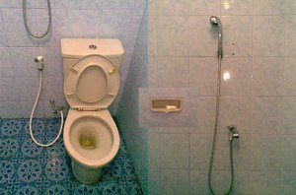

Fig. 4.1 The RSUD Wonosari wastewater treatment plant diagram

From the initial field study, it was known that most of the wastewater from hospital wards’ is treated in septic tanks. The septic tanks themselves are not properly designed and constructed, therefore the quality of the treated wastewater relatively under national standard. Besides, the treatment of wastewater using septic tank is normally producing quite high amount of sludge which is not yet stabilized. The sludge resulted from this process is commonly not properly disposed and causing several aesthetic and health problems.
The hospital tries to improve the quality of the effluent by installing an aerobic system wastewater treatment plant to treat the supernatant (effluent) of the septic tanks. Therefore, in this case, septic tanks are only a pre-treatment for the wastewater and later will be polished by the aerobic treatment plant. The sludge of septic tanks is previously desludged every 1-2 years and the discharge of the sludge was sometimes not known. Normal practice of sludge discharging in one that discharged directly to the river. Therefore, this kind of practice is not an environmental-friendly method.
In order to improve the current practice of septic tanks’ sludge diposal, a two-stage anaerobic digester was installed to treat this sludge. The german company Huber provided a pilot scale two-stage anaerobic digester to be tested in RSUD Wonosari. The capacity of the digester is about 1,000 liters (wet volume). The initial plan to have this pilot scale digester is to evaluate the possibility of using anaerobic methods to further treat sewage sludge from septic tanks in Gunung Gidul in particular and in Yogyakarta Special Region in general. After the experiments show a possitive results, an upscale plant will be installed to serve sewage sludge from at least Gunung Kidul, Bantul and the City of Yogyakarta.
The scheme and manual of the pilot plant from Huber is presented in Appendix 1.

4.2 Wastewater and Sludge Characteristics
Table 4.1 presents the main characteristics of the two substrates (i.e. wastewater from septic tanks’ supernatant and grey water and also septic tanks’ sludge) used in this study. Due to limitation of the equipment in our laboratory partners, some of the parameters are omitted from the study.
Table 4.1 The main characteristics of hospital wastewater and septic tanks’ sludge
No. | Parameter | Unit | Inlet of Wastewater Tr. (Septic tanks’ effluent) | Outlet of Sludge Tr. (Septic tanks’ sludge)
1. | COD | mg/l | 320 | -
2. | BOD | mg/l | 170,1 | -
3. | TSS | mg/l | 222 | -
4. | N Total | mg/l | 76,62 | 405
5. | Total Solid | mg/l | - | 996
6. | Mixed Liq. Vol. Susp. Sol. | mg/l | - | 716
The value(s) are an average from at least 4 measurement. The samples were taken at different time (daily/weekly)
From above table, it can be seen that the effluent of septic tanks still has quite high organic matters (as can be considered from high COD and BOD) and high solid content (TSS).
On the other hand, the septic tanks’ sludge has relatively low organic content (as can be seen from relatively low MLVSS. The sludge has only 996 mg/l total solids (less than 1 percent) which is considered as low when it is fed to an anaerobic digester because normally an anaerobic digester can treat 5%-25% total solids. This may be caused by the withdrawal of the sludge which is done very often (2-4 times a day).
Low content of solids (in the other word is low content of organic matters) is not optimum to operate an anaerobic digester. It will cause the slow start-up pahse and less biogas production due to less substrate delivered to the reactor. When this problem occurs, the operation of an anaerobic digester will not succesful as well. Therefore, for the next step, the reactor will also be fed with cow dung and/or kitchen waste to increase the organic content of the feeding substrate.
The nitrogen content of both flows is also still high indicating that the removal of nitrogen in septic tanks is also low. However, if we see nitrogen as a resources (to be applied in the agriculture activity), it can be considered to be an advantage.
4.3 Biogas Production Potential of Septic Tank’s Sludge
The potential of a substrate to be converted to biogas during anaerobic treatment is very essential to determine the suitability of a substrate as a feeding in anaerobic digester. The higher methane potential owned by a substrate the more attractive the substrate as a feeding, since it will give the higher energy recovery rate in the form of biogas. The biogas production potential of biodegradable solid wastes depends on the content of digestible carbohydrates, lipids and proteins, as well as on the content of more resistant cellulose, hemicellulose and lignin (Gallert and Winter, 1999; Hartmann and Ahring, 2006).
Figure 4.2 depicts the biogas production with time the septic tank’s sludge in the batch assay experiment which was done in IBA Laboratory, Karlsruhe Institute of Technology. The figure shows that after 2-3 days, already more than 90 % of the biogas was released. In the following 2-3 days the biogas production ceased and even upon prolonged incubation no biogas was evolved any more. The maximum biogas production potential was approximately 250 l ⋅ kg⁻¹⋅ kg⁻¹ VSadded. The highest biogas production rate was obtained within the first 48 hours with 350 m³∙ kg⁻¹ COD∙d⁻¹. The average methane content of the biogas produced by digestion of septic tanks’ sludge during the batch experiment was 62 %.

Fig. 4.2 Net Biogas Production Potential of Septic Tanks’ Sludge
Using similar batch experiments to determine the maximum methane production of source-sorted OFMSW, Hansen et al. (2003) reported that the results ranging from 0.299 to 0.544 m³ -CH₄ ∙ kg⁻¹ VS_{added} depended on the pre-treatment method applied to the raw solid waste (disc screen, screw press device and magnetic separation with shredder) with the average value appeared to be around 0.45 m³ -CH₄ ∙ kg⁻¹ VS_{added}. The authors also determined the chemical composition of the OFMSW and it was reported that for most of the samples the measured methane production reached 75–90% of the theoretical methane potential (calculated using Buswell’s formula).

4.4 Capacity Building in the village of Pucanganom
The capacity building is done in the village of Pucanganom in the form a a two-day workshops. This workshop is a collaboration between Sub Project 9 IWRM (Institut for Water and River Basin Management, Department of Aquatic Environmental Engineering, KIT), Sub Project 10 IWRM (Institut for Technology Assessment and System Analysis, KIT) and Research Team from Yogyakarta State University.
The workshop is aimed at delivering information concerning IWRM project’s plan to construct biodigesters in sub-village Pucanganom C and gaining feedback from the intended community. The main goal of biodigester construction is to protect water resource from humans’ activities pollution especially E. Coli spread. A two-day workshop (October 9-10, 2012) was conducted in the sub-village, involving the local authority (Department of Public Work, Gunung Kidul), village leaders and intended community (31 households).

Fig 4.3. Participants of the workshop Fig 4.4. Experiment on new biodigester design
The first day of the workshop focused on the principles of bio digester: how it works, the benefits and drawbacks, operational and maintenance. The second day focused on the implementation and technical design. The final decision is: three digesters in cluster level will be constructed in this sub-village and three families have agreed to donate their land for the digesters. The work will involve the community and trained labors.
4.4.1. Proposed technology: combined- cluster digesters
A floating-roof digester (Fig. 4.5) which treats human feces and cattle dung is introduced to the community. This type of biogas is selected due several reasons:
- lower construction cost, compared to a fixed-dome digester (Fig. 4.6)
- easy construction, therefore encourage self multiplication by interested households
- easy control during operational: the drum’s elevation indicates the volume of gas production. Leakage or excess gas production can be identified.

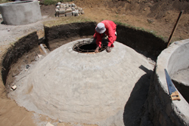
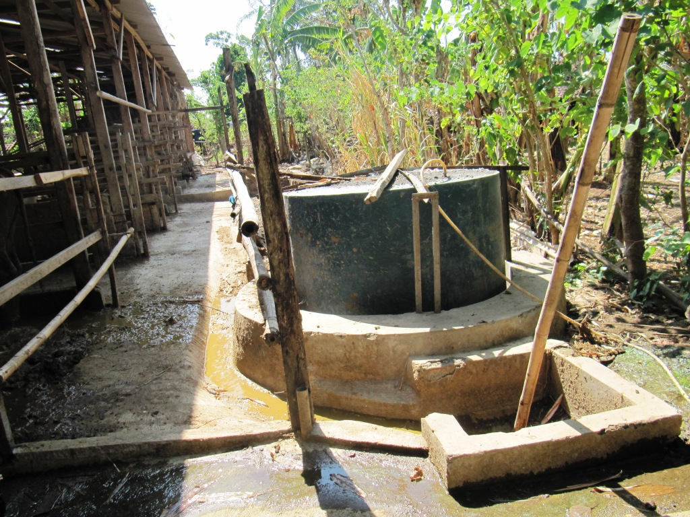

Fig. 4.5 Floating-roof digester Fig. 4 .6 Fixed-dome digester
(Source: www.azizakenya.com)

Three different schemes of biodigester development were explained during the workshop (Fig. 4.6):
- a single household-level digester, for a household with approximetely 4 members and 2 cows. Compared to communal or cluster level digester, the construction cost of this digester is high. The single household level digester can produce fertilizer and gas for cooking.
- a cluster-level digester, consists of four households (16 members) and approximately 8 cows. Such digester will produce gas for cooking and fertilizer as well.
- combined-cluster digesters. This consists of three clusters, and each cluster has a digester (3 clusters, consist of 4 households each). This system covers approximately 12 households or 48 family members and 24 cows. The gas from three digesters will be connected to a generator. The gas can be used for cooking during the day and producing electricity when excess. Fertilizer will be shared among households.

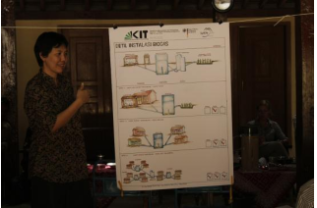

Fig. 4.7 Three alternatives of digesters
(Source: IWG-SWW, 2012)

Compared to the first two options, the last option covers more users and recovers different kinds of energy (gas for cooking and electricity). Therefore this option was offered to the community.
4.4.2. Community concerns on fertilizer
During the workshop, community expressed their concerns mainly on fertilizer. Several questions have been completely answered, but some still not fully answered.
4.4.2.1. The use of human feces as fertilizer
While the application of animal manure is well accepted, the use of humanure (treated feces) still invites pro and contra. Many user candidates had fear in using humanure as fertilizer, due to hygiene and religious reason.
During the workshop, it was explained that the feces would be treated and stabilized in the digester. Pathogen will die and the exposure to the sun in the drying bed will increase the die-off. The end product will be dark odorless dried sludge, which can be applied to the field. The application is restricted to crops which should be cooked before served.
4.4.2.2. Fertilizer as end product of the digester
Agriculture becomes the main living in this region, therefore users have more concern on the fertilizer compared to the energy (gas, electricity) recovered from the digester. Many questions were raised, concerning the form of fertilizer, its benefit compared to dried manure, its production rate and transport to the field.
Explanation was given during the workshop. The slurry coming out of the inlet contains water and need to be dried in slurry drying bed. The dried slurry and liquid part can be applied to the field. If application of liquid fertilizer seems to be a problem, the liquid can be fed again to dillute the fresh dung before entering the inlet. That way, users do not have to organize transport of liquid.
The dried slurry has more benefit compared to dried undigested manure:
- it is “stabilised” with reduced odour emissions, pathogens and weed seeds compared to undigested manure. Therefore farmers will not have to deal with weed and larva problem, which often occur by applicating dried manure on the field.
- compared to dried manure, dried slurry has less volume but finer. This reduces the number of fertilizer transported to the field, but increase the distribution/spread of the fertilizer on the field.
- the dried slurry is rich in nutrient. It is therefore suitable for application in agriculture as a fertiliser and soil conditioner. The macronutrients (N, P and K) which are contained in the substrates remain in the digestate and are easily available to plants.
4.4.2.3. Share of fertilizer
All fields in the region is non-irrigated field, which rely on the rain. The availability of the animal manure/fertilizer in the beginning of rainy season (October) is crucial. Common practise in the region is: farmers take the fresh dung and place them in a hole next to the shed, or place the dung in the corner of the shed, protected from the rain during rainy season. In the beginning of dry season, all collected dung is dried outside. After that, the dried manure is packed into several sacks and brought to the field (Fig. 4.7). Some farmers bring the sacks to the field regularly (1-2x per week) to safe the cost of transporting many sacks at once with the truck. Other farmers prefer to rent a small truck to bring all the sacks at once.
With the construction of combined-clusters digesters, all the dung should be fed to the digester from several inlets, and the slurry will exit the digester from one outlet (Fig. 4.8). The farmers have concerns on the share of the fertilizer.
Proposed solution: the share of the fertilizer will be based on the ratio of cattles ownership. The slurry will be dried and then collected in sacks. In the end, the sacks will be devided based on the number of the cows/cattles owned by each farmer. The users seemed to agree with this proposed solution, although two questions were still left:
- some farmers who used to bring the sacks regularly (not all at once) cannot continue this practice, and will have to rent a small truck- which means extra expenditure
- fertilizer share based on the number of cows might not be an ideal solution, due to the fact that each cow does not produce the same amount of dung. A big and well-fed cow will produce more dung and more fertilizer compared to a small cow.

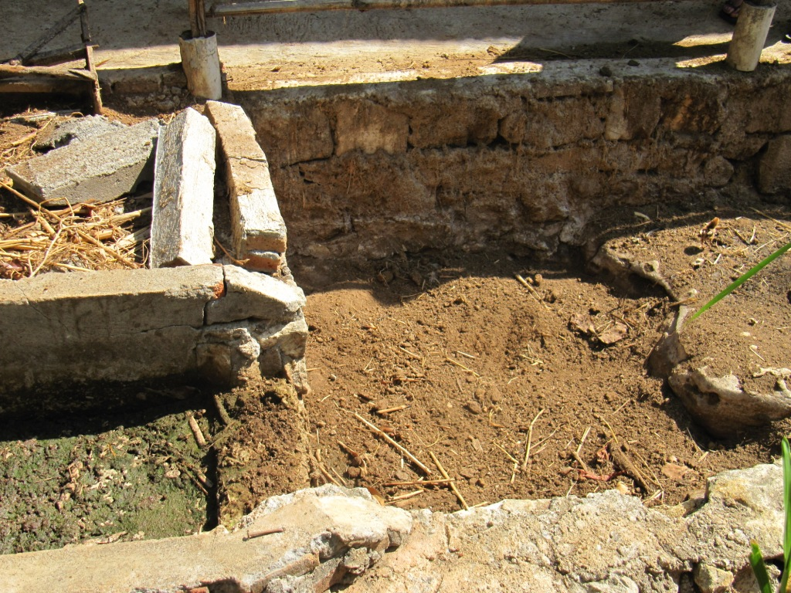
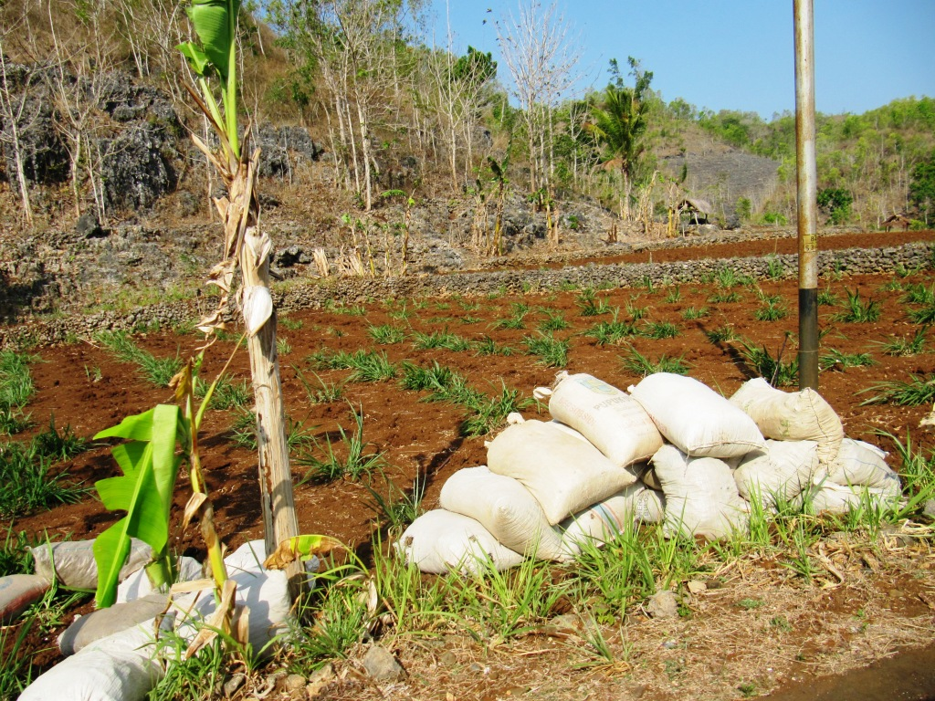

Fig. 4.8 Cattle manure brought to the field Fig.4.9 Slurry from a digester in the drying bed

4.4.2.4. Amount of water for dilluting the dung
The main water sources in Pucanganom C are rainwater and Bribin’s water. The water from Bribin should run once per week regularly. Unfortunately sometimes the water does not reach this sub-village. Biodigester requires water to transport and dillute the dung.
Several solutions were discussed during the workshop:
- moving the cattle sheds as close as possible to the digester. Short distance will require less water for transporting the dung.
- by-passing the liquid part of the slurry to the inlet, to dillute the fresh dung
- adding greywater from the kitchen in the system.
4.4.3 Remarks for the implementation phase
The second day of the workshop focused on the implemantation phase. The selection of three locations for the digester was based on several considerations:
- connectivity to sheds. A location which is accessible by more sheds is prefered, in order to optimize the coverage.
- enable the gravity-driven force. A free land with relatively low elevation is prefered to enable the gravity force from higher locations.
- owner willingness to donate the land. The ownership of the land should be clear, and there should be a written statement on the donation.
Transect walk method was applied to select the locations (Fig. 4.10). It is a systematic walk along the defined path (transect, which has been determined through surveys before the workshop) together with local community to search the proposed locations. During the walk, information was gained through observation and discussion with community.
The important results of the walk are as follows:
- three locations have been decided, and owners agreed to donate the land. Letters of agreement were signed (Fig. 4.11)
- other users agreed to move their cattle sheds and toilette to closer locations to the digester.
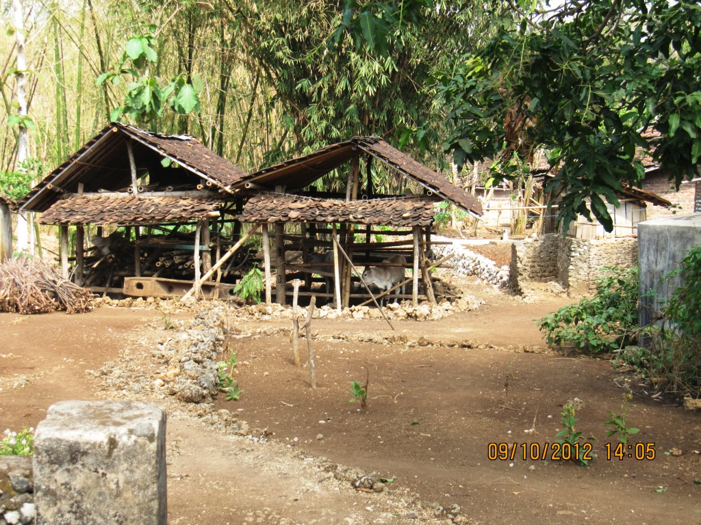
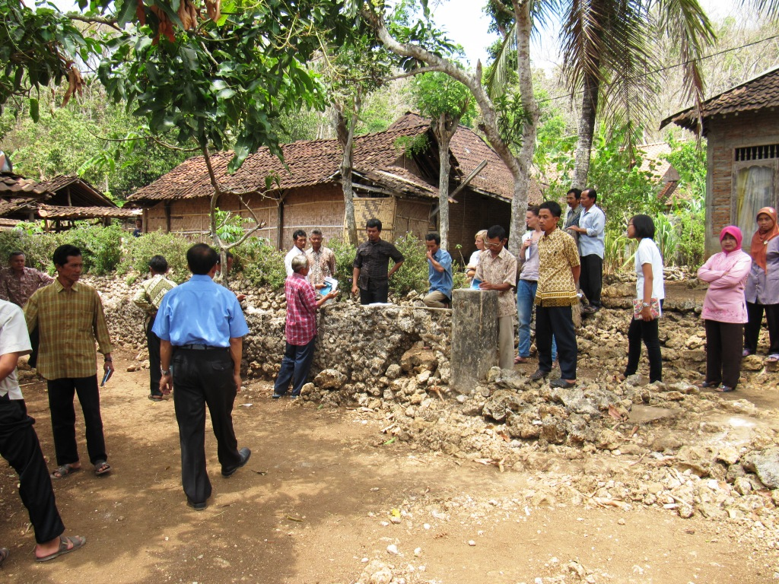

Fig. 4.10 Transect walk to identify the location Fig. 4.11 One of the selected locations

For the implementation of the digester, the people gave several suggestion based on their experience living in karst area:
- the top soil in Pucanganom (2-7 meters deep) is clay with high swelling factor, which can crack the structure. Therefore it is recommended to avoid direct contact between the structure and the soil by providing buffer zone with sand.
- to use concrete and reinforcement steel for the underground construction. These materials are ductail, therefore can reduce the crack caused by the clay swelling force and earthquake.
4.5 Treatment Efficiencies (Performance) of Wastewater Treatment and Two-Stage Anaerobic Reactor
In order to evaluate the performance of wastewater and sludge treatment plant, several chemical and physical paramaters are examined. The influent and effluent of wastewater treatment plant are daily observed. However, due to the expensive test cost, the test for some chemical parameters were only done several time randomly.
For the two-stage anaerobic reactor, the removal efficiency of organic compounds was measured by determining the elimination of total COD, BOD and Solids. When steady-state conditions was reached, biogas production, COD elimination, total solids and volatile solids of the reactor effluents were also determined.

4.5.1. Performance of wastewater treatment plant (WWTP) treating liquid effluent of septic tanks and grey water
As has been discussed before, in the hospital, several septic tanks serve as pre-treatment for wastewater from toillettes. The supernatant of the septic tanks, which is considered as pre-treated, is then discharged to a wastewater treatment plant in the hospital area. This wastewater treatment plant is using aerobic methods as its main method of treatment. Together with wastewater resulted from bathing and kitchen activities, the supernatant of septic tanks is treated in this wastewater treatment plant.
The performance of WWTP presented in Table 4.2. From the table shown below, it is known that the treatment for the effluent of septic tank can fulfil the legal requirement from the Ministry of Environment (Kepmen KLH No. 58 Th. 1995).
Table 4.2 Performance of WWTP
No. | Parameter | Unit | Septic tanks’ effluent | Outlet of WWTP | WWTP Removal Efficiency (%) | Regulation accordance
1. | COD | mg/l | 320 | 16 | 95 | Oke
2. | BOD | mg/l | 170,1 | 8,1 | 95,2 | Oke
3. | TSS | mg/l | 222 | 9 | 95,9 | Oke
4. | N Total | mg/l | 76,62 | 52,27 | 31,7 | -

4.5.2. Performance of two-stage anaerobic digester treating septic tanks’ sludge
The sludge from septic tank in the hospital is treated in a two-stage anaerobic digester. The performance of the reactor is presented in Table 4.3
Table 4.3 Performance of two-stage anaerobic biodigester
No. | Parameter | Unit | Inlet | Outlet | Removal Efficiency (%) | Regulation accordance
2. | N Total | mg/l | 405,00 | 305,46 | 24 | No regulation for solid disposal
3. | Total Solid | mg/l | 996,00 | 805,20 | 19 | No regulation for solid disposal
4. | MLVSS | mg/l | 716,00 | 688,20 | 4 | No regulation for solid disposal

From the table we know that the removal efficiency is very low. It can be possible that the sludge from septic tank fed to the reactor was less in organic content, therefore the reaction in the reactor are not running well. However, the removal of nitrogen (which is also low) is beneficial for us if we want to apply the sludge for agriculture use, since nitrogen is a substrate which is really needed by the plants.
4.5.3. Gas production of two-stage anaerobic digester treating septic tanks’ sludge during co-digestion with cow dung
The biogas production of anaerobic digester during addition of cow dung (co-digestion) was also examined in or der to evaluate the appropriateness of cow dung as a co-substrate. This is very important since anaerobic method is actually relatively sensitive to the change of environment or substrate.
At the moment we have fed the reactor with cow dung and we could see that there was significant improvement in biogas production. Apparently, the addition of cow dung as co-substrate supplied the reactor with more organic materials and also anaerobic bacteria which help the process of fermentation and methanization faster and better. Although we have not measured the data on the removal efficiency yet, we can observe that the addition of cow dung to the digester also result in higher removal of organic matters and also removal of solids.
4.6. Future Activities
Future activities of this research include:
- Calculation on the possibility of up-scaling the reactor to treat more septic tanks’s sludge in 3 regencies (Sleman, Gunung Kidul and Yogyakarta city).
- Calculation of potential energy recovery from up-scaled plant.

V. CONCLUSIONS
Several conclusions can be drawn from the results of this research. The most important conclusions can be explained as follow:
- The treatment of wastewater resulted from hospital activities were performed in two step. The first step is treatment by septic tank as pre-treatment and the second step is aerobic treatment as final treatment for the wastewater flow.
- The treatment of wastewater using septic tanks result in a quite big amount of sewage sludge which is not yet treated properly, therefore additional treatment for sewage sludge is urgently needed. In this case, anaerobic treatment using two-stage method is evaluated and considered as appropriate since it can also produce energy in the form of biogas.
- The maximum biogas production potential of sewage sludge which will be fed to the digester was approximately 250 l ⋅ kg⁻¹⋅ kg⁻¹ VS_{added}. The highest biogas production rate was obtained within the first 48 hours with 350 m³∙ kg⁻¹ COD∙d⁻¹. The average methane content of the biogas produced by digestion of septic tanks’ sludge during the batch experiment was 62 %.
- The treatment for the effluent of septic tank can fulfil the legal requirement from the Ministry of Environment (Kepmen KLH No. 58 Th. 1995), therefore the result from this treatment can be discharged directly to water bodies, such as river or small lake.
- It can be observed that the addition of cow dung to the digester also result in higher removal of organic matters, removal of solids and biogas production.

REFERENCES
Appels, L., Baeyens, J., Degrève., J. and Dewil, R., 2008. Principles and potential of the anaerobic digestion of waste-activated sludge. Progress in energy and combustion science. Vol. 34: 755–781
Fricke, K., Santen, H. and Wallmann, R., 2005. Comparison of selected aerobic and anaerobic procedures for MSW treatment. Waste management. Vol. 25: 799-810.
Gallert C and Winter J, 1999. Bacterial metabolism in wastewater treatment systems. (In: Biotechnology, Vol. 11a. Series editors: Rehm, H.J., Reed, G., Pühler, A. and Stadler, P. Volume editor: Winter, J.). Weinheim: Wiley-VCH.
Gallert, C. and Winter, J., 2005. Bacterial metabolism in wastewater treatment systems (in: Environmental biotechnology: concepts and applications. Editors: Jördening, H-J. and Winter, J.). Weinheim: Wiley-VCH.
Gerardi, M.H., 2003. The microbiology of anaerobic digesters. Hoboken, NJ: John Wiley & sons, Inc.
Gijzen, H.J., 2002. Anaerobic digestion for sustainable development: a natural approach. Water research and technology. Vol. 45 (10): 321-328.
Kabupaten Gunung Kidul website:
www.gunungkidulkab.go.id/home.php?moode=content&submode=detail&id=1030 (22.12.2008)
Kelleher, B.P., Leahy, J.J., Menihan, A.M., O’Dwyer, T.F., Sutton, D. and Leahy, M.J., Advances in poultry litter disposal technology – a review. Bioresource technology. Vol. 83 (1): 27 - 36.
Koppar, A. and Pullammanappallil, P., 2008. Single-stage, batch, leach-bed, thermophilic anaerobic digestion of spent sugar beet pulp. Bioresources technology. Vol. 99 (8): 2831-2839.
Lissens, G., Vandevivere, P., De Baere, L., Biey, E.M. and Verstraete, W., 2001. Solid waste digestors: process performance and practice for municipal solid waste digestion. Water science and technology. Vol 44 (8): 91-102.
Mata-Alvarez, J., 2002. Fundamentals of the anaerobic digestion process (in: Biomethanization of the organic fraction of municipal solid wastes. Editor: Mata-Alvarez, J.). Amsterdam: IWA publishing company.
McCarty, P.L. and Mosey, F.E., 1991. Modelling of anaerobic digestion processes. Water science and technology. Vol. 24 (8): 17-33.
Metcalf & Eddy, Inc., 2003. Wastewater engineering: Treatment and reuse. 4th ed. New York: McGraw-Hill.
Müller, K. (2009): Master thesis: Strukturerhebung der Wasserver- und Abwasserentsorgung der indonesischen Stadt Wonosari und ihrer ruralen Umgebung. Universitaet Karlsruhe.
Neves, L., Gonçalo, E., Oliveira, R. and Alves, M.M., 2008. Influence of composition on the biomethanation potential of restaurant waste at mesophilic temperatures. Waste management. Vol. 28: 965-972.
Pavlosthatis, S.G. and Giraldo-Gomez, E., 1991. Kinetics of anaerobic treatment. Water science and technology. Vol. 24 (8): 35-59.
Residua, 2009, Information sheet on anaerobic digestion of solid waste. Available online at (last access June 2009): http://www.waste.nl/content/download/472/ 3779/file/WB89-InfoSheet(Anaerobic% 20 Digestion).pdf
Stronach, S.M., Rudd, T., and Lester, J.N., 1986. Anaerobic digestion processes in industrial wastewater treatment. Berlin: Springer-Verlag.
USEPA (United States Environmental Protection Agency EPA) (2003): Getting in step: A guide for conducting watershed outreach campaigns. URL: www.epa.gov/nps (15.12.2009).html (22.12.2009)
Vandevivere, P., De Baere, L. and Verstraete, W., 2003. Types of anaerobic digesters for solid wastes (in: Biomethanization of the organic fraction of municipal solid wastes. Editor: Mata-Alvarez, J.). Amsterdam: IWA publishing company.
Veeken, A., Kalyuzhnyi, S., Scharff,H., and Hamelers, B., 2000. Effect of pH and VFA on hydrolysis of organic solid waste. Journal of environmental engineering. Vol. 126 (12): 1076 – 1081.
Veenstra, S., 2000. Wastewater treatment I. Delft: International Institute for Infrastructure, Hydraulics and Environmental Engineering (IHE Delft).
Wegelin-Schuringa, M. (2000): Public awareness and Mobilisation for Ecosanitation. Paper for presentation at International Symposium on Ecological Sanitation). Bonn, Germany, 30th to 31st October 2000. IRC International Water and Sanitation Centre.
URL: www2.irc.nl/themes/sanitation/publaw.html (21.12.2009)
Zaher, U., Cheong, D-Y., Wu,B., and Chen, S., Producing energy and fertilizer from organic municipal solid waste. Olympia, WA: Department of Biological Systems Engineering, WSU. Also available online at: http://www.ecy.wa.gov/programs/ swfa/solidwastedata/

