ANAEROBIC TREATMENT OF SEPTIC TANKS’ SLUDGE WITHIN THE FRAME OF INTEGRATED WATER RESOURCE MANAGEMENT
- A Study in Gunung Kidul, Yogyakarta
Didik Purwantoro
Satoto E. Nayono
Retna Hidayah

Abstract
Gunung Kidul district in Yogyakarta Special Province, Indonesia undergoes an acute water shortage despite receiving high amounts of precipitation during the rainy season. Since this area is a karst region, water normally infiltrates into the ground, flows through the underground caves and finally ends up in the Indian Ocean. In general, sanitation systems in Gunung Kidul consist of either pit latrines or pour-flush toilets (latrines). Pit latrines are commonly found in rural areas while in urban areas, pour flush latrines take the lead. As a case for this study is Wonosari hospital (RSUD Wonosari. This hospital is largest public hospital found in Wonosari, Gunung Kudul region. With a capacity of about 115 beds, the hospital has about 351 staff, of which 160 are non-medic and 191 are medic staff. In regard to sanitation, the hospital currently has a kind of central wastewater disposal system with a subsequent biological treatment plant. This wastewater treatment plant is however not in the good condition and operation. Most of the wastewater resulted from hospital’s activities which is treated in this plant is not treated in the wastewater plant and even the treated wastewater is not really sufficiently purified. This lack of treatment can be indicated by the high BOD and COD value of the treated wastewater which does not meet the criteria that has been issued by the government of Indonesia.
As an effort to promote sustainable sanitation and to have better results of wastewater treatment plants, a two-step anaerobic technology will be tested at the hospital area. The most suitable mode of operation is currently being tested in Germany after which the facility will be re-located to Indonesia. The first operation step of this digester is to treat sludge sediment from the hospital’s septic tanks which is not further treated and disposed properly in solid waste disposal (sanitary landfill).
The main goal of this research is to optimize the operation performance of two-step anaerobic reactor treating septic tanks‘ sludge, either by investigating the maximum organic loading rate or by co-digestion with other types of wastes for more resources recovery. This goal leads to a promotion of affordable sanitation technologies, which have the ability to recover valuable material from wastewater, especially for the less developed countries.
Keywords: anaerobic treatment, biogas, septic tank sludge, resources recovery, sustainable sanitation

I. INTRODUCTION
1.1 Background Information: Current Sanitation Situation in Gunung Kidul
Gunung Kidul district in Yogyakarta Special Province, Indonesia undergoes an acute water shortage despite receiving high amounts of precipitation during the rainy season. Since this area is a karst region, water normally infiltrates into the ground, flows through the underground caves and finally ends up in the Indian Ocean. Since inception of the IWRM-Indonesia research project in 2002, Karlsruhe Institute of Technology has been working closely with partners from academia and industry to supply the region with drinking water from the underground caves as well as provide sustainable waste and wastewater disposal solutions. In the frame of this project, the department of Aquatic Environmental Engineering of the Institute for Water and River Basin Management (IWG-SWW) is responsible for the development and realization of customized technologies for waste water and solid waste treatment within the Integrated Water Resources Management (IWRM) program which started in August 2008.
In general, sanitation systems in Gunung Kidul consist of either pit latrines or pour-flush toilets (latrines). Pit latrines are commonly found in rural areas while in urban areas, pour flush latrines take the lead (Mueller, 2009). Open defecation only happens at a low scale in the rural areas (Insani, 2009). Faecal waste in the pit latrines is simply deposited in a pit whereas for the pour-flush latrines, faecal waste is flushed off into a pit or septic tank. Although the health authority Dinas Kesehatan recommends construction of septic tanks with drainage trenches (Mueller, 2009), the fact that each household has to bear the cost leads to construction of unsealed septic tanks without drainage trenches. The liquid phase infiltrates into the ground and the septic tanks are hardly ever emptied, thus posing an evident contamination potential to groundwater in this karst region.
Gunung Kidul region is characterized by substantial economical and technological differences between the rural and urban areas. Therefore, spatial differentiated solutions and an emphasis on decentralized as well as semi-centralized waste water and solid waste treatment are inevitable. Research and development of such focus mainly on:
- urban area – City of Wonosari
- rural area – Gunung Sewu karst region
According to the usage patterns and settlement systems in both areas various starting-points for the development and realization of customized concepts can be found. For the urban area these are:
- public buildings, schools, hospitals
- commercial and industrial zones
- the local hospital
On the countryside approaches are worked out for:
- settlements
- market towns
Optimal solutions for the above named fields of application shall be found by using different technological approaches. The aim is to treat wastewater and organic waste in a way that the recirculation of nutrients and the energetic use of biogas can be achieved while protecting and saving scarce water resources. Technical feasibility and a maximization of the multiplier effect are thereby essential points for defining a specific working area. Development and introduction of new sanitary technologies go along with a program to enhance public acceptance of the systems and to advocate understanding of the systematic correlations between water supply and waste water disposal. Realization of the developed concepts shall boost and ensure further economical advancement of the whole region by saving natural resources.

1.2 Resources-recovery-based Sanitation Technology: Case Study of RSUD Wonosari and Pucanganom Village
In an effort to promote sustainable sanitation and to have better results of wastewater treatment plants, a two-step anaerobic technology will be tested at RSUD Wonosari area. The most suitable mode of operation is currently being tested in Germany after which the facility will be re-located to Indonesia. The first operation step of this digester is to treat sludge sediment from the hospital’s septic tanks which is not further treated and disposed properly in solid waste disposal (sanitary landfill).
A new concept of sanitation technology will also be introduced to the villagers of Pucanganom in Ponjong, Gunung Kidul. This new concept is also based on resource recovery of wastes. A mixed treatment of domestic waste and animal waste will be applied in the area.
1.3 Goal and Objectives of the Research
The main goal of this research is to optimize the operation performance of two-step anaerobic reactor treating septic tanks‘ sludge, either by investigating the maximum organic loading rate or by co-digestion with other types of wastes for more resources recovery. This goal leads to a promotion of affordable sanitation technologies, which have the ability to recover valuable material from wastewater, especially for the less developed countries.
In order to reach the goal, this research will comprise several objectives as follows:
- to examine the sanitation plant of a public space, in this case is RSUD Wonosari,
- to evaluate the operation performance of two-step anaerobic reactor treating the septic tank sludge,
- to determine the potential biogas production of anaerobic degradation of septic tank sludge and potential improvement of biogas if the sewage sludge is co-digested with other types of waste namely cow dung,
- to examine the stability of cow dung if they are used as a co-substrate in anaerobic digestion of septic tank sludge, and
- to evalauate the possible application of new technology innovation in a village in order to promote higher sanitation standard.
II. LITERATURE REVIEW
2.1 Microbiological Process in Anaerobic Treatment
Anaerobic digestion, specifically methane fermentation, is both an effective and simple method for stabilizing sludge. Optimizing process efficiency for increased biogas production, however, is complex because it relies heavily on microbial activity. Anaerobic digestion is described as a series of processes involving microorganisms to break down biodegradable material in the absence of oxygen. The overall result of anaerobic digestion is a nearly complete conversion of the biodegradable organic material into methane, carbon dioxide, hydrogen sulfide, ammonia and new bacterial biomass (Veeken et al., 2000; Kelleher et al., 2002; Gallert and Winter, 2005).

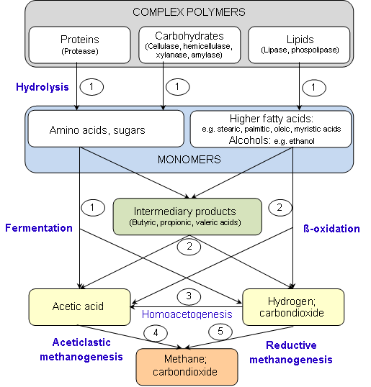
Figure 2.1 Schematic diagram of complete anaerobic digestion of complex polymers. Names in brackets indicate the enzymes excreted by hydrolytic bacteria. Numbers indicate the bacterial groups involved:
1. Fermentative bacteria
2. Hydrogen-producing acetogenic bacteria
3. Hydrogen-consuming acetogenic bacteria
4. Aceticlastic methanogenic bacteria
5. Carbon dioxide-reducing methanogenic bacteria
2.2 Important Parameters in Anaerobic Digestion
Several factors can affect the performance of the anaerobic digestion, either by process enhancement or inhibition, influencing parameters such as specific growth rate, degradation rates, biogas production or substrate utilisation. This proposal will briefly discuss those factors namely: pH, temperature, substrate, retention time, organic loading and mixing condition.
2.2.1 pH
The pH value of the digester content is an important indicator of the performance and the stability of an anaerobic digester. In a well-balanced anaerobic digestion process, almost all products of a metabolic stage are continuously converted into the next breaking down product without any significant accumulation of intermediary products such as different fatty acids which would cause a pH drop.
Alkalinity and pH in anaerobic digestion can be adjusted using several chemicals such as sodium (bi-) carbonate, potassium (bi-) carbonate, calcium carbonate (lime), calcium hydroxide (quick lime) and sodium nitrate. Addition of any selected chemical for pH adjustment should be done slowly to prevent any adverse impact on the bacteria. Because methanogenic bacteria require bicarbonate alkalinity, chemicals that directly release bicarbonate alkalinity are preferred (e.g. sodium bicarbonate and potassium bicarbonate are more preferred due to their desirable solubility, handling, and minimal adverse impacts). Lime may be used to increase digester pH to 6.4, and then either bicarbonate or carbonate salts (sodium or potassium) should be used to increase the pH to the optimum range (Gerardi, 2003)
2.2.2 Temperature
Temperature is one of the major important parameters in anaerobic digestion. It determines the rate of anaerobic degradation processes particularly the rates of hydrolysis and methanogenesis. Moreover, it not only influences the metabolic activities of the microbial population but also has a significant effect on some other factors such as gas transfer rates and settling characteristics of biosolids (Stronach et al., 1986 and Metcalf & Eddy Inc., 2003). Anaerobic digestion commonly applies two optimal temperature ranges: mesophilic with optimum temperature around 35 °C and thermophilic with optimum temperature around 55 °C (Mata-Alvarez, 2002, see also Figure 2.2). The biphasic curve typically is a result of insufficient adoption nd selection time by increasing the mesophilic and lowering the thermophilic temperature and not awaiting several retention times. If enough adaptation time in fed-batch and continuous cultivation is allowed, the selected populations at 30,37,45, 50 and 55 °C will produce biogas at similar rates (Figure 2.2 dotted line), with slightly lower residual fatty acid concentrations at the lower temperatures.

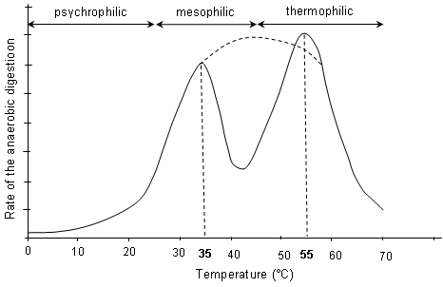
Figure 2.2 Influence of temperature on the rate of anaerobic digestion process. Optimum temperature for mesophilic around 30 – 40 °C and for thermophilic 50 – 60 °C
(Source: Mata-Alvarez, 2002)
2.2.3 Substrate characteristics
The characteristics of solid wastes determine the successful anaerobic digestion process (e.g. high biogas production potential and degradability). In municipal waste, substrate characteristics may vary due to the method of collection, weather season, cultural habits of the community etc. Substrate characteristics such as its composition, C/N ratio and particle size will be briefly discussed in this sub-chapter.
The degradability and biogas production potential from solid waste in an anaerobic digester are dependent on the amount of the main components: lipids, proteins, carbohydrates such as cellulose and hemicelluloses as well as lignin (Hartmann and Ahring, 2006). Among them lipids are the most significant substances in the anaerobic digestion, since the methane yield from lipids is higher than from most other organic materials. The theoretical gas yield of glyceride trioleate is, for example, 1.4 m³ per kilogram of oil with a methane content of 70%. Although organic waste with a high content of lipids is an attractive substrate for biogas production, Neves et al. (2008) reported that the lowest hydrolysis rate constants were obtained in the assays fed with kitchen waste that contained an excess of lipids. This was presumably due to a synergetic effect on the degradation of the other components since lipids adsorb onto solid surfaces and may delay the hydrolysis process by reducing the accessibility of enzyme attack. Lignocellulosic (cellulose and hemicelluloses which are tightly bound to the lignin) waste can be found in abundant amount in the form of garden waste, paper residue or agricultural waste. Due to the presence of lignin, lignocellulosic waste is considered to be quite resistant to anaerobic digestion and hydrolysis is the rate limiting step in the overall process. In order to improve the rate of enzyme hydrolysis and increase yields of fermentable sugars from cellulose or hemicellulose in lignocellulosic waste, several pretreatment methods such as thermal (steam or hot water), chemical (acid, lime or ammonia addition) or combination of both methods were proposed by several researchers.
III. RESEARCH METHODOLOGY
3.1 Materials
3.1.1 Anaerobic digester
This research is based on experimental works conducted in a pilot plant at RSUD Wonosari, Gunung Kidul. In cooperation with KIT, Hans Huber AG Berching, Germany delivered a two-step anaerobic fully automated technology as a pilot plant in a container (6 x 2,5 m). The pilot plant consists of two reactors installed in series. The first reactor acts as a hydrolysis compartment while the other one acts as acidification and methanogenesis compartment. The total volume of the anaerobic reactor is approx. 1,000 liter with a capacity to treat sewage sludge up to 100 population equivalent.
3.1.2 Substrates
The main substrate of this research is sewage sludge from septic tank treating wastewater from hospital wards. The sewage sludge is pumped from the bottom of septic tank every one hour to the hydrolysis tank. After hydrolysis process is completed, the sewage sludge is then pumped to acidogenesis/methanogenesis tank.
In order to improve biogas production and optimize the operation of the reactor, the main substrate is co-digested with other types of waste with presumably have a lot of organic content. The first type of waste which is indicated to have high organic content and presumably suitable as co-substrate is waste collected from kitchen activities of the hospital. This type of waste has to be minced to have smaller size in order to accelerate the process of hydrolysis.
3.2 Design of the Experiment
Initially the reactor was fed with only sewage sludge from septic tank at HRT of 20 days and after reaching the steady-state, all of the sludge parameter (inlet and outlet) are measured. After that phase, cow dung with low quantity is fed to the reactor to examine the effect to the hydrolysis process and biogas production. The quantity of cow dung is gradually increased to examine the maximum organic loading rate can be handled by the reactor. The sewage sludge feeding was maintained at regular feeding assuming that the full-scale reactor treats relative constant amount of sewage sludge.
Together with cow dung, kitchen waste is also added to the reactor with the same procedure in order to utilize other stream of waste to produce biogas. Additional substrates such as cow dung or kitchen waste as co-substrates were added to the sewage sludge suspension before the feeding and mixed well. The increment of co-substrate was done when the performance of the reactor in each increment was considered to be in a steady state condition. The reactor was fed with the substrate mixture thrice a day at 09.00 a.m, 12.00 am and 16.00 p.m. The sequence of processes and sampling of the research can be depicted in Figure 3.1 for sole substrate digestion with sewage sludge and Figure 3.2 for multi-substrate digestion with cow dung and kitchen waste.
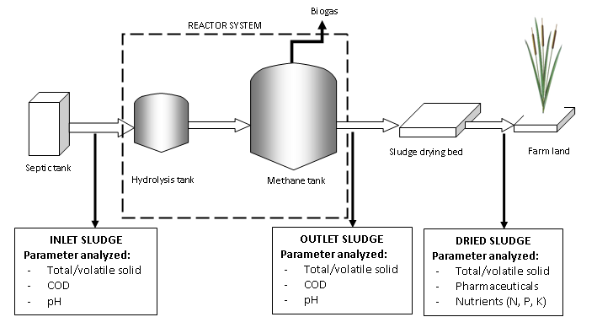
Figure 3.1 Sequence and sampling procedure for sole substrate digestion
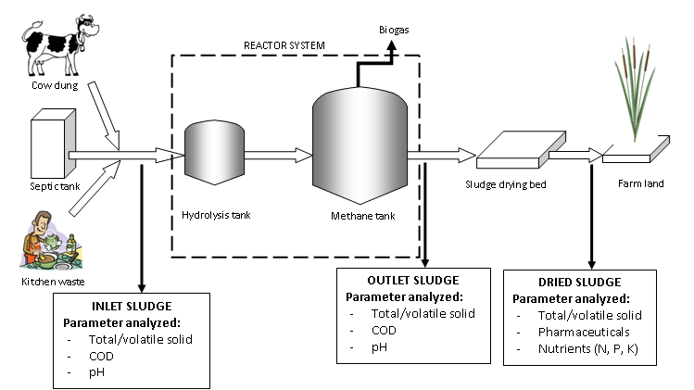
Figure 3.2 Sequence and sampling procedure for multi substrate digestion

3.3 Analytical methods
To characterize the wastes and evaluate the performance of the reactor, several parameters were measured and determined, namely: COD, TS, VS, biogas production, pH, nutrients content, and pharmaceuticals content. The German partner will do the analyses of nutrient and pharmaceutical content.
3.3.1 Chemical oxygen demand (COD)
The COD is a measure of the oxidizability of a substrate, expressed as the equivalent amount in oxygen of an oxidizing reagent consumed by a substrate. Organic matter was oxidized with potassium dichromate (K₂Cr₂O₇) in a mixture of sulphuric acid and phosphoric acid (H₂SO₄ + H₃PO₄). Possible method using KMnO₄ can also be applied to analyze this parameter.
3.3.2 Total solids and volatile solids
For determining the total solids (TS), samples with certain volume or weight were placed in ceramic vessels and dried in a drying oven at 105 ± 2 °C for 15 - 20 hours until constant weight. After cooling in the desiccators, the samples were weighed for TS measurement. The samples then oxidized at 550 °C for 2 hours for volatile solids (VS) determination. The volatile solids (VS) were determined by subtraction of the minerals content of the sludge sample (residual ash after oxidation) from the total solids content.

The calculation of TS and VS can be described as follows:

where, TS : total solids
dv_{s} : vessel + dried sample weight
dv_{e} : empty vessel weight
V_{s} : volume of sample
where, VS : volatile solids
dv_{s} : vessel + dried sample weight
dv_{s*} : vessel + ash weight
dv_{e} : empty vessel weight
V_{s} : volume of sample
3.3.3 Biogas production
Biogas production of the anaerobic reactor was measured daily using a water displacement method by a wet gas meter from Ritter Co which is supplied by German partner. This gas meter is installed on the top of the second reactor and can be read daily.
3.3.4 Ammonia nitrogen (NH₄-N) and total Kjeldahl nitrogen (TKN)
Ammonia was determined by using a method with preceding distillation. The distillation process was used to separate the ammonia from interfering substances. Ammonia in the sample was distilled into a solution of boric acid and determined titrimetrically with standard H₂SO₄ with a mixed indicator.
Total Kjeldahl Nitrogen (TKN) is used to determine the sum concentration of both organic nitrogen and ammonia nitrogen. The method involves a preliminary digestion to convert the organic nitrogen to ammonia, then distillation of the total ammonia into an acid absorbing solution and determination of the ammonia by titration method. The method employed sulphuric acid as the oxidizing agent.
3.3.5 pH value
The pH value of the reactor’s effluent or of batch experiment was determined electrochemically with an Ingold pH electrode. As the check reference, pH paper was also used to determine the pH value.
3.4 Capacity Building
The success of sanitation programmes depend critically on effective public awareness and mobilization through information, education and communication (Wegelin 2000). It is therefore important to understand how different communities and organizations function in different cultural and geographical settings before commencing an awareness program. Basic information about the target audience such as demographics, knowledge base, attitudes, beliefs and perceptions, communication channels and social data must be established.
The needs for capacity building are always changing. There are no ready solutions, and any programme must be appropriate for the local situation and organization (GDRC 2009). For instance, in a survey undertaken in the Kecamatan Wonosari, more than 50% of those interviewed did not consider wastewater infiltrating into the ground from their septic tanks as a potential groundwater contaminant (Mueller 2009).
To promote the most favourable solutions as well adopted program to create awareness and capacity hat to be developed and implemented in the region for different target group like local authorities, students and pupils as well as residents. In this research, the capacity building to increase awareness of the people toward the importance of sanitation to protect water sources was done through a workshop in Pucanganom Village in Ponjong, Gunung Kidul. During the workshop field experiment and observation are also done in order to have some specific parameters to decide which technology of sanitation is suitable for the village.

IV. RESULTS AND DISCUSSIONS

4.1 Wastewater Treatment Plant System in RSUD Wonosari
With a capacity of about 115 beds, RSUD Wonosari has about 351 staff, of which 160 are non-medic and 191 are medic staff (Gunung Kidul, 2008). In regard to sanitation, the hospital currently has a kind of central wastewater disposal system with a subsequent biological treatment plant. This wastewater treatment plant is however not in the good condition and operation. Most of the wastewater resulted from hospital’s activities which is treated in this plant is not treated in the wastewater plant and even the treated wastewater is not really sufficiently purified. This lack of treatment can be indicated by the high BOD and COD value of the treated wastewater which does not meet the criteria that has been issued by the government of Indonesia.
The hospital’s wastewater treatment diagram is shown in Fig. 4.1 as follow:

Septic tank’s supernatant treatment plant: aerobic system
Previously desludged every 1-2 years: untreated
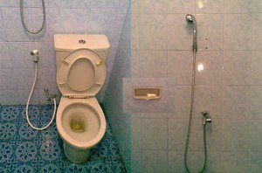

Fig. 4.1 The RSUD Wonosari wastewater treatment plant diagram

From the initial field study, it was known that most of the wastewater from hospital wards’ is treated in septic tanks. The septic tanks themselves are not properly designed and constructed, therefore the quality of the treated wastewater relatively under national standard. Besides, the treatment of wastewater using septic tank is normally producing quite high amount of sludge which is not yet stabilized. The sludge resulted from this process is commonly not properly disposed and causing several aesthetic and health problems.
The hospital tries to improve the quality of the effluent by installing an aerobic system wastewater treatment plant to treat the supernatant (effluent) of the septic tanks. Therefore, in this case, septic tanks are only a pre-treatment for the wastewater and later will be polished by the aerobic treatment plant. The sludge of septic tanks is previously desludged every 1-2 years and the discharge of the sludge was sometimes not known. Normal practice of sludge discharging in one that discharged directly to the river. Therefore, this kind of practice is not an environmental-friendly method.
In order to improve the current practice of septic tanks’ sludge diposal, a two-stage anaerobic digester was installed to treat this sludge. The german company Huber provided a pilot scale two-stage anaerobic digester to be tested in RSUD Wonosari. The capacity of the digester is about 1,000 liters (wet volume). The initial plan to have this pilot scale digester is to evaluate the possibility of using anaerobic methods to further treat sewage sludge from septic tanks in Gunung Gidul in particular and in Yogyakarta Special Region in general. After the experiments show a possitive results, an upscale plant will be installed to serve sewage sludge from at least Gunung Kidul, Bantul and the City of Yogyakarta.
The scheme and manual of the pilot plant from Huber is presented in Appendix 1.

4.2 Wastewater and Sludge Characteristics
Table 4.1 presents the main characteristics of the two substrates (i.e. wastewater from septic tanks’ supernatant and grey water and also septic tanks’ sludge) used in this study. Due to limitation of the equipment in our laboratory partners, some of the parameters are omitted from the study.
Table 4.1 The main characteristics of hospital wastewater and septic tanks’ sludge
No. | Parameter | Unit | Inlet of Wastewater Tr. (Septic tanks’ effluent) | Outlet of Sludge Tr. (Septic tanks’ sludge)
1. | COD | mg/l | 320 | -
2. | BOD | mg/l | 170,1 | -
3. | TSS | mg/l | 222 | -
4. | N Total | mg/l | 76,62 | 405
5. | Total Solid | mg/l | - | 996
6. | Mixed Liq. Vol. Susp. Sol. | mg/l | - | 716
The value(s) are an average from at least 4 measurement. The samples were taken at different time (daily/weekly)
From above table, it can be seen that the effluent of septic tanks still has quite high organic matters (as can be considered from high COD and BOD) and high solid content (TSS).
On the other hand, the septic tanks’ sludge has relatively low organic content (as can be seen from relatively low MLVSS. The sludge has only 996 mg/l total solids (less than 1 percent) which is considered as low when it is fed to an anaerobic digester because normally an anaerobic digester can treat 5%-25% total solids. This may be caused by the withdrawal of the sludge which is done very often (2-4 times a day).
Low content of solids (in the other word is low content of organic matters) is not optimum to operate an anaerobic digester. It will cause the slow start-up pahse and less biogas production due to less substrate delivered to the reactor. When this problem occurs, the operation of an anaerobic digester will not succesful as well. Therefore, for the next step, the reactor will also be fed with cow dung and/or kitchen waste to increase the organic content of the feeding substrate.
The nitrogen content of both flows is also still high indicating that the removal of nitrogen in septic tanks is also low. However, if we see nitrogen as a resources (to be applied in the agriculture activity), it can be considered to be an advantage.
4.3 Biogas Production Potential of Septic Tank’s Sludge
The potential of a substrate to be converted to biogas during anaerobic treatment is very essential to determine the suitability of a substrate as a feeding in anaerobic digester. The higher methane potential owned by a substrate the more attractive the substrate as a feeding, since it will give the higher energy recovery rate in the form of biogas. The biogas production potential of biodegradable solid wastes depends on the content of digestible carbohydrates, lipids and proteins, as well as on the content of more resistant cellulose, hemicellulose and lignin (Gallert and Winter, 1999; Hartmann and Ahring, 2006).
Figure 4.2 depicts the biogas production with time the septic tank’s sludge in the batch assay experiment which was done in IBA Laboratory, Karlsruhe Institute of Technology. The figure shows that after 2-3 days, already more than 90 % of the biogas was released. In the following 2-3 days the biogas production ceased and even upon prolonged incubation no biogas was evolved any more. The maximum biogas production potential was approximately 250 l ⋅ kg⁻¹⋅ kg⁻¹ VSadded. The highest biogas production rate was obtained within the first 48 hours with 350 m³∙ kg⁻¹ COD∙d⁻¹. The average methane content of the biogas produced by digestion of septic tanks’ sludge during the batch experiment was 62 %.

Fig. 4.2 Net Biogas Production Potential of Septic Tanks’ Sludge
Using similar batch experiments to determine the maximum methane production of source-sorted OFMSW, Hansen et al. (2003) reported that the results ranging from 0.299 to 0.544 m³ -CH₄ ∙ kg⁻¹ VS_{added} depended on the pre-treatment method applied to the raw solid waste (disc screen, screw press device and magnetic separation with shredder) with the average value appeared to be around 0.45 m³ -CH₄ ∙ kg⁻¹ VS_{added}. The authors also determined the chemical composition of the OFMSW and it was reported that for most of the samples the measured methane production reached 75–90% of the theoretical methane potential (calculated using Buswell’s formula).

4.4 Capacity Building in the village of Pucanganom
The capacity building is done in the village of Pucanganom in the form a a two-day workshops. This workshop is a collaboration between Sub Project 9 IWRM (Institut for Water and River Basin Management, Department of Aquatic Environmental Engineering, KIT), Sub Project 10 IWRM (Institut for Technology Assessment and System Analysis, KIT) and Research Team from Yogyakarta State University.
The workshop is aimed at delivering information concerning IWRM project’s plan to construct biodigesters in sub-village Pucanganom C and gaining feedback from the intended community. The main goal of biodigester construction is to protect water resource from humans’ activities pollution especially E. Coli spread. A two-day workshop (October 9-10, 2012) was conducted in the sub-village, involving the local authority (Department of Public Work, Gunung Kidul), village leaders and intended community (31 households).

Fig 4.3. Participants of the workshop Fig 4.4. Experiment on new biodigester design
The first day of the workshop focused on the principles of bio digester: how it works, the benefits and drawbacks, operational and maintenance. The second day focused on the implementation and technical design. The final decision is: three digesters in cluster level will be constructed in this sub-village and three families have agreed to donate their land for the digesters. The work will involve the community and trained labors.
4.4.1. Proposed technology: combined- cluster digesters
A floating-roof digester (Fig. 4.5) which treats human feces and cattle dung is introduced to the community. This type of biogas is selected due several reasons:
- lower construction cost, compared to a fixed-dome digester (Fig. 4.6)
- easy construction, therefore encourage self multiplication by interested households
- easy control during operational: the drum’s elevation indicates the volume of gas production. Leakage or excess gas production can be identified.

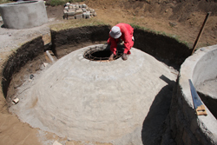
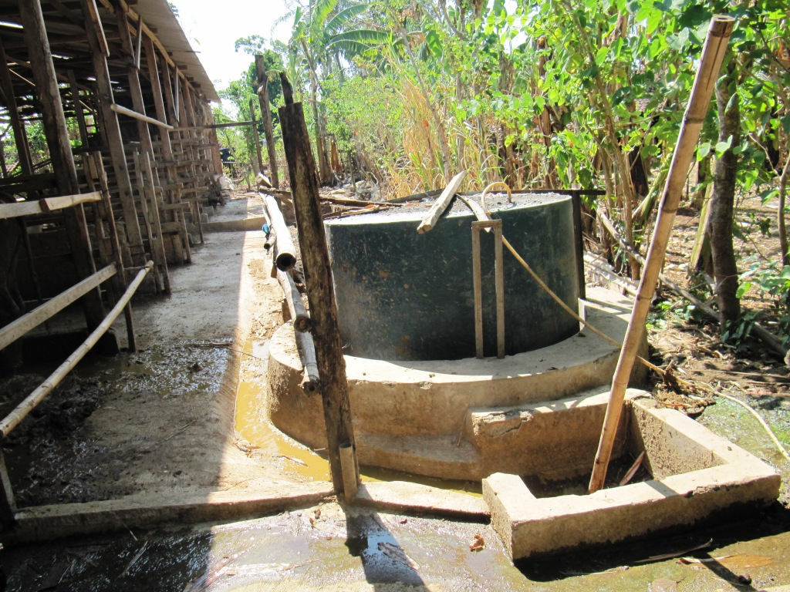

Fig. 4.5 Floating-roof digester Fig. 4 .6 Fixed-dome digester
(Source: www.azizakenya.com)

Three different schemes of biodigester development were explained during the workshop (Fig. 4.6):
- a single household-level digester, for a household with approximetely 4 members and 2 cows. Compared to communal or cluster level digester, the construction cost of this digester is high. The single household level digester can produce fertilizer and gas for cooking.
- a cluster-level digester, consists of four households (16 members) and approximately 8 cows. Such digester will produce gas for cooking and fertilizer as well.
- combined-cluster digesters. This consists of three clusters, and each cluster has a digester (3 clusters, consist of 4 households each). This system covers approximately 12 households or 48 family members and 24 cows. The gas from three digesters will be connected to a generator. The gas can be used for cooking during the day and producing electricity when excess. Fertilizer will be shared among households.

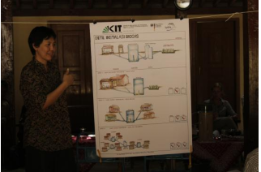

Fig. 4.7 Three alternatives of digesters
(Source: IWG-SWW, 2012)

Compared to the first two options, the last option covers more users and recovers different kinds of energy (gas for cooking and electricity). Therefore this option was offered to the community.
4.4.2. Community concerns on fertilizer
During the workshop, community expressed their concerns mainly on fertilizer. Several questions have been completely answered, but some still not fully answered.
4.4.2.1. The use of human feces as fertilizer
While the application of animal manure is well accepted, the use of humanure (treated feces) still invites pro and contra. Many user candidates had fear in using humanure as fertilizer, due to hygiene and religious reason.
During the workshop, it was explained that the feces would be treated and stabilized in the digester. Pathogen will die and the exposure to the sun in the drying bed will increase the die-off. The end product will be dark odorless dried sludge, which can be applied to the field. The application is restricted to crops which should be cooked before served.
4.4.2.2. Fertilizer as end product of the digester
Agriculture becomes the main living in this region, therefore users have more concern on the fertilizer compared to the energy (gas, electricity) recovered from the digester. Many questions were raised, concerning the form of fertilizer, its benefit compared to dried manure, its production rate and transport to the field.
Explanation was given during the workshop. The slurry coming out of the inlet contains water and need to be dried in slurry drying bed. The dried slurry and liquid part can be applied to the field. If application of liquid fertilizer seems to be a problem, the liquid can be fed again to dillute the fresh dung before entering the inlet. That way, users do not have to organize transport of liquid.
The dried slurry has more benefit compared to dried undigested manure:
- it is “stabilised” with reduced odour emissions, pathogens and weed seeds compared to undigested manure. Therefore farmers will not have to deal with weed and larva problem, which often occur by applicating dried manure on the field.
- compared to dried manure, dried slurry has less volume but finer. This reduces the number of fertilizer transported to the field, but increase the distribution/spread of the fertilizer on the field.
- the dried slurry is rich in nutrient. It is therefore suitable for application in agriculture as a fertiliser and soil conditioner. The macronutrients (N, P and K) which are contained in the substrates remain in the digestate and are easily available to plants.
4.4.2.3. Share of fertilizer
All fields in the region is non-irrigated field, which rely on the rain. The availability of the animal manure/fertilizer in the beginning of rainy season (October) is crucial. Common practise in the region is: farmers take the fresh dung and place them in a hole next to the shed, or place the dung in the corner of the shed, protected from the rain during rainy season. In the beginning of dry season, all collected dung is dried outside. After that, the dried manure is packed into several sacks and brought to the field (Fig. 4.7). Some farmers bring the sacks to the field regularly (1-2x per week) to safe the cost of transporting many sacks at once with the truck. Other farmers prefer to rent a small truck to bring all the sacks at once.
With the construction of combined-clusters digesters, all the dung should be fed to the digester from several inlets, and the slurry will exit the digester from one outlet (Fig. 4.8). The farmers have concerns on the share of the fertilizer.
Proposed solution: the share of the fertilizer will be based on the ratio of cattles ownership. The slurry will be dried and then collected in sacks. In the end, the sacks will be devided based on the number of the cows/cattles owned by each farmer. The users seemed to agree with this proposed solution, although two questions were still left:
- some farmers who used to bring the sacks regularly (not all at once) cannot continue this practice, and will have to rent a small truck- which means extra expenditure
- fertilizer share based on the number of cows might not be an ideal solution, due to the fact that each cow does not produce the same amount of dung. A big and well-fed cow will produce more dung and more fertilizer compared to a small cow.

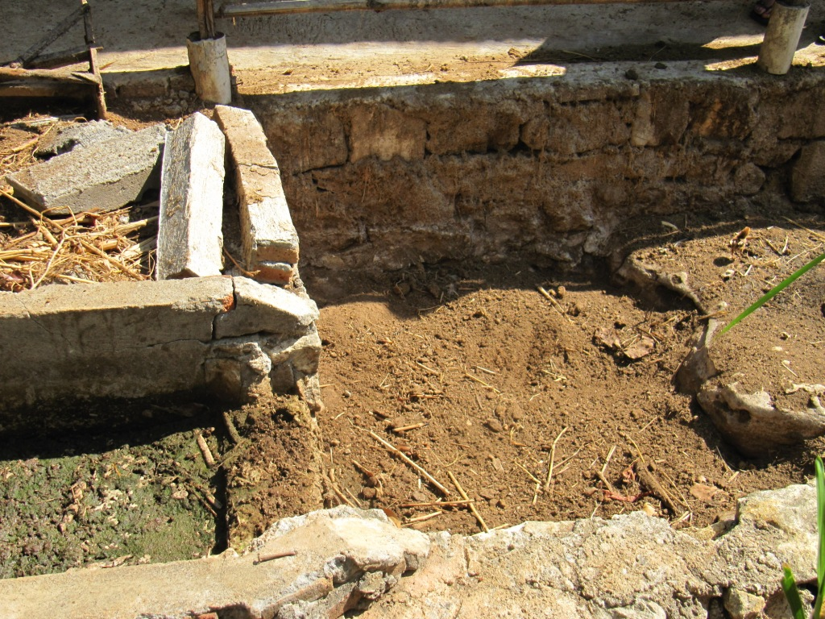
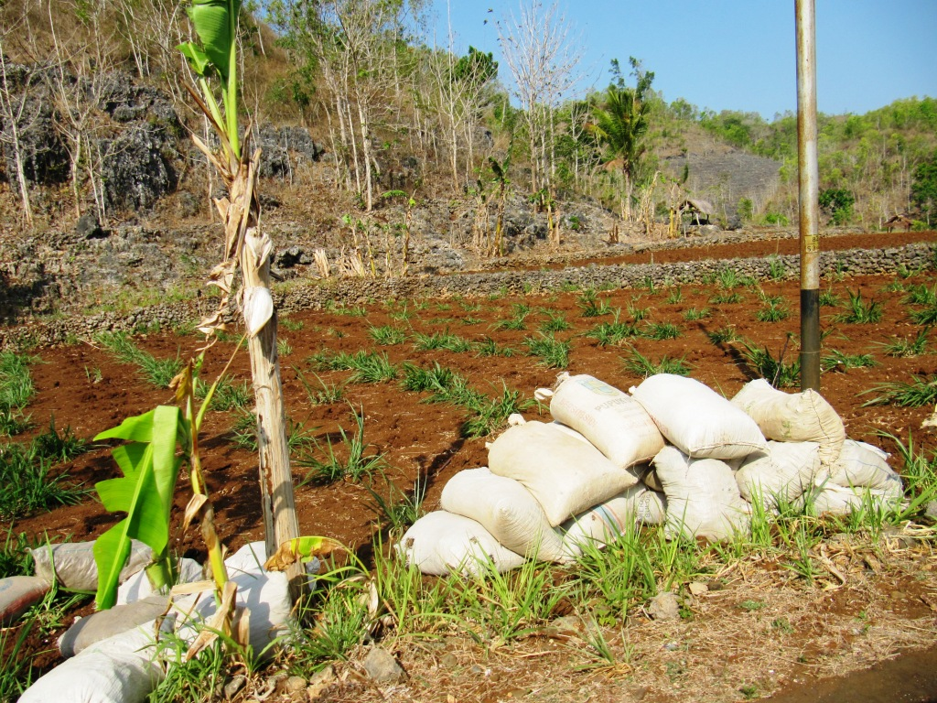

Fig. 4.8 Cattle manure brought to the field Fig.4.9 Slurry from a digester in the drying bed

4.4.2.4. Amount of water for dilluting the dung
The main water sources in Pucanganom C are rainwater and Bribin’s water. The water from Bribin should run once per week regularly. Unfortunately sometimes the water does not reach this sub-village. Biodigester requires water to transport and dillute the dung.
Several solutions were discussed during the workshop:
- moving the cattle sheds as close as possible to the digester. Short distance will require less water for transporting the dung.
- by-passing the liquid part of the slurry to the inlet, to dillute the fresh dung
- adding greywater from the kitchen in the system.
4.4.3 Remarks for the implementation phase
The second day of the workshop focused on the implemantation phase. The selection of three locations for the digester was based on several considerations:
- connectivity to sheds. A location which is accessible by more sheds is prefered, in order to optimize the coverage.
- enable the gravity-driven force. A free land with relatively low elevation is prefered to enable the gravity force from higher locations.
- owner willingness to donate the land. The ownership of the land should be clear, and there should be a written statement on the donation.
Transect walk method was applied to select the locations (Fig. 4.10). It is a systematic walk along the defined path (transect, which has been determined through surveys before the workshop) together with local community to search the proposed locations. During the walk, information was gained through observation and discussion with community.
The important results of the walk are as follows:
- three locations have been decided, and owners agreed to donate the land. Letters of agreement were signed (Fig. 4.11)
- other users agreed to move their cattle sheds and toilette to closer locations to the digester.
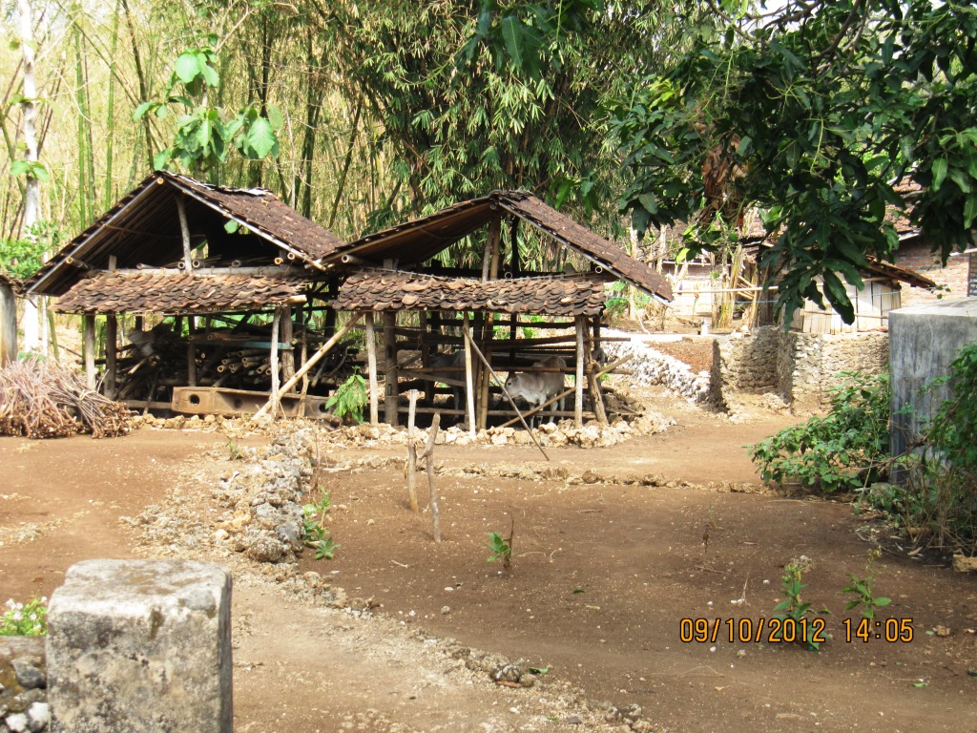
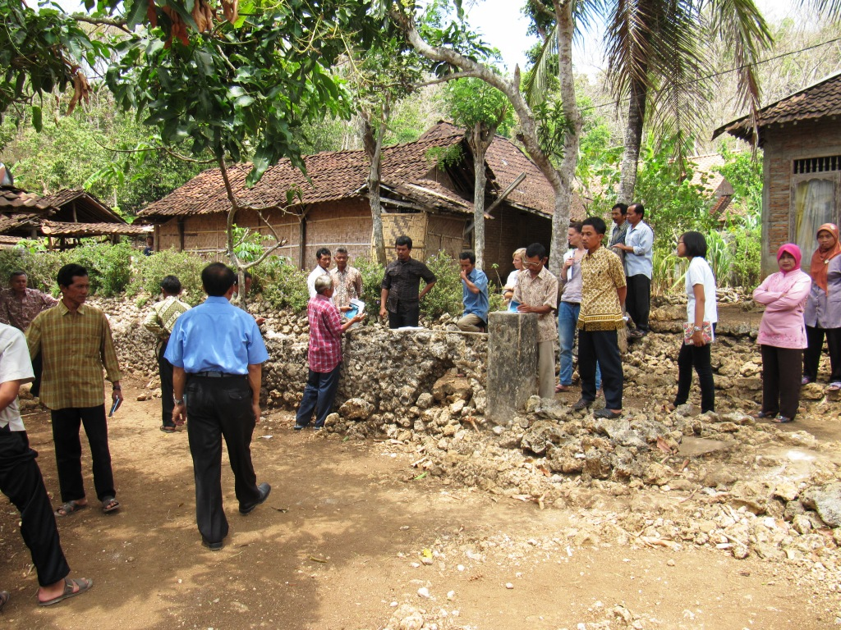

Fig. 4.10 Transect walk to identify the location Fig. 4.11 One of the selected locations

For the implementation of the digester, the people gave several suggestion based on their experience living in karst area:
- the top soil in Pucanganom (2-7 meters deep) is clay with high swelling factor, which can crack the structure. Therefore it is recommended to avoid direct contact between the structure and the soil by providing buffer zone with sand.
- to use concrete and reinforcement steel for the underground construction. These materials are ductail, therefore can reduce the crack caused by the clay swelling force and earthquake.
4.5 Treatment Efficiencies (Performance) of Wastewater Treatment and Two-Stage Anaerobic Reactor
In order to evaluate the performance of wastewater and sludge treatment plant, several chemical and physical paramaters are examined. The influent and effluent of wastewater treatment plant are daily observed. However, due to the expensive test cost, the test for some chemical parameters were only done several time randomly.
For the two-stage anaerobic reactor, the removal efficiency of organic compounds was measured by determining the elimination of total COD, BOD and Solids. When steady-state conditions was reached, biogas production, COD elimination, total solids and volatile solids of the reactor effluents were also determined.

4.5.1. Performance of wastewater treatment plant (WWTP) treating liquid effluent of septic tanks and grey water
As has been discussed before, in the hospital, several septic tanks serve as pre-treatment for wastewater from toillettes. The supernatant of the septic tanks, which is considered as pre-treated, is then discharged to a wastewater treatment plant in the hospital area. This wastewater treatment plant is using aerobic methods as its main method of treatment. Together with wastewater resulted from bathing and kitchen activities, the supernatant of septic tanks is treated in this wastewater treatment plant.
The performance of WWTP presented in Table 4.2. From the table shown below, it is known that the treatment for the effluent of septic tank can fulfil the legal requirement from the Ministry of Environment (Kepmen KLH No. 58 Th. 1995).
Table 4.2 Performance of WWTP
No. | Parameter | Unit | Septic tanks’ effluent | Outlet of WWTP | WWTP Removal Efficiency (%) | Regulation accordance
1. | COD | mg/l | 320 | 16 | 95 | Oke
2. | BOD | mg/l | 170,1 | 8,1 | 95,2 | Oke
3. | TSS | mg/l | 222 | 9 | 95,9 | Oke
4. | N Total | mg/l | 76,62 | 52,27 | 31,7 | -

4.5.2. Performance of two-stage anaerobic digester treating septic tanks’ sludge
The sludge from septic tank in the hospital is treated in a two-stage anaerobic digester. The performance of the reactor is presented in Table 4.3
Table 4.3 Performance of two-stage anaerobic biodigester
No. | Parameter | Unit | Inlet | Outlet | Removal Efficiency (%) | Regulation accordance
2. | N Total | mg/l | 405,00 | 305,46 | 24 | No regulation for solid disposal
3. | Total Solid | mg/l | 996,00 | 805,20 | 19 | No regulation for solid disposal
4. | MLVSS | mg/l | 716,00 | 688,20 | 4 | No regulation for solid disposal

From the table we know that the removal efficiency is very low. It can be possible that the sludge from septic tank fed to the reactor was less in organic content, therefore the reaction in the reactor are not running well. However, the removal of nitrogen (which is also low) is beneficial for us if we want to apply the sludge for agriculture use, since nitrogen is a substrate which is really needed by the plants.
4.5.3. Gas production of two-stage anaerobic digester treating septic tanks’ sludge during co-digestion with cow dung
The biogas production of anaerobic digester during addition of cow dung (co-digestion) was also examined in or der to evaluate the appropriateness of cow dung as a co-substrate. This is very important since anaerobic method is actually relatively sensitive to the change of environment or substrate.
At the moment we have fed the reactor with cow dung and we could see that there was significant improvement in biogas production. Apparently, the addition of cow dung as co-substrate supplied the reactor with more organic materials and also anaerobic bacteria which help the process of fermentation and methanization faster and better. Although we have not measured the data on the removal efficiency yet, we can observe that the addition of cow dung to the digester also result in higher removal of organic matters and also removal of solids.
4.6. Future Activities
Future activities of this research include:
- Calculation on the possibility of up-scaling the reactor to treat more septic tanks’s sludge in 3 regencies (Sleman, Gunung Kidul and Yogyakarta city).
- Calculation of potential energy recovery from up-scaled plant.

V. CONCLUSIONS
Several conclusions can be drawn from the results of this research. The most important conclusions can be explained as follow:
- The treatment of wastewater resulted from hospital activities were performed in two step. The first step is treatment by septic tank as pre-treatment and the second step is aerobic treatment as final treatment for the wastewater flow.
- The treatment of wastewater using septic tanks result in a quite big amount of sewage sludge which is not yet treated properly, therefore additional treatment for sewage sludge is urgently needed. In this case, anaerobic treatment using two-stage method is evaluated and considered as appropriate since it can also produce energy in the form of biogas.
- The maximum biogas production potential of sewage sludge which will be fed to the digester was approximately 250 l ⋅ kg⁻¹⋅ kg⁻¹ VS_{added}. The highest biogas production rate was obtained within the first 48 hours with 350 m³∙ kg⁻¹ COD∙d⁻¹. The average methane content of the biogas produced by digestion of septic tanks’ sludge during the batch experiment was 62 %.
- The treatment for the effluent of septic tank can fulfil the legal requirement from the Ministry of Environment (Kepmen KLH No. 58 Th. 1995), therefore the result from this treatment can be discharged directly to water bodies, such as river or small lake.
- It can be observed that the addition of cow dung to the digester also result in higher removal of organic matters, removal of solids and biogas production.

REFERENCES
Appels, L., Baeyens, J., Degrève., J. and Dewil, R., 2008. Principles and potential of the anaerobic digestion of waste-activated sludge. Progress in energy and combustion science. Vol. 34: 755–781
Fricke, K., Santen, H. and Wallmann, R., 2005. Comparison of selected aerobic and anaerobic procedures for MSW treatment. Waste management. Vol. 25: 799-810.
Gallert C and Winter J, 1999. Bacterial metabolism in wastewater treatment systems. (In: Biotechnology, Vol. 11a. Series editors: Rehm, H.J., Reed, G., Pühler, A. and Stadler, P. Volume editor: Winter, J.). Weinheim: Wiley-VCH.
Gallert, C. and Winter, J., 2005. Bacterial metabolism in wastewater treatment systems (in: Environmental biotechnology: concepts and applications. Editors: Jördening, H-J. and Winter, J.). Weinheim: Wiley-VCH.
Gerardi, M.H., 2003. The microbiology of anaerobic digesters. Hoboken, NJ: John Wiley & sons, Inc.
Gijzen, H.J., 2002. Anaerobic digestion for sustainable development: a natural approach. Water research and technology. Vol. 45 (10): 321-328.
Kabupaten Gunung Kidul website:
www.gunungkidulkab.go.id/home.php?moode=content&submode=detail&id=1030 (22.12.2008)
Kelleher, B.P., Leahy, J.J., Menihan, A.M., O’Dwyer, T.F., Sutton, D. and Leahy, M.J., Advances in poultry litter disposal technology – a review. Bioresource technology. Vol. 83 (1): 27 - 36.
Koppar, A. and Pullammanappallil, P., 2008. Single-stage, batch, leach-bed, thermophilic anaerobic digestion of spent sugar beet pulp. Bioresources technology. Vol. 99 (8): 2831-2839.
Lissens, G., Vandevivere, P., De Baere, L., Biey, E.M. and Verstraete, W., 2001. Solid waste digestors: process performance and practice for municipal solid waste digestion. Water science and technology. Vol 44 (8): 91-102.
Mata-Alvarez, J., 2002. Fundamentals of the anaerobic digestion process (in: Biomethanization of the organic fraction of municipal solid wastes. Editor: Mata-Alvarez, J.). Amsterdam: IWA publishing company.
McCarty, P.L. and Mosey, F.E., 1991. Modelling of anaerobic digestion processes. Water science and technology. Vol. 24 (8): 17-33.
Metcalf & Eddy, Inc., 2003. Wastewater engineering: Treatment and reuse. 4th ed. New York: McGraw-Hill.
Müller, K. (2009): Master thesis: Strukturerhebung der Wasserver- und Abwasserentsorgung der indonesischen Stadt Wonosari und ihrer ruralen Umgebung. Universitaet Karlsruhe.
Neves, L., Gonçalo, E., Oliveira, R. and Alves, M.M., 2008. Influence of composition on the biomethanation potential of restaurant waste at mesophilic temperatures. Waste management. Vol. 28: 965-972.
Pavlosthatis, S.G. and Giraldo-Gomez, E., 1991. Kinetics of anaerobic treatment. Water science and technology. Vol. 24 (8): 35-59.
Residua, 2009, Information sheet on anaerobic digestion of solid waste. Available online at (last access June 2009): http://www.waste.nl/content/download/472/ 3779/file/WB89-InfoSheet(Anaerobic% 20 Digestion).pdf
Stronach, S.M., Rudd, T., and Lester, J.N., 1986. Anaerobic digestion processes in industrial wastewater treatment. Berlin: Springer-Verlag.
USEPA (United States Environmental Protection Agency EPA) (2003): Getting in step: A guide for conducting watershed outreach campaigns. URL: www.epa.gov/nps (15.12.2009).html (22.12.2009)
Vandevivere, P., De Baere, L. and Verstraete, W., 2003. Types of anaerobic digesters for solid wastes (in: Biomethanization of the organic fraction of municipal solid wastes. Editor: Mata-Alvarez, J.). Amsterdam: IWA publishing company.
Veeken, A., Kalyuzhnyi, S., Scharff,H., and Hamelers, B., 2000. Effect of pH and VFA on hydrolysis of organic solid waste. Journal of environmental engineering. Vol. 126 (12): 1076 – 1081.
Veenstra, S., 2000. Wastewater treatment I. Delft: International Institute for Infrastructure, Hydraulics and Environmental Engineering (IHE Delft).
Wegelin-Schuringa, M. (2000): Public awareness and Mobilisation for Ecosanitation. Paper for presentation at International Symposium on Ecological Sanitation). Bonn, Germany, 30th to 31st October 2000. IRC International Water and Sanitation Centre.
URL: www2.irc.nl/themes/sanitation/publaw.html (21.12.2009)
Zaher, U., Cheong, D-Y., Wu,B., and Chen, S., Producing energy and fertilizer from organic municipal solid waste. Olympia, WA: Department of Biological Systems Engineering, WSU. Also available online at: http://www.ecy.wa.gov/programs/ swfa/solidwastedata/

