Short Phrase Recognition Based on Micro-camera
Preliminary Result of Voice Generator Based on Microcamera for Laryngectomies Patients

Sigit Yatmono(¹), Fatchul Arifin^{(1, 2)}, Tri Arief Sardjono⁽²⁾, Mauridhi Hery Purnomo⁽²⁾
¹Electronic Departement Universitas Negeri Yogyakarta, fatchul@uny.ac.id,s_yatmono@yahoo.com
²Electrical Engineering Department ITS Surabaya, sardjono@elect-eng.its.ac.id, hery@ee.its.ac.id,

Abstract.To rescue patients with advanced laryngeal cancer, It was conducted a total surgical. Removal of the larynx automatically also remove the vocal cord, so the patient can not speak again as before. Voice is the main tools of human communication. Without a sound, humans can no longer communicate. The option for the patient to speech again is electro-larynx speech and esophageal speech. However, these sound have a poor quality and it is often not understandable. In this paper it is proposed another way to speech. It was based on Microcamera. Two microcamera (Intra oral mouth and external camera) will be used to identify laryngectomies speech.
Keywords: Laryngectomies speech. Intra oral and external camera
- Introduction
More than 8900 persons in the United States are diagnosed with laryngeal cancer every year [1]. The average number of laryngeal cancer patients in RSCM is 25 people per year [2]. The exact cause of cancer of the larynx until now is unknown, but it is found some things that are closely related to the occurrence of laryngeal malignancy: cigarettes, alcohol, and radioactive rays.
Ostomy is a type of surgery needed to make a hole (stoma) on a particular part of body. Laryngectomy is an example of ostomy. It is an operations performed on patients with cancer of the larynx (throat) which has reached an advanced stage. The impact of this operation will make the patients can no longer breathe with their nose, but through a stoma (a hole in the patient's neck) [3].
Human voice is produced by the combination of the lungs, the valve throat (epiglottis) with the vocal cords, and articulation caused by the existence of the oral cavity (mouth cavity) and the nasal cavity (nose cavity) [3]. Removal of the larynx will automatically remove the human voice. So that post-surgery of the larynx, the patient can no longer speak as before.
Several ways to make Laryngectomes can talk again has been developed., for example:

- Esophageal Speech,
- Tracheoesophageal
- Electrolarynx Speech.

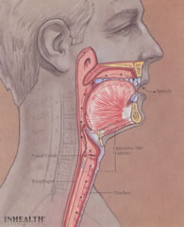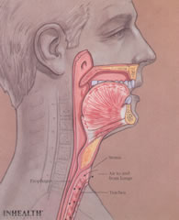

- (b)

Fig. 1a. Before the larynx removed [3]
Fig. 1b. After the larynx was removed [3]

Esophageal speech is a way to talk with throat as high as the original vocal cords as a source of sound. The vibration comes from swallowed air, before entering into the stomach [1]. Tracheoesophageal is a device which implanted between the esophagus and throat. The voice source of this method is esophagus [4]. It can happen, when laryngectomies speaking, the flow of air into the stoma must be closed. So the air will lead to the esophagus through the vocal cords replacement has been planted. Another device for helping laryngectomies to speak is Electrolarynx. This tool is placed on the lower chin and make the neck vibrates to produce a sound. The sound that produced by electrolarynx is monotone and no intonation at all. So it likes robots and not attractive. In the other hand this tool is very expensive.
As a description earlier, that we need a breakthrough to the physically impaired laryngeal can talk back easily and cheaply, and also with quality of a natural sound. In this paper presented the design of model based on microcamera voice generator. Microcamera will model the form of the mouth when producing sound. Furthermore, the model of the mouth is used to generate a voice to the patient's larynx impaired.
- Development Of System
Movement or change of mouth shape when pronouncing a certain word recorded through the microcamera. The recording results of the many types of words from a number of volunteers is stored in the data base. Then the image signal is extracted to its distinctive features. Next will be built image recognition system to recognize an image is correlated with a particular utterance. The next stage will be built the system that can generate a synthesized voice. Voice generator will be correlated with a specific image.Global picture of the voice generator based on microcamera for laryngectomiest Patients can be seen in fig.3

Mouth Cavity Sensor
Signal Conditioning
Signal/image Extraction
Image Recognition
Voice/speech Generation
Testing Sistem

Figure 3, Global design of voice generator based on microcamera
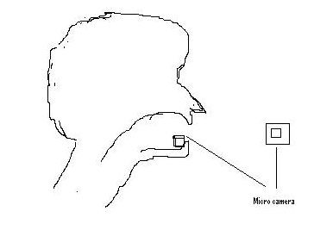

Fig. 4, Interface of Voice recognition based on Micro camera

In this paper will focus on vocal recognition based on microcamera, as a result of voice prelimenery generator based on microcamera.The development of this system is based on two micro cameras. An oral micro camera is placed in the mouth, the other one is placed externally (in front of the lips). It can be showed at figure 4.Intra oral micro camera is used to identify mouth cavity. In the other hand external camera (in front of lips) is used to identify the shape of lips.

- Material And Method
In this research there are two persons as volunteer. Each person was asked to speak some short phrase. For testing system they were asked to say: “kali”, “meja”, and “sapu”. Each phrase repeated ten times. A half of the data will be used for training set, and the other one is for testing.
All of the recorded data will be processed for their feature (feature extraction process). The output of feature extraction will be fed to the pattern recognition process. The development of processing data can be shown at figure 5.

Micro oral camera
External Camera
Feature extraction

Feature extraction
Pattern Recognition
Output of recognition

Figure 5, Data Processing

Mulai
Pengambilan data video
Pre-Processing data Video
Pengubahan citra RGB menjadi Gray
Penyesuaian ukuran citra/matriks
Peningkatan kualitas citra
Deteksi tepi / Feature Extraction
Pengenalan pola / JST
Output hasil deteksi
Pengolahan
Per- frame
Selesai
Dibuat matriks baris
Penggabungan data dalam sau video

Figure 6. Some steps of Data Processing

The video was processed to be some frames / pictures. Each frame will be processed as: RGB to gray scale process, improving of image intensity, resize matrix image so to be uniform, and edge detection. Output of edge detection from each frame was combined and fed to the pattern recognition. These steps can be seen in the diagram in Figure 6. Examples of data processing stages can be seen in Figure 7.

Short Video
Video to be some frames
RGB to Gray
Increase the intensity
Rezize the matriks
Edge Detection
Pattern Recognition
Data Base Suara

Figure 7. Example of Data Processing

Many methods of pattern recognition that can be used. In this research the chosen method is artificial neural network.Before the system is used to recognize the patterns, ANN should learn first. After the system reach goal, it can be used for recognition. In this research it was designed four layers ANN namely: the input layer, hidden layer and two layer output. The number of neurons in each layer: Inpu layer = number of image pixel, first hidden layer is 8 neuron, second hidden Layer is 4 neuron, and output layer is 1 neuron. While the activation function that it was used are tansig, logsig, and purelin. Performance of training system can be seen in Figure 8a.

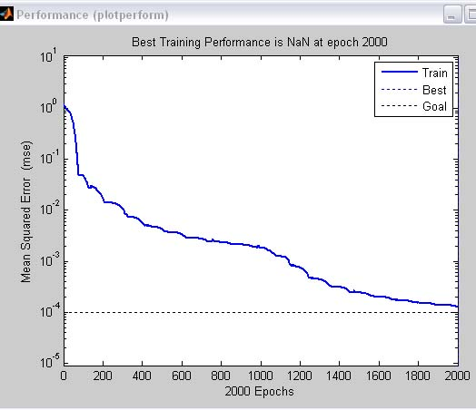

Figure 8. System performance

- Result
After completing the trainning session, then the system is used to recognize the real image patterns. The system was tested for the overall data that has been taken. Test results for the introduction of the fourth pronunciation A volunteer can be seen in table 1

Tabel 1
Result of video recognation
Video Input |  | Hasil Pengenalan |  |  | Coment
 |  | kali | meja | sapu
1 | Kali1 | x |  |  | Benar
2 | kali2 | x |  |  | Benar
3 | kali3 |  |  | x | Salah
4 | kali4 |  |  | x | Salah
5 | kali5 |  |  | x | Salah
6 | kali6 | x |  |  | Benar
7 | Meja1 |  | x |  | Benar
8 | meja2 |  | x |  | Benar
9 | meja3 |  | x |  | Benar
10 | meja4 |  | x |  | Benar
11 | meja5 |  | x |  | Benar
12 | meja6 |  | x |  | Benar
13 | meja7 |  |  | x | Salah
14 | meja8 |  | x |  | Benar
15 | sapu1 |  |  | x | Benar
16 | sapu2 |  |  | x | Benar
17 | sapu3 |  |  | x | Benar
18 | sapu4 |  |  | x | Benar
19 | sapu5 |  |  | x | Benar
20 | sapu6 |  |  | x | Benar
21 | sapu7 |  |  | x | Benar

From the results above seems there are 4 untruth outputs from total 21videos. Thus the validity of the system = (17/21) x 100% = 81%. May be it was caused by the placement of camera (the angle of recording) and the lighting.

- Summary
From the description above it can be concluded:
  - Camera placement, angles recording, and lighting greatly affect the results of data retrieval. Therefore it is necessary to get more attention on.
  - The video recognition has been developed. It is consist of framing (change short video to some frames), RGB to gray processing, intensity increasing, matrix resizing, edge detection, and pattern recognition
  - The human speech generator has been developing using data base of human speech recording.

- Acknowledgements
Thank you very much to National Education Ministry of Republic Indonesian that gave funds for this research so it can run well.

- References

Nury Nusdwinuringtyas, 2009, Tanpi pita suara: bicara kembali, Blog spot, Februari,

American Cancer Society. -2002 Cancer facts and figures

Nopember 2009,http://www.speakagain.org/index.php?page=surgery,

Tantra, Tri arief sardjono, 2009, Design of low cost electro larynx, Tugas Akhir Electro ITS

Fellbaum, K, 1999, Human-Human Communication and Human-Computer, Interaction by Voice. Lecture on the Seminar "Human Aspects of Telecommunications for Disabled and Older People". Donostia (Spain), 11 June

http://go-kerja.com/proses-produksi-suara-manusia/ (17 april 2010)

http://id.shvoong.com/exact-sciences/physics/1803946-pengolahan-citra-image-processing/ (17 april 2010)

Tri Arief Sardjono, 2009, Voice spectrum analyzes of laryngectomies patients

Fatchul Arifin, Tri Arief, Hery Mauridhy, 2010, Electro Laring, Esophagus, and Normal Speech Classification, International Confernce on Green Computing-AUN/SEED-Net

Andy Noortjahja, Tri Arief, Hery Mauridhy. 2010, Filtering of normal and laryngectomies patiens using ANFIS, International Confernce on Green Computing-AUN/SEED-Net

Jason Pauelsen, Ward Van Houven, VM Optic sensor, Hanzehogeschool, UMCG, Netherlands

http://www.tradekorea.com/sell-leads-detail/S00035938

http://szstartec.en.made-in-china.com/product/AqMmGjxJBQia/China-PC-Camera-ST-CAM003-.html

