PROCESS COMPONENTS CONVEYOR and SUPPORTERS
MACHINE IN TOBACCO LEAF CHOPPER
by:
Agus Apriyanto
07508134004

ABSTRACT
The purpose of the preparation of this Final Project is: (1) to identify the materials used in the manufacture of conveyor components in tobacco chopper machine, (2) to find out what tools are used in the manufacture of conveyor and conveyor support components, (3) to determine working steps in the manufacture of conveyor tobacco chopper machine, (4) to determine the test performance of the engine components and tobacco chopper.
The method used in the manufacture of conveyor and conveyor supporting components are identified working drawings, identify the material, identify the tools and machines used, identify the steps workmanship conveyor components on Tobacco chopper machine that consists of several parts including: upper and lower conveyor shaft, iron pipes roller up and down, up and down pebutup Reller, conveyor stand right and left, right and left adjusting conveyor, plate conveyor link, V belt conveyor, conveyor and timber barrier, to make the process of manufacture of conveyor components, and to test the function of conveyor components. Things to consider in making conveyor is to be given the primary function of the conveyor and the installation in order to have a meeting.
The results of the manufacturing process conveyor components are: (1) Dimensions for shaft Ø12 x 248 mm, roller coverings for Ø37 x 20 mm, roller tube for 42 x 140 mm, for mounting plates angled conveyor 30 x 30 x 3 mm, for plate conveyor connecting plates 370 x 22 x 4 mm, for adjusting conveyor diameter Ø17 x 28 mm and the plate 54 x 27 x 5 mm, and for limiting use of mahogany conveyor 465 x 270 x 35 mm; (2) The material used is mild steel St-37, (3) serves to continue the rotation shaft conveyor roller and pulley connecting the power, through the connecting plate conveyor conveyor shaft serves as a liaison on the spur pinion which is connected via the connecting pulley, the machine leaves chopper tobacco; (4) tobacco leaf chopper machine capable of chopping tobacco leaves with chopped the volume capacity is 1.09 kg per minute.

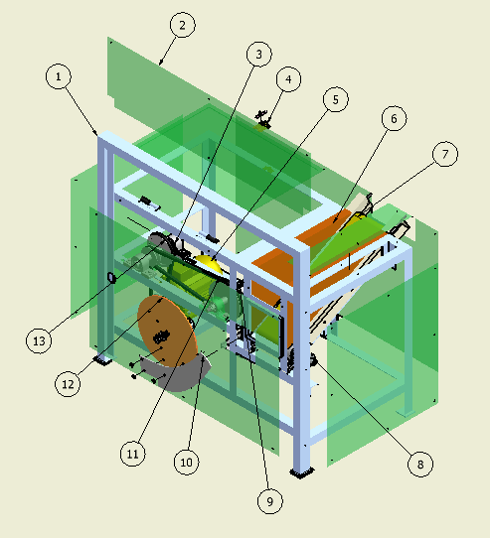

Keterangan :
- Rangka mesin 8. Bearing satu arah
- Cassing 9. Poros
- Bearing 10. Pisau
- Engsel pengunci 11. V belt
- Motor listrik 12. Dudukan pisau
- Kayu pembatas konveyor 13. Pulley
- Konveyor

